**learnmate.**

BY TYE GOULDER

# Analysis

**PROBLEM IDENTIFICATION**

Learners and Teachers spend unnecessary amounts of time deciding between different resources and platforms to manage educational duties and responsibilities. In addition,typically the most effective and costly revision resources are used by the wealthier learners. Scattered resources and self-management systems result in more effort being required to complete educational duties, which may be completed to a lower standard if the motivation of teachers and students is at a minimum. Higher stress levels among students can lead to a decline in their wellbeing, deeming them unable to attend education. In addition, the difference in accessible resources creates an unfair academic advantage between Students of differing socio-economic backgrounds. LearnMate will be suitable to assist any type of Learner regardless of their status and ability, all users will be able to benefit from a free centralised resource containing all necessary features education-wise, leading to an increase in the quality of learning and a less stressful environment. The program will represent a complex solution, making use of algorithms to recommend tailored content to each learner. The program will have an elevated level of complexity as Learners can level up their knowledge by taking advantage of these algorithms to recommend practice questions based on the subjects they enrol on and to manage their time using the built-in Time Scheduler, automating the visual allocation of events across their calendar to assist with their time management.

**STAKEHOLDERS**

One group of suitable clients would be Teachers and Younger Students belonging to an educational institution, whom of which are typically overworked and under constant pressure of performing to the best of their ability during teaching and exams. Students can use the application to complete assignments added by their teachers as well as to Organise their time, Learn and revise for their subjects, taking advantage of the all-in-one nature of the program to practice easier and more efficiently, while Teachers, as well as Students, can use the built in Time Organiser to plan their time teaching with ease. Both Teachers and Students require a solution to assist their organisation and workflow, hence as LearnMate can be used by students managed by a school, wider opportunities are created for the students regardless of their disadvantages, making sure every user gets the experience they deserve.

An additional targeted group of clients would be any user outside of a place of education seeking to excel in their subjects. This can include anyone using a desktop computer for the purposes of learning and will be classed as ‘Home Learners.’ Home learners will be able to utilize the Time Organiser, Revise, Learn & Practice features of the program to step up their independent learning experience to achieve the grade they desire. For a substantial proportion of students in schools and colleges, the environment is overwhelming and hence is responsible for declining mental health within such places. Allowing LearnMate to be usable by any Individual outside an institution ensures those who are unable to attend their place of education, or who are simply interested in a new subject, can still take part and receive the qualification they require to progress with their future. Additionally, a demographic this large allows the effect of the app to be analysed more in depth, leading to an increase in the amount of feedback received to improve the application, ready for improved future iterations.

WHY LEARNMATE IS SUITABLE TO A COMPUTATIONAL APPROACH

The nature of the application implies that it can only be conducted on a computer due to the required hardware to process the user interface components, as well as the specific Operating system software required for the program to run. Each stage of the program is an event driven action, allowing the overall design of it to be broken down into subtasks for each action, using decomposition. Additionally, in practice the program would store thousands of students’ details (e.g., Subject taken, Class, Teacher, Emergency Contact details) in a database; A computer as a server is highly suitable for storing large amounts of data with the ability to back up data in the event of hardware failure, ensuring data about Home learners, students and teachers is kept safe and secure.

COMPUTATIONAL METHODS THE PROGRAM SUITS

**Figure 1 – Rough system diagram plan**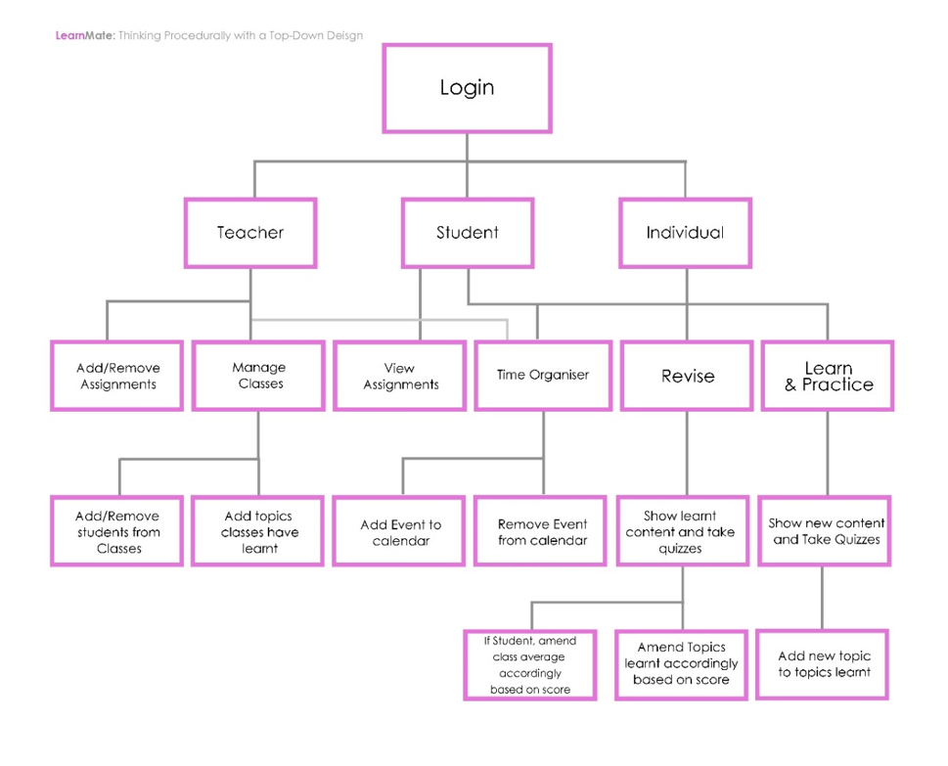

In regard to Thinking Procedurally,the internal structure of the program will reflect a modular design, combining procedures of differing purposes:

Procedural programming allows for each module of LearnMate to be developed and evaluated individually and applying the procedural mindset when developing allowed for easier decomposition of the problem, which was beneficial when designing the main structure of the solution using a top-down design as shown in Figure 1. Each leaf of the ‘tree’ shown above represents a different property of the program and will be created as subroutines. These will be activated by the users’ input and will be combined at the end by calling and passing data between each method.

**Abstraction**I will also implement several types of abstraction in my program, which is presenting essential details by removing unnecessary features. The first type I will use is procedural abstraction, which generalises subroutines as much as possible, allowing them to be used to produce a variety of different outputs by removing unnecessary specific parts to the function which would otherwise bind it to one purpose. For example, a subroutine loadForm() being able to load a form into the parent form, with which form it loads being dependent on the parameter. This is more effective in comparison to multiple load functions, like “loadLogin()”, “loadTimeOrganiser()” etc. The program will also implement functional abstraction, which is producing an output for a given input while how the output is created is hidden. This can be applied to the use of elements, such as text boxes, of the UI and getting an Output. As for example, with a given input to a topic quiz, the program will output if the answer was correct or not without showing the user how the output was generated within the internal structure of the program. All the users must focus on whether they got the answer to the quiz right or wrong.

**Thinking Ahead**  
In terms of thinking ahead, I have considered the inputs and outputs to the program which are needed, and are likely to consist of:  
-**Drop-down list boxes** to pick an answer out of a choice with their mouse while completing quizzes  
-**Text boxes** to enter their answer into the system, as well as general actions like searching up a user or entering an event into their calendar. This is done with their keyboard.  
-**Picture boxes**, buttons and their text labels displayed on their screen.  
All such actions advocate Learnmate is creatable by thinking ahead as I can prepare the user experience by considering the necessary elements and controls within the application. (e.g. making sure there aren’t too many controls on one screen as the user will feel overwhelmed)  
  
And for the overall program design, I have considered data to be kept in a separate file, instead of being computed within the UI. This is so that the data will be easier to manage, as necessary changes will reflect throughout the program by changing accordingly from the data file. Preparing for this in advance allows me to consider the backend communication easier when it comes to designing.  
The overall sequence of the program will require the following:  
- For all users, they’ll login (if pre-existing) or sign up if not. The login/sign in screen will be separate from the main screen. From this, I can determine the following necessary process: Checking if entered Login details are correct and if so return true or false. All users will also have the option to organise their time using the built in time organiser. This will require adding or removing events from a calendar.  
- Within the main screen, each main action will lead to a sub-form of which sub-actions will bring up more sub-forms. E.g. a user clicks manage classes (main action which brings up the Manage Classes subform), then they want to edit a class so another sub form comes up with the students within that class. Therefore, a loadForm() function will be necessary.  
- Teachers will be able to manage their classes and the students in them, e.g. add or remove. The process of adding or removing assignments (by adding/removing its details from a database) and adding removing students to/from classes (by adding/removing their details from a database) will be needed.

In addition, all mentioned actions will be considered in the design section, making sure the layout of the application is as required.

**Divide and conquer**  
Each process will be worked on individually. For each action the user completes, these mentioned processes will be combined applying the benefit of reusable code from a modular design. E.g. for the login system, the two processes “Login details are checked” and “different elements of the homepage are loaded based on the type of user” are then combined.

**Research**

**Figure 3**



**Figure 2**

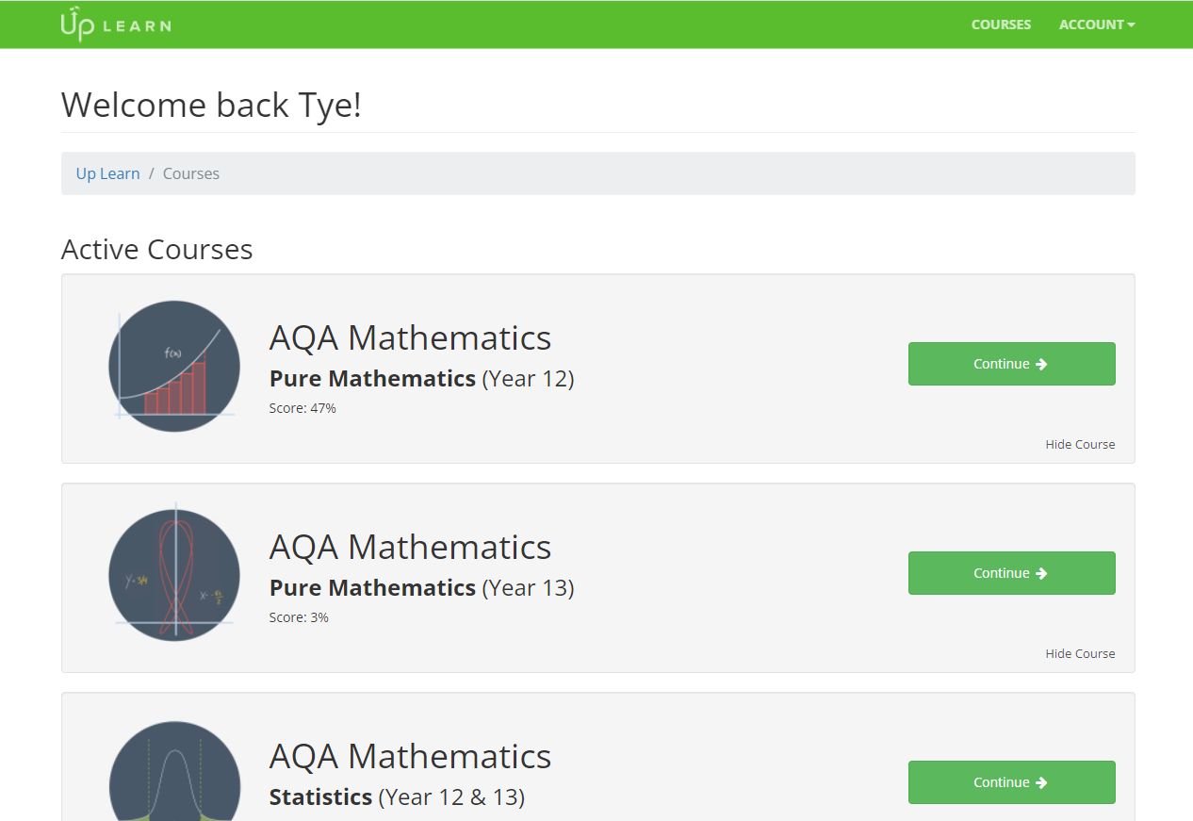

The first revision resource I am going to analyse is UpLearn, an A-Level revision resource website, featuring practice papers, video content to learn and practice quizzes and walkthroughs (Figure 2,3). On their homepage (Figure 2), the user is personally greeted in a friendly manner; the experience has clearly been considered as this landing page is aesthetically pleasing to look at due to the colour scheme used. Green is regularly associated with success and positivity, encouraging motivation for Students and Home learners to remain on the site therefore making them more inclined to get involved with learning. Another positive aspect I considered while browsing the UpLearn website are the buttons to easily perform the user’s desired task; this allows for ease of use as users can revise in only a few clicks, showing minimal effort is required by the user to lead to a significant increase in grades. From the homepage, users can complete videos and be evaluated on them simultaneously, ensuring they are paying attention and learning efficiently. Although, a feature I was not so keen on was that content on each topic is short and separated hence the website frequently switches pages to move onto the next part of the topic (as shown in Figure 4). Students who wish to revise content quickly may not consider UpLearn to be an optimal choice as all the resources are kept separate, regularly interrupting their flow of learning. Also, if their internet connection is not stable, this will negatively affect their learning experience. In addition, specific topics can be difficult to revise with since once a link has been viewed, the algorithm behind the website will not take the user back to it. This makes revising take longer since the user must manually revisit each link to each video explaining the topic they wish to revise. With this information, users are likely to diverge off to other websites to revise specific content. Within LearnMate, all students will be able to revisit content freely. For the features to implement from UpLearn into LearnMate, there will be practice quizzes after videos making sure the user was concentrating and understanding. I will also include the option to present the user with general summary videos and notes for each Subject within LearnMate’s learning section, as well as implementing the bold buttons to promote usability and excellent user experience to navigate round the application with ease. I will create a smooth learning experience by dividing resources into section per topic, as well as the idea of the using bright colours with my main colour scheme. While learning, I will change the colour to green as the use of green presents calmness and promotes motivation while the user browses throughout LearnMate, allowing students to learn with heightened concentration.

**Figure 4**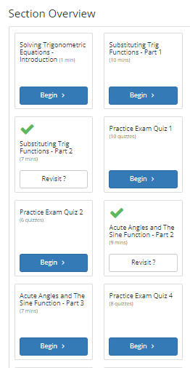

*“No highlighting in the end – make the main parts clear by bolding”*

**Figure 5**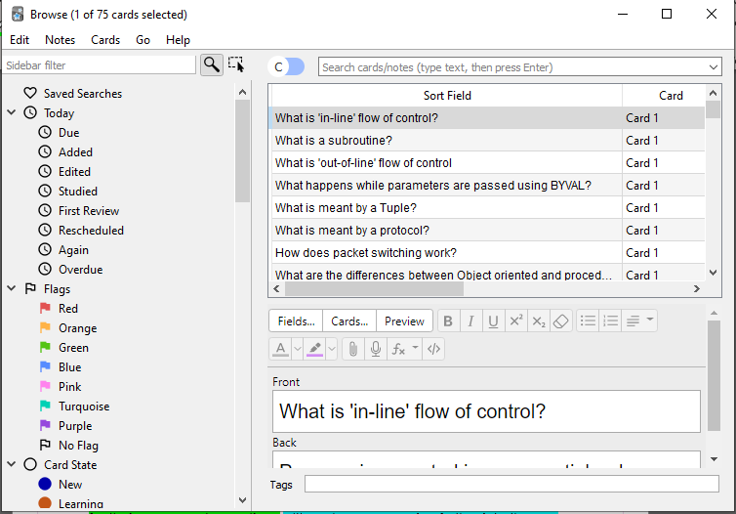

**Figure 4**

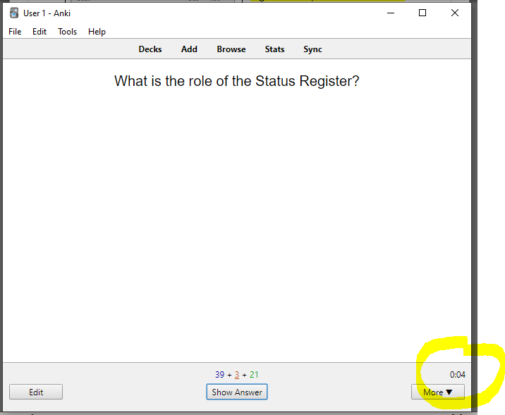

**Figure 3**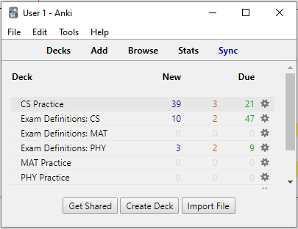

The second revision tool I am looking at is Anki (Figure 3). This desktop application makes use of active recall algorithms to present flashcards at specific times for the user to successfully remember long term data. The main menu (figure 3) is simplistic, offering a limited number of boldly labelled controls whose colours are highly contrasted with the background. This improves the accessibility of the program since those who may be visually impaired by struggling to distinguish features of neighbouring colours will not have as much difficulty using the program. I also admire the use of a timer (Figure 4) to replicate the typical pressure of being under exam conditions which trains the user ready for their assessments over time. I also observed that as the application is lightweight due to the fact that mostly text (and some images) is being rendered by the GPU. Therefore, the required performance to run the application is low.   
Although, as progressing further into the user interface, the controls become more complex to understand (Figure 5) and became overwhelming during initial uses which may drive away potential users who are looking for an app which is straightforward to use. From the advantages, I will implement a highly abstracted UI with fewer necessary controls and elements to verify most users can fluently use my application. My application will be lightweight by minimising GPU intensive tasks (such as rendering a high amount of images at once) and this is since low running resource cost is suitable for organisations using lower-powered machines, which is most used in Colleges and Schools featuring integrated graphics on motherboards. In addition, I will add the timer to assist Learners with timing when answering built-in topic questions; the timer will also be useful for analysing the user’s fluency with the topic they are answering questions for depending on how long they take. This fluency amount will influence whether they need to Learn content again (if they repetitively took a long amount of time).

**Interview**

I consulted with one of my suitable stakeholders, Sarker Zarif (Student) about the features the features he would like to see in a revision program. I received the following feedback:  
“Each main action (e.g. organise time, manage classes, learn and practice) could be separated within the homepage, and for each action to have a corresponding colour.”  
“Students could have a system where they can view their performance over time.”

**Interview Analysis**

From these responses, I have decided that I will implement the corresponding colours promote that each has action an immersive feeling, resulting in higher engagement levels among users. Also, I’ll add a performance tracker as one of the main actions possible among students, motivating them to continue learning and improving their grades. I’ll display this as a graphical chart showing their working at grade against time.

**Essential Features**

One essential feature is that a user is able to login. A login system prevents private data being vulnerable and accessible to unauthorized users. It also makes sure that a user is permitted to use the software, as well as allowing for differentiation of types of accounts logged in and the abilities of each, so various parts of the system are made available depending on the type of user logged in. (e.g., Students cannot manage a teacher’s classes). Features of the interface are limited depending on their type of account; The validation aspect prevents logging into the wrong type of account, putting data at risk, which makes sure that critical data, such as information about Learners and their grades, is not viewed by and amended by unauthorized users.

Also, data needs to be stored somewhere. Storing data allows it to be operated on. Without the storage of data, no actions would be possible within learnmate. Two examples of this are as follows: users wouldn’t be able to login as there would be no login info to compare to. They also wouldn’t be able to learn or practice as there would be no subject information stored to be retrieved and displayed. Teachers wouldn’t be able to manage their classes as there would be no stored classes to modify.

New users are required to sign up. This way, learnmate can display and retrieve information on the current user, so that information specific to them is displayed. For example, the welcome message on the landing page will be displaying the current username. Another example is that any notes in their diary are loaded, and the notes are stored in a list/array with a corresponding userID. Username and passwords are also needed so that the user can login.

All students and home learners should be required to enter the subjects they’re studying. This is essential so that learnmate knows what subjects to display in the learning section. For example, if a user is studying physics and maths, they’ll have the option to learn physics or maths content.

A student’s school should be configured upon signup. If they didn’t, teachers wouldn’t be able to view information on them, and they wouldn’t be able to complete their assignments. They also wouldn’t be able to conduct typical admin tasks within classes (such as managing assignments and monitoring students) to ensure their groups are performing as required. The largest part of the application is to challenge students and push them to their maximum potential by learning and revising content.

Finally, there should be minimal controls on each form, improving the user experience. The user should be able to know what they want to do and where to find it on the application, and with too much text/ too many controls on the application, the user may become overwhelmed with actions and their flow of use will be interrupted. The purpose of learnmate is to create a simple and seamless learning experience to users, becoming advantageous over competitors. A difficult user experience will drive users away from this software.

**Limitations**

Currently, my limited expertise at coding and small given time frame affects the program in the following ways:  
- Accessibility features like high contrast and varying text size are not a priority to develop and may not be included in the final prototype  
-Only a limited amount of subjects and topics can be included   
- When learning content with videos, I won’t be able to show videos. Pre-made videos won’t be able to be used due to copyright issues.  
  
Since I’ll be developing the database to go with the application rather than on a separate server, the higher the amount of data, the more sluggish the program will run. This is because the program will have to search through all stored data until it finds the required data on multiple situations (e.g. logging in, removing a user from a class).

The program is intended for implementation in A-Level education only. This is the content I currently desire to develop for, and is the highest qualification I have obtained.

-Multiple users will not be able to use it at once as the storage of the data cannot be added to a separate server to be accessible by multiple and instead entered data is stored in the directory of the software, locally.

**Requirements**

**The requirements hardware-wise are:**  
-Available Storage of at least 50MB: The minimum space required in practice would be around 1GB, which would be needed as media is stored when learning content due to a large amount of high quality videos and pictures used for quizzes. (Although, for this final prototype, without the videos it would be around 25MB) Icons are also needed throughout the UI.  
-A screen: Display is needed to show the outputted data from the computer system’s GPU  
-A desktop computer: The program is being designed for a desktop platform only. A GPU within the computer is needed to render the visual elements of the application, so the user can see it.  
-I/O Peripherals: Keyboard and Mouse are required as every part of the program is event-driven and therefore relies on input. The program is only controllable via a keyboard and mouse, for the inputs and outputs of the program previously mentioned (Drop Down boxes, text boxes and buttons). Used for navigation around the program.  
**And for software,**  
-A desktop device running Windows OS: As WPF applications (.exe) cannot run on any other OS, and this development process does not include a mobile version.

**Success Criteria**

For my program to be successful, it will be able to conduct the following:

|  |  |
| --- | --- |
| **Criteria** | **Justification** |
| WHAT MUST BE INCLUDED | |
| Every type of account must be able to be created | Features available on the homepage after login must reflect the type of account logged into |
| New and existing users can login using their Username, Password, and institution code | Users need a way of accessing the system while also applying protection to the data it contains. Their login information being unique verifies non permitted users are kept away from the software, and that a user does not log into the wrong account which may end up in compromised data. |
| Experience using the program should be high quality and represent that of in person. | Browsing learnmate must be enjoyable and inspiring to use. Browsing a non-aesthetically pleasing program easily becomes tiresome and boring to the user, and a key part of a revision software is making sure users can remain in the cycle of learning for the longest possible time span.  Also, the relation between teachers and students in the application must reflect that of in person, e.g., clicking into a class brings up students, like how by looking at a class you see its students |
| Users can have a study timetable to keep them motivated | Incorporating a calendar makes the experience using learnmate more all-in-one. Users are unlikely to deviate from the app and can plan around their education easier. |
| Each of the essential forms is created | Without the main forms (time organiser, manage classes, learn & practice) there would be no purpose in learnmate |
| Users are able to access different actions depending on their user type. | A student shouldn’t be able to manage classes in their school. |
| **WHAT SHOULD BE INCLUDED** | |
| Design must be aesthetically pleasing | A minimalistic and intuitive application adds to the simplicity which is optimal for using such a complex application. This confirms that more of a variety of users, even those less technologically competent, can navigate around the software with ease. Eye-catching colours, shapes and overall design encourages an improved experience using Learnmate. |
| Runs lightweight | Ensures the program is usable on more of a variety of machines |
| Data must be stored consistently across multiple entities | Without this, data would not be updated everywhere leading to references of null objects within code and overall incorrect information being displayed. |
| **WHAT COULD BE INCLUDED** | |
| Retrieval of a summary of data | A teachers’ ability to save a summary of data entered to a text file |
| A Timer during practice exam questions | Beneficial as it mimics exam conditions but is difficult to implement. |
| Teachers would be able to manage students’ logins | If a student has forgotten their password, a Teacher can change it for them so they can access their account. |
| Simple navigation for non technical users | Allows more of a variety of users to access the software |
| Students’ knowledge is tracked | Learnmate could recommend content to users based on what they don’t know. Teachers could tell learnmate their knowledge, and it would be automatically modified by completing practice questions. |
| WHAT WOULD BE INCLUDED | |
| Messaging system | Teachers and Students would be able to communicate with each other |

# Design

**Introduction**  
As LearnMate is an event driven program, each event performed can be carried out by a given function which can be independently developed. For example, functions such as editStudent(), loadForm() etc can be worked on individually. Doing so breaks the program down into subprograms which can be combined at the end to form the program. The nature of this approach presents decomposition, as well as thinking procedurally, as the problem is being broken down into subproblems, which is required to manage the solution by parts with a clearer understanding of what needs to be developed.  
Having so many subroutines involved automatically tends towards developing in prototypes, where each is checked to see if it works.

For the prototypes, I will be basing each off of the mentioned essential features and what should be included:

**Prototype 1** - Data needs to be stored in a backend

**Prototype 2** *-* A user can login and sign up

**Prototype 3** - Students and home learners can enter the subjects they’re studying

**Prototype 4** - A student’s school should be configured upon signup

**Prototype 5 –** Each essential form is created with a minimalistic UI

**Prototype 6 –** Each action is linked up to the backend

I am breaking the program down into these stages as I need to ensure the bare functionality is included in the frontend and backend before linking them together. From this, I can focus primarily on making sure the application works properly with minimal errors.

**Final System Diagram**

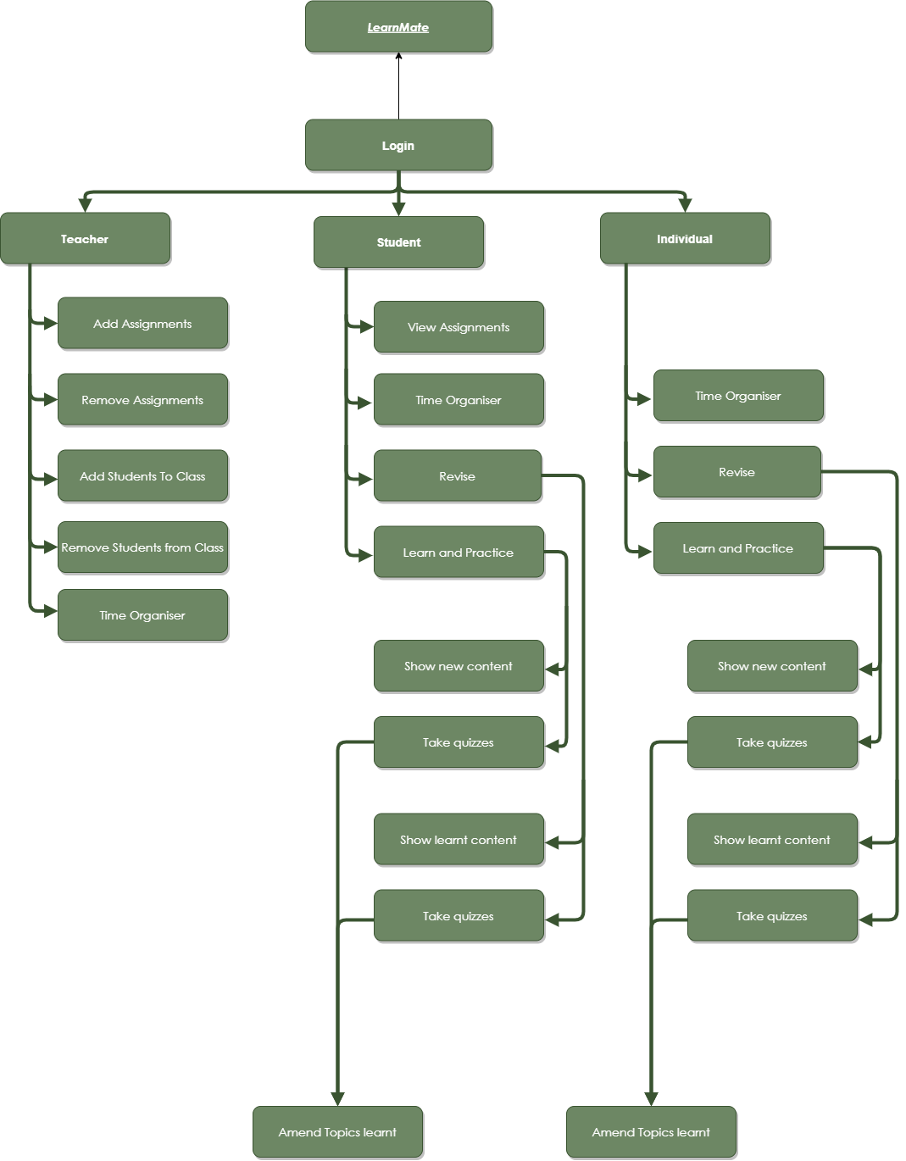

**Program Functions**

When developing prototype 5, the program can be broken down into separate subroutines in three main sections: Student, Teacher and Individual. Each role will be able to perform the following:  
**Students and Home learners**- Revise   
- Learn & Practice

**Students**- Complete assignments

**Students, Teachers and Home learners**- Time Organiser

**Teachers**- Manage Assignments  
- Manage Classes

Looking at each function in more detail:

**Revise**

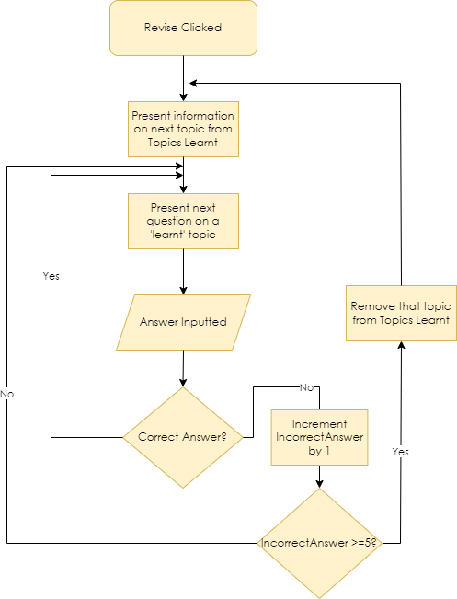

On their homepage, Students and Individual users can be presented with content on topics they have learnt by clicking the revise button. If there are topics that the user has previously learnt, information (images and videos) will be available for users to relearn before they attempt the questions. Once the questions are started, the user getting the questions wrong over 5 times will remove that topic from the list of learnt topics, and will be available to be learnt from the ‘Learn and Practice’ section on the homepage instead. This process is repeated until there are no more Topics learnt or the user closes the program.

**Learn and Practice**

Clicking this presents the user with information on the next available topic to learn (or the topic they have chosen to learn). Doing this creates a session, with 10 questions worth. Introducing short sessions makes the user more inclined to complete their homework. Once the information has been read through, they are shown questions to answer. If the answer was correct on more than 5 questions in that topic, that topic is added to ‘topics learnt’, and the user moves onto the next topic. Once the questions answered reaches 10, the end of session summary is presented.

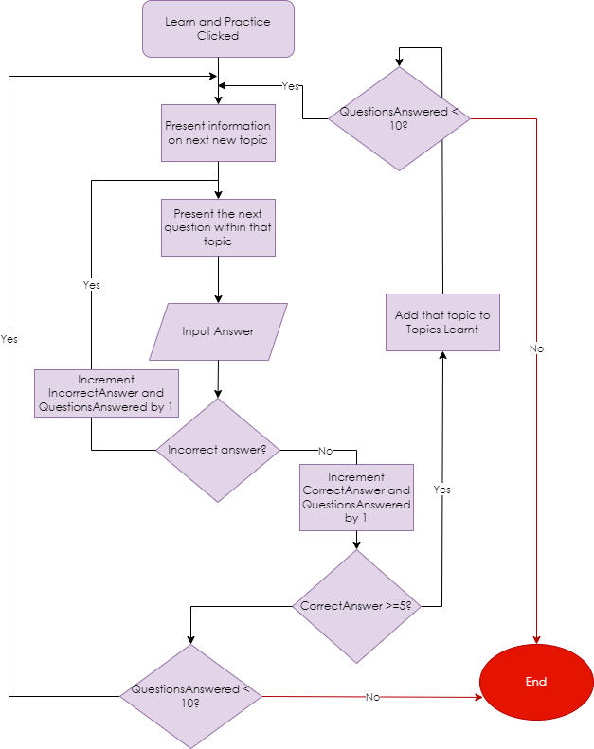

**Time Organiser**

Users can plan out their events and organise their time using the calendar from the homepage. The calendar may already contain events entered, so the next available day and time from the DayArray and TimeArray is found, and the entered data is added to the calendar by writing data into NameArray (Parallel to TimeArray) and DescriptionArray (Parallel to TimeArray). (These structures will be implemented in the program or using a database)

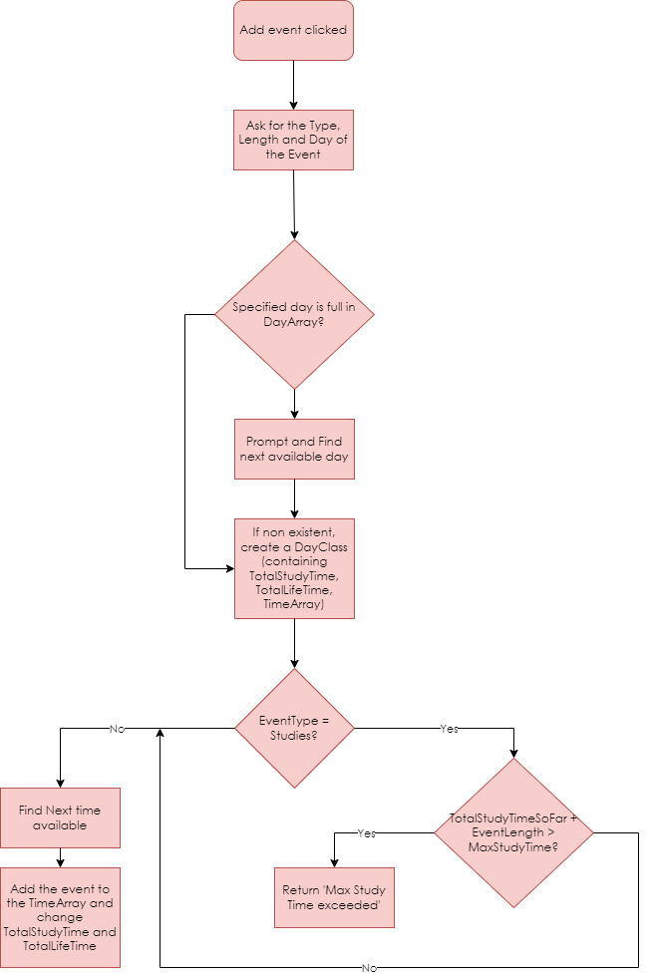

**Managing Assignments**

Teachers can manage assignments (topics to learn) for classes to learn, with the added/removed assignments being amended to the database. Upon loading, these assignment details are retrieved from the database to present to students.

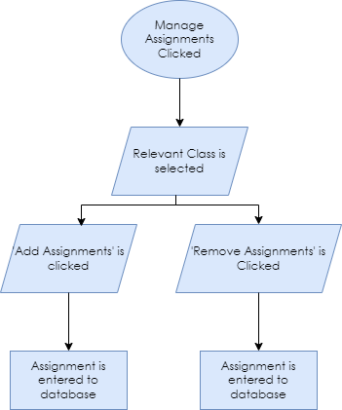

**Conclusion**

These functions all fit together by the general order that the user uses the program in. What links all these sections together is the List of Topics Learnt. Initially, the user will need to learn the content before practicing it, so, for classes, the teacher will set the topics that need to be learnt in an assignment (or the student can add a topic they want to learn). For Home learners, they will select their own topics to be learnt. The Learn&Practice section then uses these topics that need to be learnt, practicing the users’ knowledge. When the user clicks ‘do assignment’, it takes them to the Learn&Practice section with that topic loaded in. If the practicing goes well and many questions are correct, the topics are added to the Topics Learnt. Once this is done, the user can regularly visit the Revise section, which uses the Topics Learnt to know what to test the user on. If the user fails the practice questions in the revise section, then that topic is no longer marked as Learnt, and is available back in the Learn&Practice section as an assignment from LearnMate instead.

In terms of the rest of the functions, all the mentioned functions are available on the homepage of the program. The Time Organiser button will be presented first, with View Assignments, Learn&Practice, Revise buttons coming after that to help with a flow of what to use and when, as users will usually organise their time before working, then progress along the cycle of learning.

**Form Design – High fidelity prototype**- All colours used here will aim to be implemented in the final design.

**Login Screen**

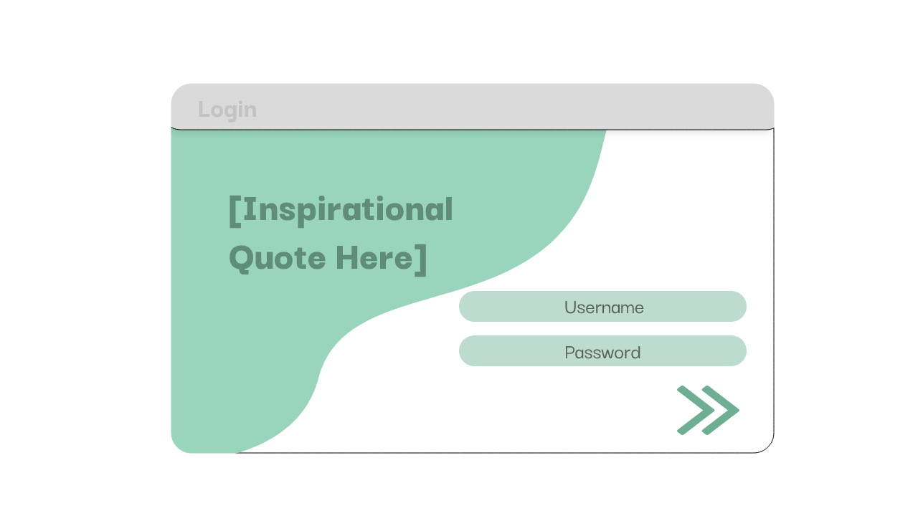

System-Wide font will be Darker Grotesque.

The program will be white with a green and teal accent

Minimal controls on the login screen allows for ease of use.

Go button allows user to progress to the homepage (if the details are correct)

Text Boxes with built in labels allow the user to input data to the system

Minimal Controls on Login screen allows for Ease of 

|  |  |  |
| --- | --- | --- |
| Usability Feature | Description | Justification |
| Text Boxes | Allows the user to enter data | The username and password of a user is required to query the type of account and other attributes belonging to that user |
| Button | Go button is a Clickable area providing a response | The user can progress onto the next form |
| Label | Labels showing ‘Username’ ‘Password’ and an inspirational quote | Guides and motivates the user to use the application correctly |

**Homepage**

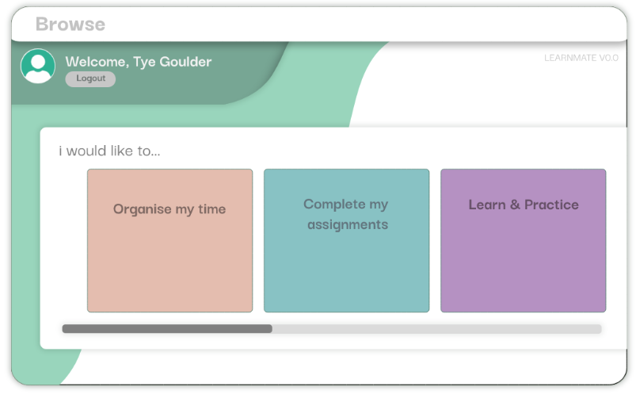

Bold Logout button takes the user back to the homepage

Layering different shades of green with shadow effects makes the application look more pleasing

Each of these buttons take the user to a different screen, related to the functions mentioned above

Scroll bar allows the user to navigate through the different options the user has on the homepage

(In terms of the homepage for Home learners and Teachers, Home learners won’t have the option to complete their assignments as they have no teacher to set them. Teachers will have Options: Manage Assignments, Manage Classes, Time Organiser in place of the boxes shown above.)

|  |  |  |
| --- | --- | --- |
| Usability Feature | Description | Justification |
| Buttons | Interact with the UI by clicking the mouse | Needed to progress onto the desired page |
| Labels | Displays text | Guides the user aroud the application |
| Scroll bar | Navigation | The user can navigate through the full list of options with a limited view |

**Time Organiser**

Orange accent colour with the title represents the time organiser section

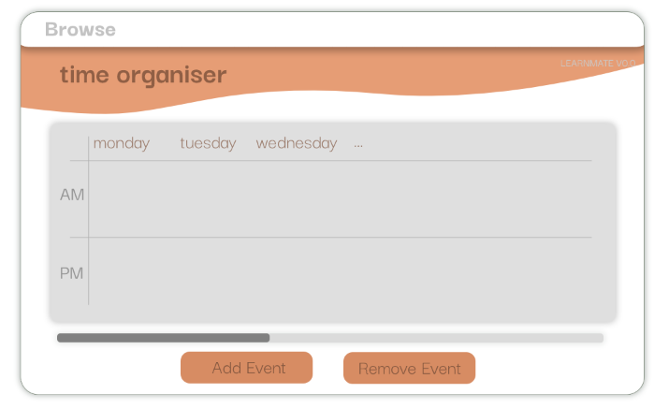

All these time blocks under each day will be filled in as events are added

Scroll bar maybe needed to navigate round the days of the week(?)

(When the Add event and Remove event buttons are clicked, a submenu would appear allowing them to enter the event description and type, the program generates a time to allocate the event to)

|  |  |  |
| --- | --- | --- |
| Usability Feature | Description | Justification |
| Label | Text | Used to give the form a title so the user knows the section they’re on, and labelling the days of the week |
| Buttons | Users can control the UI | User needs to interact to add an event |
| Scroll bar | Users can control the UI | User needs to view the full amount of information |
| Text Boxes | Users can input information | When the user needs to add an event, they will need to input the information about the event. |

Buttons to add and remove events in the main colour to show they’re main buttons of the screen

**Learn and Practice**

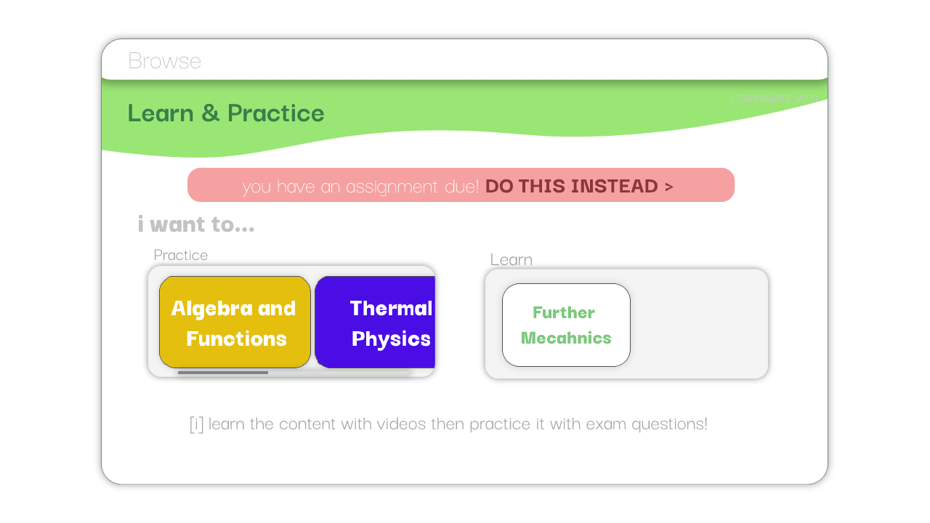

Label showing information on the page

|  |  |  |
| --- | --- | --- |
| Usability Feature | Description | Justification |
| Buttons | Shows the user the topics they could learn & practice and lets them progress to it | In order to interact with the UI to select the topic they desire, a button would be most suitable |
| Labels | Shows text for guiding the user round the application | The user wouldn’t know what the buttons are for if they don’t see labels round them. |

Colour green motivates the users to learn

Label showing information on the page

**Manage Classes**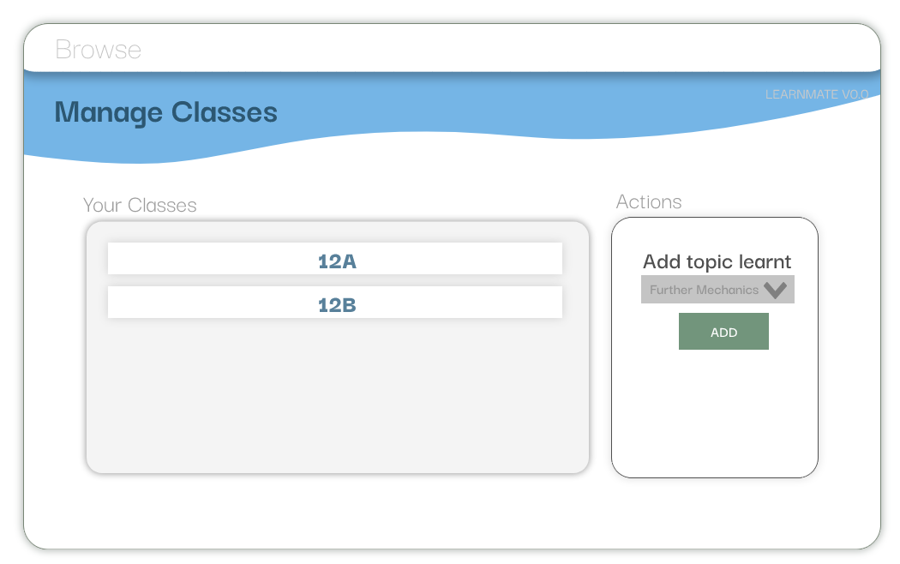

Add an assignment:  
  
select assignment type  
[DROPDOWN BOX]

select assignment subject  
[DROPDOWN BOX]

select assignment topic  
[DROPDOWN BOX]

ADD [BUTTON]

Labels

Buttons

DropDown Box

|  |  |  |
| --- | --- | --- |
| Usability Feature | Description | Justification |
| Buttons | Shows the user the topics they could learn & practice and lets them progress to it | In order to interact with the UI to select the topic they desire, a button would be most suitable |
| Labels | Shows text for guiding the user round the application | The user wouldn’t know what the buttons are for if they don’t see labels round them. |
| DropDown menu | Shows the user a list of topics to add to a class | Students wouldn’t be able to complete assignments without knowing the topic they need to complete |

**Interview**

I interviewed my mother (former teacher) who gave me the feedback of each control needs to be clearer with its corresponding action. She also said there is too much content in the actions box, making the screen difficult to navigate.

Sarker, as previously interviewed, mentioned that there needs to be less text on the manage classes screen, so he would know where to read easier.

**Interview Analysis**

I have decided to implement a tooltip within the controls, meaning when a user hovers over a control, its action is displayed next to the mouse. I also combined all assignment related actions to one “class assignments” button. Once clicked, it will bring up a subform as shown below:

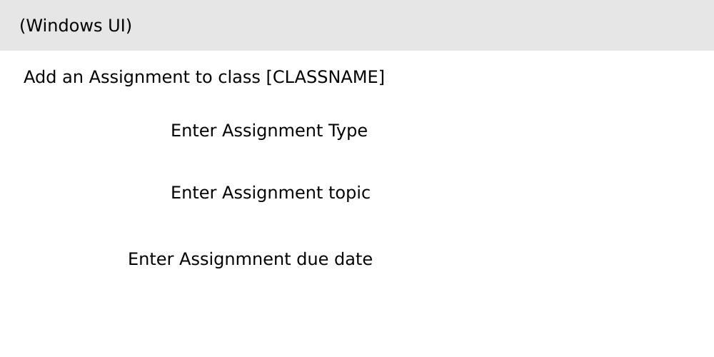

In response to Zarif’s feedback, the title of the subform will now be implemented within the titlebar, along with the brand as shown below:



**ER Diagram**

I am aiming to implement the backend to an Access database file.

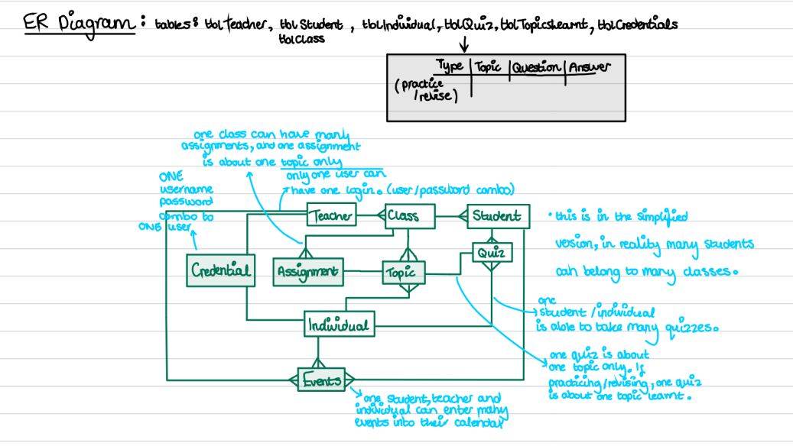

Logging in requires for one user to have one set of credentials. If the user logs in as a teacher, one teacher can have many classes, and many classes can contain many students. Of these classes, one class (and one individual) can have a set of topics, which they’ve learnt or not learnt. (These topics are used for assignments: one assignment is about one topic). These topics learnt or not learnt are also used for quizzes, where one topic is associated with one quiz. For the time organiser menu, a teacher, student and an individual can enter many events into their calendar.

**Data Dictionary**

**Teacher Table**

|  |  |  |  |
| --- | --- | --- | --- |
| Field | Type | Purpose | Validation |
| [PRIMARY] TeacherID | Integer | Stores the unique identifier of each teacher | N/A – It’s auto generated |
| UserID | Integer filled from Credentials table | Stores the userID of this teacher | N/A – Its auto generated |
| TeacherName | Short text | Stores the name of the teacher. Used for showing who assignments are set by | Like “A”LL …, so e.g. Tye Goulder, John Appleseed |
| ClassIDTaught | List (Selection from the Class table) | Stores the ID of the class the teacher belongs to | Must be an integer |

**Learner Table**

|  |  |  |  |
| --- | --- | --- | --- |
| Field | Type | Purpose | Validation |
| [PRIMARY] LearnerID | Autonumber | Stores the ID of each learner as a unique identifier in case of repeated names | N/A – It’s auto generated |
| LearnerType | List (Individual or Institutional) | Stores the type of the student so the correct homepage is loaded upon login | “Individual” OR “INSTITUTIONAL” |
| LearnerFirstName | Short Text | Stores the first name of the learner. Doesn’t store the full name as fields should be atomic | **(no spaces)** |
| LearnerLastName | Short Text | Stores the last name of the learner. Doesn’t store the full name as fields should be atomic | **(no spaces)** |
| UserID | **Integer (filled from Credentials table)** | Stores the unique ID of the user | None - autonumber |

**Class Table**

|  |  |  |  |
| --- | --- | --- | --- |
| Field | Type | Purpose | Validation |
| [PRIMARY] ClassID | Short Text | Stores the ID of each class | (e.g. 12F, 09B) |
| ClassName | Short Text | Stores the name of the class | Short text (e.g. Tye’s CS class) |
| TopicsLearntByClass | Short Text | Adds learners’ topics to study from input. A learner changing their topics learnt changes this value to “-“ as values differ | One word |

**Subject Table**

|  |  |  |  |
| --- | --- | --- | --- |
| Field | Type | Purpose | Validation |
| SubjectID | **Short Text** | Stores the ID of each class | **Input mask LLL** |
| SubjectName | **Short Text** |  |  |

**Topic Table**

|  |  |  |  |
| --- | --- | --- | --- |
| Field | Type | Purpose | Validation |
| TopicID | Short Text | Stores the ID of each topic | LLLL ????  (e.g. FURTH MECH / ELEC) |
| TopicName | Short Text | Stores the name of each topic | No validation (e.g. Further Mechanics, Electricity) |
| TopicQuestions | Array | Stores all the topic questions | None - predefined |
| SubjectID | Dropdown (from subject table) | Allows association of multiple topics to one subject | LLL (e.g. MAT, PHY, CSC…) |

**Topic Quiz Table**

|  |  |  |  |
| --- | --- | --- | --- |
| Field | Type | Purpose | Validation |
| [PRIMARY] QuizID | Autonumber | Stores the number of the quiz | No validation, Autonumber |
| SubjectID | Short Text | Stores the subjectID to link many questionsets to one subject | LLL (e.g. MAT, PHY, CSC…) |
| TopicID | Short Text | Stores the ID of the quiz topic | LLLL ????  (e.g. FURTH MECH / ELEC) |
| QuizQuestionsID | Integer Array | Stores the IDs of the corresponding topics to be t | None - predefined |

**Quiz Question Set Table**

|  |  |  |  |
| --- | --- | --- | --- |
| Field | Type | Purpose | Validation |
| [PRIMARY] QuizQuestionsID | Autonumber | Stores the ID of the quiz question set | No validation |
| Question 1 | Long Text | Stores the information/question to be tested | No validation |
| Question 2 | Long Text |
| Question 3 | Long Text |
| Question 4 | Long Text |
| Question 5 | Long Text |
| Question 6 | Long Text |

**Quiz Answer Set Table**

|  |  |  |  |
| --- | --- | --- | --- |
| Field | Type | Purpose | Validation |
| [PRIMARY] QuizAnswersID | Autonumber | Stores the ID of the quiz answer set | None - predefined |
| Answer 1 | Long Text | Stores the information/question to be tested | No validation |
| Answer 2 | Long Text |
| Answer 3 | Long Text |
| Answer 4 | Long Text |
| Answer 5 | Long Text |
| Answer 6 | Long Text |

**Assignment Table**

|  |  |  |  |
| --- | --- | --- | --- |
| Field | Type | Purpose | Validation |
| [PRIMARY] AssignmentID | Autonumber | Stores the number of the quiz | No validation, Autonumber |
| AssignmentName | Short Text | Stores the name of the assignment | None - predefined |
| ClassID | Integer |  | None - predefined |
| QuizQuestionSetID | Integer |  | None - predefined |

**Credentials Table**

|  |  |  |  |
| --- | --- | --- | --- |
| Field | Type | Purpose | Validation |
| UserID | Autonumber | Stores the unique ID of the user | None - autonumber |
| UserType | Short Text | So that a new learner or teacher can be created | Like “Teacher” or “Learner” - One option or the other |
| DBUsername | Short Text | Stores the username of the user | Like “L”000000 for a learner or “T”000000 |
| DBPassword | Short Text | Stores the password of the user for login | Must have a capital letter, less than 16 chars and a special character |

**Variable Table**

**This is only a rough outline of the main variables I will use – I am unable to document all of the possible variables which would be useful at this moment in time.**

|  |  |  |  |  |
| --- | --- | --- | --- | --- |
| Name | Data type | Scope | Purpose | Validation |
| UserUsername | String | Local to login function? | Stores the username of the user from the login form to the database | Less than 12 characters |
| UserPassword | String | Local to login function? | Stores the password of the user from the login form to the database | Less than 12 characters |
| UserType | String | Global to login function and search function | Stores the type of a user for easy searching, and to know which form to open on signup: Learner sign up or Teacher sign up | “Teacher” or “Learner” must be selected from dropdown |
| TeacherName | String | Global to all institution related functions | Stores the name of the teacher to put it in database | Less than 12 characters |
| LearnerName | String | Global to all institution related functions | Stores the name of the learner | Less than 12 characters |

**Data Structures**

**This is only a rough outline of the main data structures I will use – I am unable to document all of the possible data structures which would be useful at this moment in time.**

|  |  |  |  |  |  |  |
| --- | --- | --- | --- | --- | --- | --- |
| Name | Type | Scope | Purpose | Validation | How will it be implemented? | To be included in prototype… |
| createActionBox | Function | Local | For selecting their desired action on the homepage, multiple boxes of differing properties can be made from one box class | Enter a valid TopicName When passing data into it | On the homepage, createActionBox will be called for every action possible for that user, with the parameter of text. E.g. if user = student, createActionBox(“Learn and Practice”), … | 1 – Home screen |
| School | Class |  | Holds the institution code, teachers and students |  | School SSFC = new School()  SSFC.addTeacher(x) | 2 |
| actionArray | Array | Local | Stores what actions the user can perform in the homepage. | No validation – nothing is inputted into this array, fills itself with available actions based on the user | This array exists in the code and will be filled by each case of the user type logged in. (E.g. if user is student, actionarray=…) | 1 – Home screen |
| addEvent(title,time,note)t | FUnction | Local | Allows for multiple events with base characteristics (Length, Time, Type [Study/Life]) to be made | Enter EventName, with a valid EventType when passing data into it | An event can be created from this class, holding events with base characteristics (Length, Time, Type [Study/Life]). A method within this class can be used to add the event to the form as a control. |  |
| generateTimeTable() | Function |  | Enter times to avoid and make a timetable around that. |  |  |  |
| daysClass | Class | Local | Allows for multiple days with base characteristics (Slot AM, Slot PM) to be created | Generates 5 days…topics can be seen as a class | Add function can be used after creating this class. E.g. daysClass Monday = new daysCLass(). Monday.addEvent(time)  With the addevent procedure created separately. |  |
| topicBoxClass | Class | Local | For selecting their desired topic on this page, multiple boxes of differing visual properties can be made from one box class |  |  |  |
| topicArray | Array | Local | Fills topics in from assignments set to learn/topics to practice |  |  |  |
| quizID | Class | Local | Creates a quiz based on the chosen type |  |  |  |

**PLAN**

|  |  |  |
| --- | --- | --- |
| User | Action | How this is possible |
| Any | Sign up | User inputs their desired username, password and their type in the text boxes upon first load. Saves to credentials table, then is saved to teacher/learner table |
| Teacher | Adds a subject | Homepage is shown. Manage assignments is clicked; shows existing assignments. Add assignment clicked: shows existing subjects. Add subjects is clicked? Enters the subject name in the text box, a new subject record is created from this in the subject table. |
| Teacher | Adds a topic | User selects a subject. Shows existing topics. Add topic clicked? Enters a topic name and topic code in a text box. These are entered directly into the topic table to make a new record of a topic.  Once topic is selected, preloaded quizzes of differing types can then be added to the quiz table based only on which detectable topics have been added, done by a procedure |
| Teacher | Changes a quiz | There are already pre existing quizzes, which are shown. Add a quiz? Teacher Selects which quiz from the filterable list, of types in the subject, topic and type of the quiz <learn or practice> (one form?). New topicquiz record is created, Then is able to edit each question of the generated quiz (another form?) NOTE THAT THE NUMBERS INVOLVED ARE AUTO GENERATED UPON QUIZ LOADING |
| Teacher | Adding a class, Adds an assignment to a class | Classes are listed. New class?Types in the name of that class. New record of a class is made. Then, Institutional learners are listed. They are selected and can be added to class NAME.  With this, The teacher selects a class, Types in assignment name and chooses the Quiz name they want to assign their class to belong to. Clicking complete creates a new assignment record. |
| Student | Completing an assignment | Complete assignment button clicked. Assignments are listed (from the quiz table). After one is clicked, this just takes them to the quiz screen, loading in the quiz details (from the corresponding quiz questions table). The quiz answers are auto generated based on the equation required to solve each question, and are stored in the quiz answers table. Once complete, the assignment record gets removed |
| Student | Learn and practice: Learn - Completing a quiz | Show ‘what would yoj like to learn? Allowing them to search, show list from where quiztype = learn, then when they select a topic, select quizquestions, from the quiz table where topicID = selectedtopicID>takes them to the quiz screen, loading in the quiz details (from the corresponding quiz questions table just shown). The quiz answers are auto generated based on the equation required to solve each question, and are stored in the quiz answers table. |
| Student | Learn and Practice: Practice – Completing a quiz | Show ‘what would you like to practice?’ Allowing them to search, show list from where quiztype = practice, then when they select a topic, select quizquestions, from the quiz table where topicID = selectedtopicID>takes them to the quiz screen, loading in the quiz details (from the corresponding quiz questions table just shown). The quiz answers are auto generated based on the equation required to solve each question, and are stored in the quiz answers table. |

# Development

As mentioned, my prototypes were:

**Prototype 1** - Data needs to be stored in a backend

**Prototype 2** *-* A user can login and sign up

**Prototype 3** - All users will choose subjects during signup. Students and Homelearners can learn or practice topics within these subjects, and teachers can allocate subject-specific groups with this.

**Prototype 4** – A student and teacher can affiliate with a school

**Prototype 5 –** Each essential form is created with a minimalistic UI, with actions linking to backend

**//STATUS: Finish #1 and show errors within it. Show testing backend as the console output debug.**

**A recap of the success criteria**

|  |  |
| --- | --- |
| **Criteria** | **Justification** |
| WHAT MUST BE INCLUDED | |
| Every type of account must be able to be created | Features available on the homepage after login must reflect the type of account logged into |
| New and existing users can login using their Username, Password. Students can affiliate with schools using an institution code upon signup. | Users need a way of accessing the system while also applying protection to the data it contains. Their login information being unique verifies non permitted users are kept away from the software, and that a user does not log into the wrong account which may end up in compromised data. |
| Experience using the program should be high quality and represent that of in person. | Browsing learnmate must be enjoyable and inspiring to use. Browsing a non-aesthetically pleasing program easily becomes tiresome and boring to the user, and a key part of a revision software is making sure users can remain in the cycle of learning for the longest possible time span.  Also, the relation between teachers and students in the application must reflect that of in person, e.g., clicking into a class brings up students, like how by looking at a class you see its students |
| Users can have a study timetable to keep them motivated | Incorporating a calendar makes the experience using learnmate more all-in-one. Users are unlikely to deviate from the app and can plan around their education easier. |
| Each of the essential forms is created and is able to be navigated around | Without the main forms (time organiser, manage classes, learn & practice) there would be no purpose in learnmate |
| Data must be stored consistently across multiple entities | Without this, data wouldn’t be updated everywhere leading to references of null objects within code and overall incorrect information being displayed. |
| Users are able to access different actions depending on their user type. | A student shouldn’t be able to manage classes in their school. |
| Effortless learning and practicing | The act of completing studies should take minimal effort to maximise motivation. |
| **WHAT SHOULD BE INCLUDED** | |
| Design could be aesthetically pleasing | A minimalistic and intuitive application adds to the simplicity which is optimal for using such a complex application. This confirms that more of a variety of users, even those less technologically competent, can navigate around the software with ease. Eye-catching colours, shapes and overall design encourages an improved experience using Learnmate. |
| Runs lightweight | Ensures the program is usable on more of a variety of machines |
| **WHAT COULD BE INCLUDED** | |
| Retrieval of a summary of data | A teachers’ ability to save a summary of data entered to a text file |
| A Timer during practice exam questions | Beneficial as it mimics exam conditions but is difficult to implement. |
| Teachers would be able to manage students’ logins | If a student has forgotten their password, a Teacher can change it for them so they can access their account. |
| Simple navigation for non technical users | Allows more of a variety of users to access the software |
| Students’ knowledge is tracked | Learnmate could recommend content to users based on what they don’t know. Teachers could tell learnmate their knowledge, and it would be automatically modified by completing practice questions. |
| WHAT WOULD BE INCLUDED | |
| Messaging system | Teachers and Students would be able to communicate with each other |

**Introduction**

For prototypes 1-4, the UI I used to test the code is a heavily simplified test UI. This will not be the actual UI used, although the functions behind each control (e.g. a login button executing the login function) will be used in the real UI. Therefore, the validation and testing used in this login button on the real final UI in prototype 5 for exmaple, will not be explained, as it has already been explained prototype 2.

I will make and test the necessary functions by assigning them to the heavily simplified test UI controls in protypes 1-4, then I will design each form in prototype 5, applying those same functions to each control in the real UI. This is to ensure the necessities of the application are developed before moving onto designing the aesthetics of the application.

The documentation format of each developing prototype is as follows:

**Process** -> **Review**

The review will consist of:

Usability (features & testing) -> Validation (features & testing) -> Amendments  
Each error to be fixed or change to be implemented will be shown in the amendments section.

For prototype 5, this Process -> Review sequence will apply to the development of each form and subform. E.g. the ‘manage classes’ form has a ‘add a student’ subform. So within the process of creating the manage classes form, the ‘Process -> Review’ of the ‘add a student’ subform will be written, as the ‘add a student’ form is included in the process of the ‘manage classes’ form. So, this example would be written as follows:

**Process** (manage classes form), **[Process** (add a student form) -> **Review** (add a student form)**]** -> **Review** (manage classes form)

**Developing Prototype 1***Prototype aim:* “Data needs to be stored in a backend*”*

**The process**  
Rather than using Microsoft Access, I have changed my storage location to within the application. I created a class called backend.cs, which will store all the backend information that the frontend depends on. This change still fullfils the criteria that data is stored in a data store.



I re-designed the plan for data storage, following a new layout.

I previously mentioned towards the start that I will use divide and conquer to help the production of this code. I am applying it to the creation of the backend as each node in the below design will be implemented as a class within backend.cs, using an object-oriented fashion. Object-specific functions (e.g. addTaughtClass for teachers) will be implemented within the object, and general functions (e.g. findSchoolIDByInstitutionCode) will be added outside an obejct, as a public function, referenceable by forms. Developing each of these forms using divide and conquer will increase my efficiency with my workflow, and will allow for easier debugging and maintenance in the future.

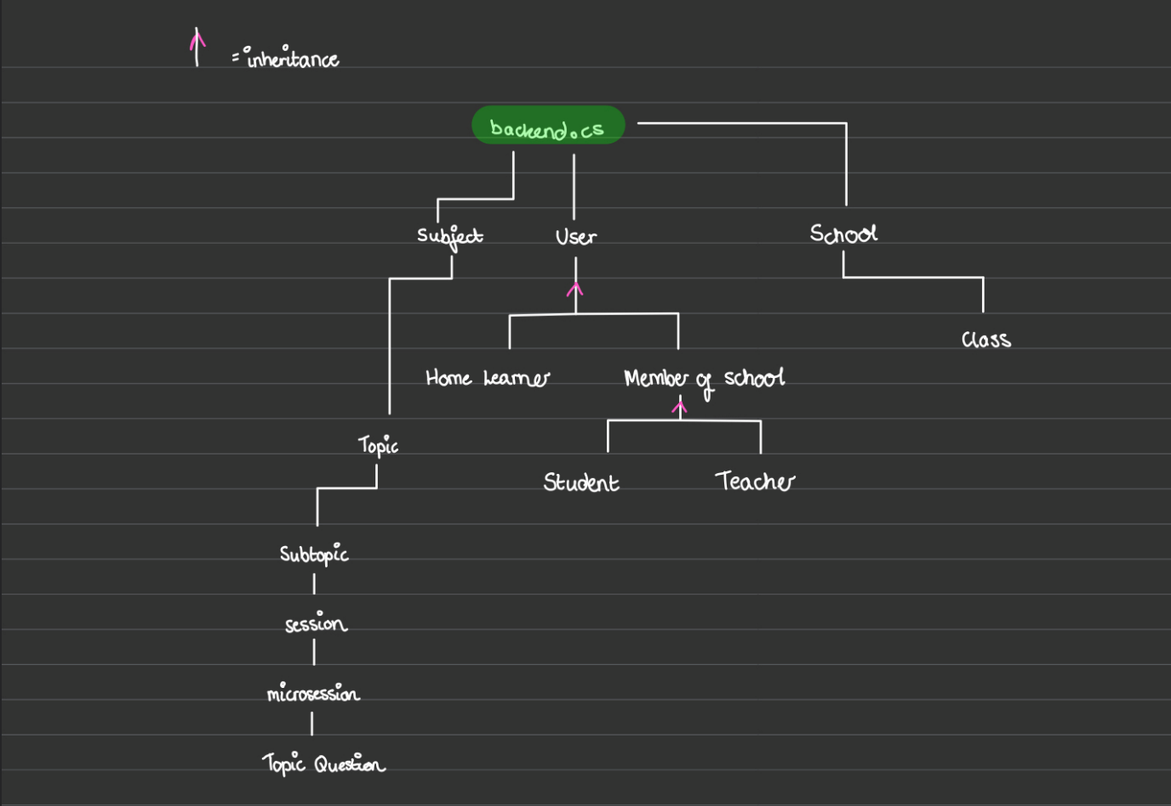

I have added the “Users” class, with the following essential attributes, considering the previously mentioned features of a user. With users being required to sign up enter the subjects they’re studying and enter their account type, attributes have been created to accommodate this:  
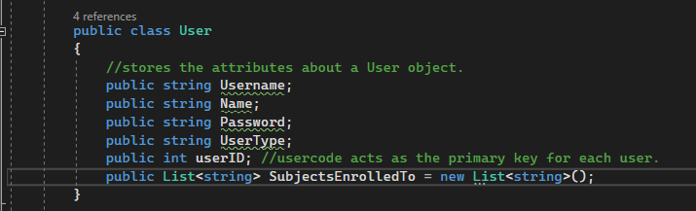

I also considered the fact that users will have events personal to them as part of the time organiser form. I created a class called “Event” holding the necessary information about an event. 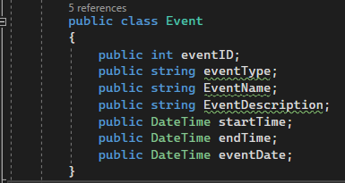

Then, every user will have a list of events, so I updated the user class:

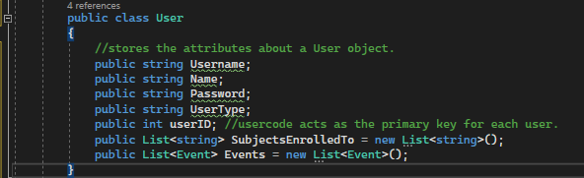

To keep track of each user that is created, I made a list of type user:



Then, for homelearners, they are all users. So, I made classes for each, deriving from the Users class, setting their essential attributes via values which will be passed into the function via the frontend:

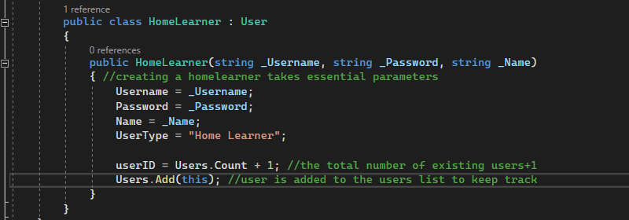

For students and teachers however, they’re both members of a school.   
In creating the schools, I have created a schools list to keep track of the schools:

  
I am now creating a school class, holding the unique institution code, its ID and the classes within it. I realised that students and teachers mustn’t be stored directly within the School class as it would make it hard to know what Class they’re a part of. So, I made a list named classesInSchool which will contain students and a teacher within each class element of the list.

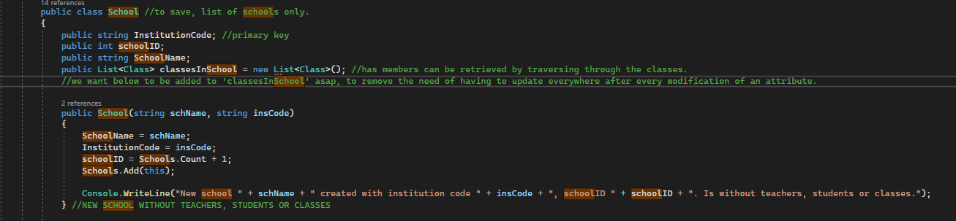

To store teachers and students within a school, they will be stored within the “Class” class. This class must have a searchable name, a unique ID and a track of its teacher and TA.

Both teachers and students are part of a school; I created a “memberOfSchool” class, holding the school ID attribute of that member.

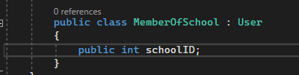

An earlier mentioned success criterion was that ‘new and existing users can login using their username, password and institution code’. The schoolID will be entered from their entered institution code, so this criteria is being met.

Then, I created the Teacher and Student classes, deriving from “MemberOfSchool”, setting essential attributes to be passed from frontend. A list of type integer storing class IDs taught by each teacher has been added.  
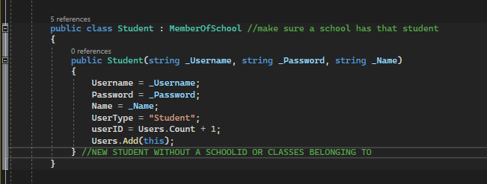

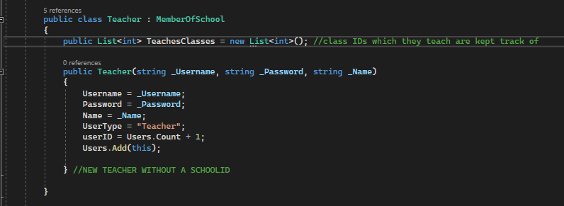

Having a list of classes taught for each teacher represents that of in person. I am therefore considering the criterion: “experience using the program must be high quality and represent that of in person”

Aside from user information, subject/topic information is also required.

I have split the quiz system into a different structure, with quiz sessions instead. Each quiz session will contain topic questions, so I have created the topic class: 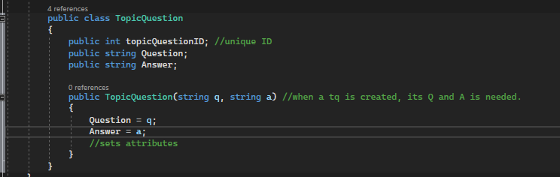

And then the quiz session class, holding multiple topic questions, a video for learning and the session name:

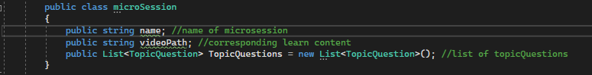  
  
Each subtopic, e.g. “Components of a processor” in computer science, will contain multiple microsessions (practice quizzes with videos). So I have created a class which does just that:  
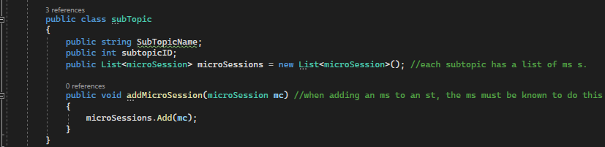

And each topic will have multiple subtopics, so I created a class holding that:  
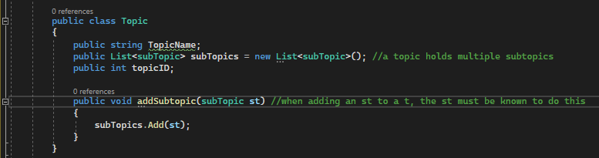

Now that I have made the quiz structure, I can now fill it with subject information. I have stored each subject as a class, so that creating a new subject is easy. I have implemented an if statement to fill in specific subject information based on which subject is being created. Each subject will contain topics, subtopics, microsessions and topic questions. Storing a list of topics alone stores the rest.

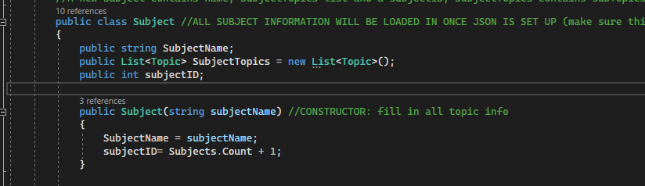

Keeping track of the subjects by creating a subjects list of type Subject  


Now, depending on which subject I add, specific topic questions and information should be included. To add pre-defined subjects, I have created a function within the subject class which fills the specified subject information.  
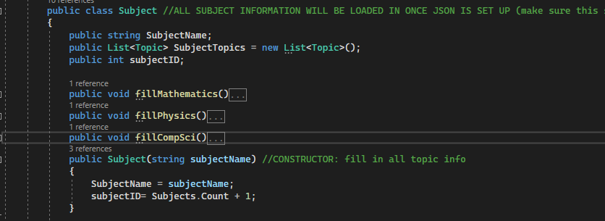

**W**ithin each function, It will fill in the subjectTopics list, by first filling in a number of topic questions, adding them to a session then adding a number of sessions to the subtopic. **A** number of subtopics will be added to each topic, and a number of topics will be added to the SubjectTopics list. **I** found this complex to implement at first, but I planned it with a similar approach to the layout of the user information. **I** started from the most simple object, a session. I defined each session, then added these multiple sessions to a subtopic. I defined each subtopic, then added these multiple subtopics to a topic. I defined these topics, and added multiple topics to a subject: 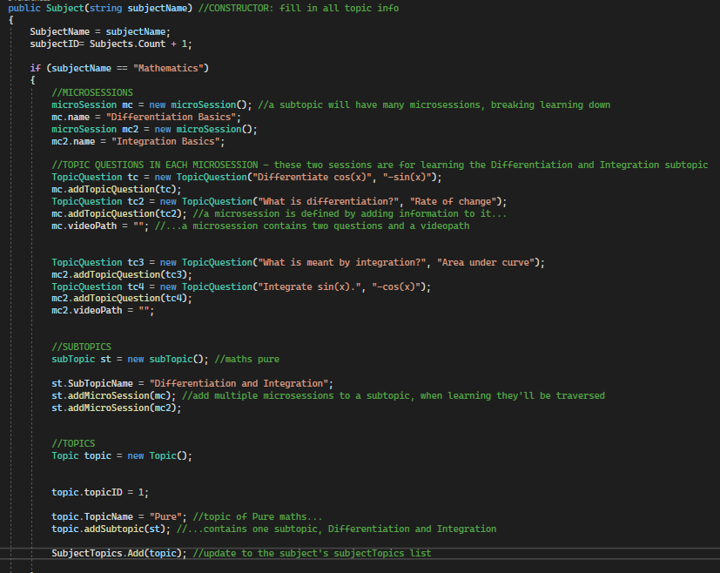

Later on, the UI will need to output each chosen microsession while the student has chosen to learn a subtopic. I created a function beginSession() which simulates a specified learning session, traversing through each microsession within a chosen subtopic, in which it traverses through the videos and questions:

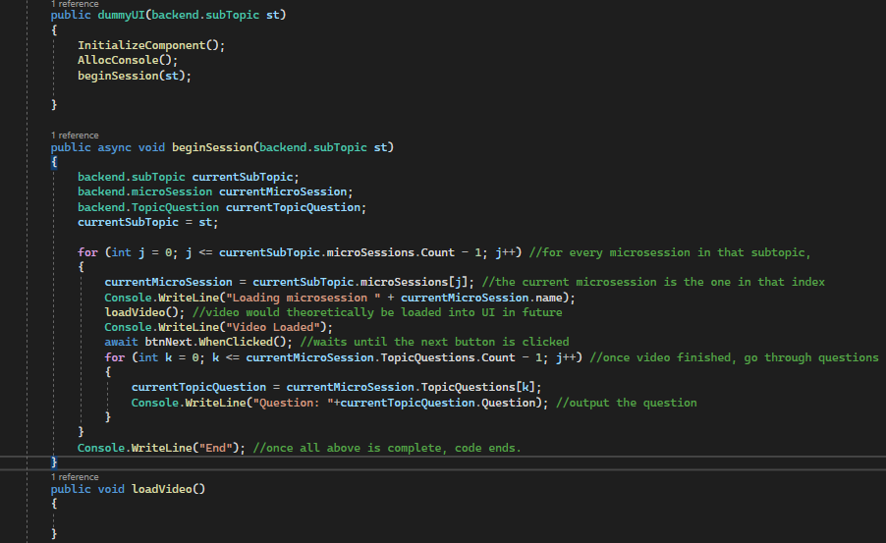

**Reviewing**

Usability Features (backend)

I am listing elements of the UI from my testing interface.

|  |  |  |
| --- | --- | --- |
| Element | Form used in | Feature |
| Buttons | Testing UI | I can output testing/debugging information about the backend by clicking it. |

Usability testing - Client Feedback (backend)

I received feedback from my mother that a student or teacher may not be part of a class yet. I took this into consideration: I have created two additional variables inside the school class called unassignedStudents and unassignedTeachers. These will store users who haven’t said what class they’re part of during sign up when they affiliated themselves with a school.

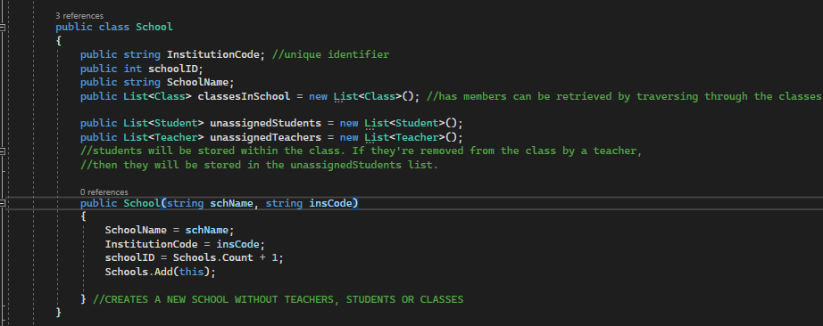

Other than this, she was satisfied that the application stores the data it is required to.

**Testing**  
Testing the prototype (backend)

The backend will be tested by running each form and seeing if basic functionality works. The backend outputs a log of each major action which happens, printing information which was handled to the console for easier debugging.

To test in action, I created a testing interface mimicking the controls which will invoke such actions in the backend. This is only a mock UI and won’t be used in the real prototype, so therefore its usability features don’t need to be considered.

It will consist of three buttons used to output the schools, users and an example student, named amanda, a pre-existing user.  
Here is an example showing the use of naming conventions in my code when creating these controls:  
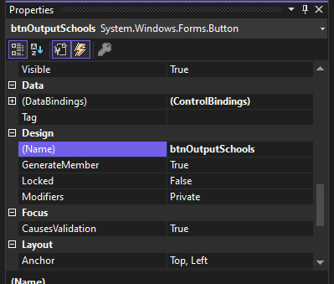

For user data, in backend.cs I have instantiated the following students, teachers and homelearners:  
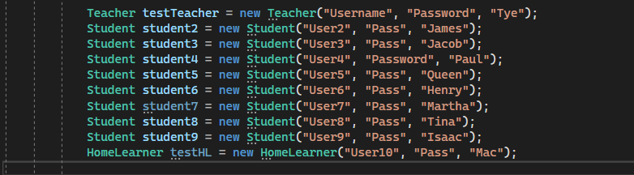

And I’ve added an ‘output users’ button to the testing UI. This outputs all the usernames in each element of the “Users” list. I also added an ‘output schools’ button which does the same thing, but prints all users in the school including their status: assigned to a class or unassigned. To represent adding a student or teacher (a member of a school), I’ll add a ‘add user’ button to the testingUi, and for a home learner, I’ll also add a separate button.

To test the school functionality, I have added test data mimicking students in a class in a school:  
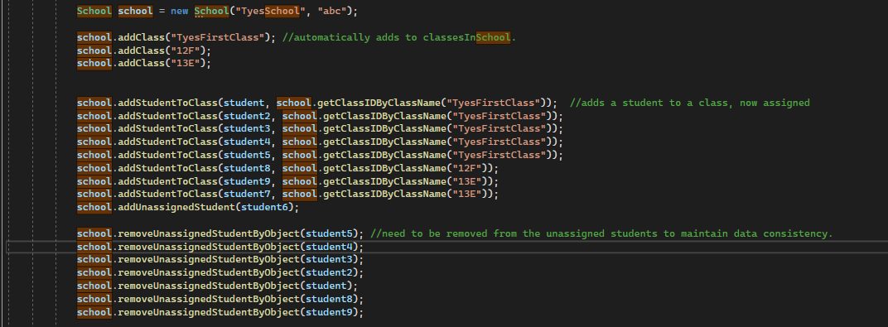

Note that all errors in the following testing procedure are recorded will be explained, reviewed and fixed after this section.

|  |  |  |
| --- | --- | --- |
| **TEST DATA** | **EXPECTED OUTCOME** | **RESULT** |
| Show a list of users | Pre-defined users (which should be stored in ‘Users’ class) are outputted | Successful |
| Adding a user | The user (and their attributes) is added to the users list and update to users is shown in CLI | Unsuccessful, the same users were outputted after ‘add amanda’ was clicked. Amanda was supposed to consist in the list. |
| Show a list of school(s) | Pre-defined school(s) (teachers, classes and students) are outputted correctly | Successful – school object of name ‘TyesSchool’ was outputted via JSON Serialisation |

|  |  |  |
| --- | --- | --- |
| **TEST DATA** | **EXPECTED OUTCOME** | **RESULT** |
| Adding a school | The school (and its classes, students and teachers) is added to the Schools list and update to schools is shown in cli | Successful |
| Adding a homelearner | The homelearner (and their attributes) are added to the users class and update to users is shown in CLI | Successful |
| Studying a Sub Topic | List of topics for each subject is outputted correctly when ‘Output all maths topics’ | Successful |
| Studying a topic | List of subtopics for each subject is outputted correctly | Unsuccessful – There are no repeated subtopics |
| Studying a topic | Microsessions are traversed in the right order | Unsuccessful – There should be no repeated topic questions |
| Studying a topic | Microsessions show a video and then 2 practice questions – these actions should be shown in CLI | Successful – Correct order of microsessions |

A note about the backend’s validation and Usability testing

User input is not used at this stage. The backend has no elements where text can be entered via the testing UI. Instead, information inputted through the real frontend into different functions of the backend as a parameter will be tested in the corresponding form’s design section shown later on.

Reviewing errors and making amendments (backend)  
In response to the data obtained from testing, From the data obtained from testing (Adding a new user ouputs the same users as before), I discovered that I hadn’t added the new instance of user to the users list in the user constructor, so I did that by typing Users.Add(this) in the user class’s constructor. Also, for the issues with studying a topic, I discovered that it was the wrong letter being used in the inner loops which caused the wrong data to be outputted in both cases. (k++ was j++). The correct version is shown below:

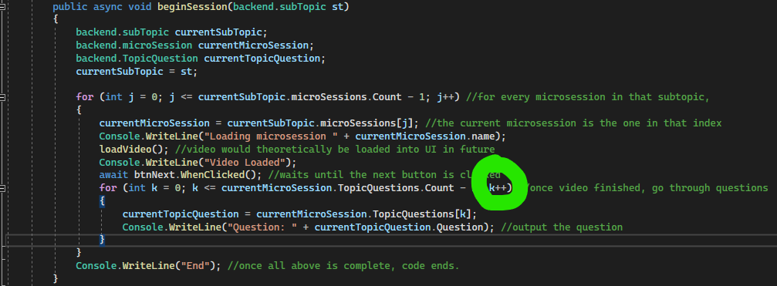

Prototype results compared to success criteria

|  |  |
| --- | --- |
| WHAT MUST BE INCLUDED | How it was met / partially met |
| Every type of account must be able to be created | Every type of class has been made |
| New and existing users can login using their Username, Password. Students can affiliate with schools using an institution code upon signup. | A users’ username and password is stored, and a school consists of an institution code. |
| Data must be stored consistently across multiple entities | When adding a student or a teacher to a class, they are removed from the unassigned [user] list. Maintains data integrity. |
| Experience using the program should be high quality and represent that of in person. | References and Inheritance between classes represents that of in person. E.g. A class contains a list of many students like in real life. |

**Developing Prototype 2***Prototype aim:* “*A user can login, logout and sign up”*

**The process**  
I have chosen to implement the login function within the backend.cs file, so that multiple forms will be able to access it in the future. (e.g. the sign up form and the login form can both call login.) I have considered what this function will need to contain: if the login is successful or unsuccessful. It would be successful if the user’s entered username and password matched that of in the users list.

To speed up the process, I am focusing on using IDs for quicker data retrieval. I have added an assistance function within backend.cs named getUserIDWithEnteredUsername which is self explanatory.

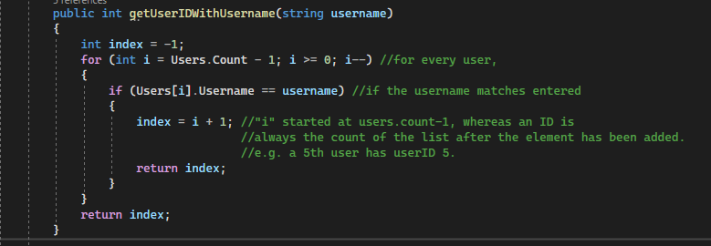

The frontend will use this getUserID function just mentioned, passing it to this login function created to check entered credentials.  
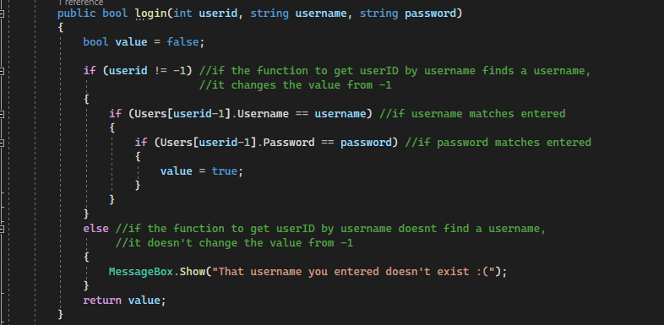  
  
For logging out of the application, I have assigned an attribute named ‘loggedin’ so that the backend knows which user is currently logged in, and can set this for false for logging out: 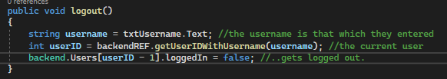

Then adjusting the login function accordingly (setting logged in to true for successful logins):

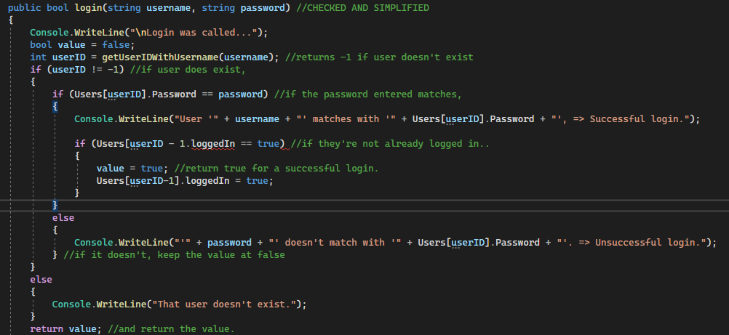

For signing up, I needed a way for the backend to add a new member of a school to an existing school. Or, if one doesn’t already exist then if they have the right permissions then they can create one. So, within backend.cs I created additional assistance functions in backend.cs: 1) getSchoolID(), returning a school ID for an entered institution code during sign up, 2) checkASchoolExists() to see if a specified institution code refers to an actual school, 3) checkAnySchoolExists() to prompt the creation of a new school if one doesn’t already exist,, addToSchool():

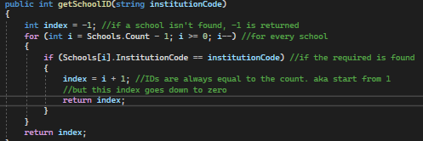

The getSchoolID function takes in an institution code and returns a schoolID to its sender. Its other features are commented.

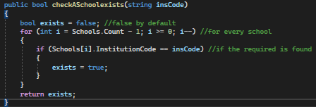

The checkASchoolExists() function will be useful for making sure the user has entered the right institution code.

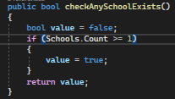

The checkAnySchoolExists() function will be useful for e.g. presenting a “Create new school?” dialogue for teachers during signup. Students won’t be able to sign up if no schools exist. (Home learners can though as they aren’t part of a school).

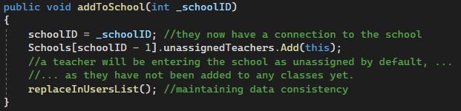

The addToSchool() function is within every Teacher or Student’s constructor. In this example, it sets the teacher to be affiliated with a school, while telling that school to enter the teacher as an unassigned teacher. The reason is commented.

For clarification of code, here is the testing UI for signing up:  
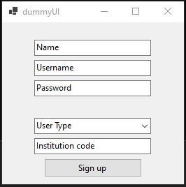

I considered different actions to take place depending on the user which was entered. Therefore, I contained logic within a three-part if statement for each user type. I also incorporated previously-mentioned assistance functions within the sign up code to enhance readability and for easier debugging should an error arise. The sign up logic is as shown:

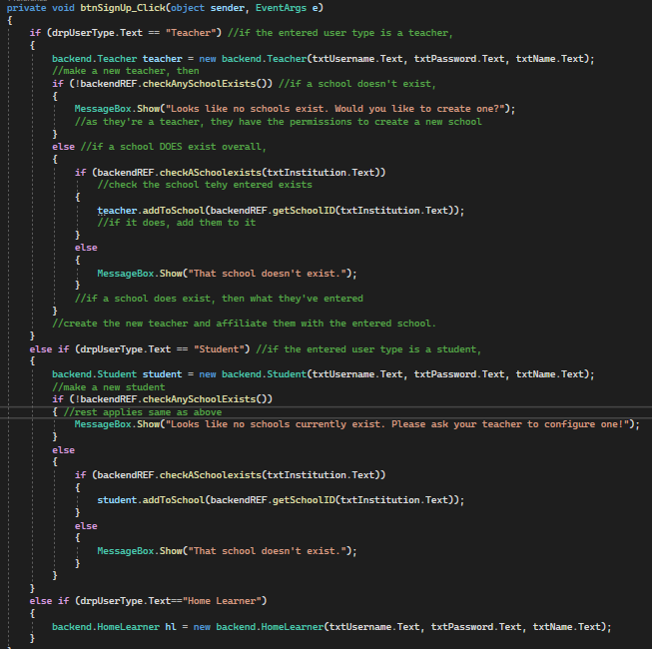

**Reviewing**

Usability Features (login form)

|  |  |  |
| --- | --- | --- |
| Element | Form used in | Feature |
| Text Boxes (txtUsername, txtPassword | Sign up | Enables user input to enter the required information |
| Button | Sign up | Login button allows the user to login with a click |

Usability Testing - Client Feedback (login form)

Sarker liked the idea of having a personal account with each users’ individual data, and was happy with the general usage of the controls in the testing UI. He did however suggest that a user may have forgotten their password. Acting on this, I have created a function called changePassword() which changes the password of that user, if 1) the entered user is found and 2) if the password entered matches that which is stored: 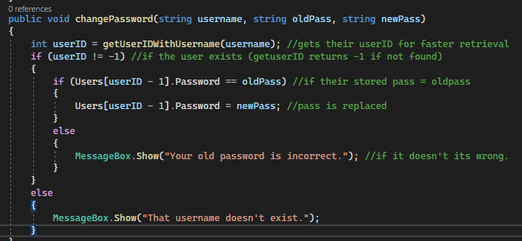

Additional feedback he gave was that instead of filling in the institutional code in the text box provided only if applicable, it should be hidden if the selected user type wasn’t a member of a school to reduce visual complexity. I will have this in mind when implementing the actual design.

**Testing**  
Testing the prototype (Login form)  
To test in action, I used the testing interface mimicking the controls which will invoke such actions in the backend.

Note that all errors recorded will be explained, reviewed and fixed after this section.

|  |  |  |
| --- | --- | --- |
| **TEST DATA** | **EXPECTED OUTCOME** | **RESULT** |
| Logging into a correct user | Console window outputs true | Unsuccessful – error |
| Logging out and logging back in | Console window outputs correct details about currently logged in user | Unsuccessful – loaded the data about the previous user as shown below |
| Signing up | Successfully creates and stores a user instance able to be logged back in again | Successful |
| Teacher (or student) enters an incorrect school | “That school doesn’t exist” messagebox | Successful |
| Logging in with an incorrect user | Returns an error | Successful |
| Changing a password | Successfully changed | Successful |
| Teacher signs up with no schools stored | Prompt asking creation of new school | Successful |
| Student signs up with no schools stored | Prompt saying they should refer to a teacher | Successful |
| Teacher (or student) enters wrong institution code during signup | Prompt stating the school doesn’t exist | sUCCESSFUL |
| Student or teacher presses sign up with the correct information | They are added to the corresponding school in the unassigned students list. Their school ID is set to the ID of the school they signed up to. | Successful |

Setting up the validation

|  |  |
| --- | --- |
| Element | Validation |
| txtUsername | No spaces to simplify data. |
| txtPassword | No spaces |
| txtInstitution | No spaces |
| txtName | -String characters only as names don’t contain numbers.  -  Must contain a space as in the future, the proper UI will show their first name only to greet them. It will know this with the separation character “ “. Will prevent the error of ‘no space found’ in the future. |
| User Type dropdown | Test can only be a specific value,  Setting the dropdownstyle to dropdownlist makes sure text cannot be entered into the field. The user can only select out of the available items. |

Testing the validation

|  |  |  |  |
| --- | --- | --- | --- |
| Element | Input | Type | Output |
| txtUsername | “User name” | Erronous |  |
| txtPassword | “Pass word” | Erronous |  |
| txtName | 23432 | Erronous |  |
| drpUserType | Click | Normal |  |

Reviewing errors and making amendments (login form)  
Having the backend search through every username to search that of entered in the frontend and then comparing every password to that entered would take longer than necessary for larger amounts of data. So I created the function getUserIDWithUsername. Once it has the ID, this is passed to the login function which can work more quicly and smoothly. Here is the login function utilising that function:

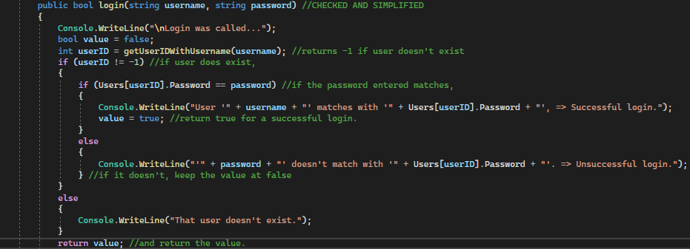

In response to the data obtained from testing (same user data displayed when logging out and logging back in as a different user), I created public variables holding information about the current user which get filled in when a user logs in or signs up to fix this issue. In the future, the elements of the UI will retrieve information about these public variables, e.g. in the name label showing the current username. I have also decided that I will just close the current logged in form and present the sign in page during the real thing.

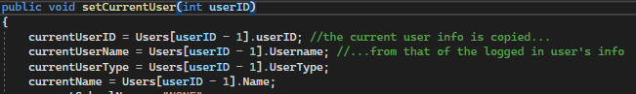

Also, I discovered that logging into the correct user was dysfunctional because within the login function, I had put “userID” instead of userID-1:

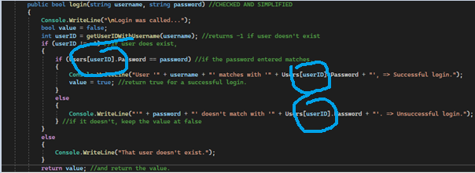

After testing again replacing userID with userID-1 since the array index is zero based, here were the results: Successful – logging into “Tye”’s account with credentials Username:Password returns true as shown below.

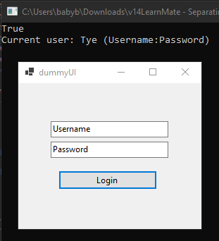

Prototype results compared to success criteria

|  |  |
| --- | --- |
| WHAT MUST BE INCLUDED | How it has been met/partially met |
| New and existing users can login using their Username, Password. Students can affiliate with schools using an institution code upon signup. | Users can login with an efficient traversal of the data store. They can easily login and log out while the backend keeps track of the currently logged in user. |
| Data must be stored consistently across multiple entities | When a user is added to a school, (using the addToSchool() function), the school instance holds that user in its members.  With many changing data across many entities, the need had risen for a user owning a function to replace their instance in the users list. |

**Developing Prototype 3***Prototype aim* – *“All users will choose subjects during signup. Students and Homelearners can learn or practice chosen topics within these subjects, and teachers can teach chosen subjects with the ability to allocate subject-specific groups with this.”*

**The process**I have mimicked a signup within backend.cs by creating an instance of a student and adding a pre-defined subject to their “subjectsEnrolledTo” list.

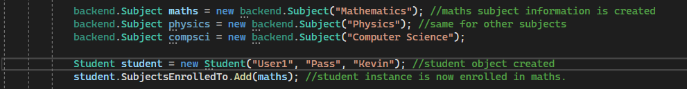

By itself, teachers can discover students with a chosen subject in their “subjectsEnrolledTo” list by a simple traversal through the school’s users, so that aim is met. I am carrying this out by creating a function createClassBySubject() in the backend which takes in the subject as a parameter and will traverse through all unassigned students, organising them into groups of a maximum of some specified amount.

For a teacher being able to teach certain subjects, a similar method applies:

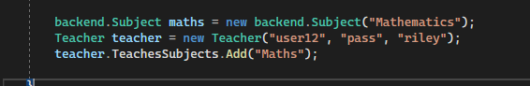

At this stage, the aim is only partially met. Enforcing the user to enroll into a subject will come after the creation of the real user interface. So “*all users will choose subjects during signup*” will be met later.

Students being able to learn and practice topics will implement by seeing what elements exist in “SubjectsEnrolledTo”, then presenting the selected subject as previously developed in the backend section. The array TeachesSubjects or SubjectsEnrolledTo is only present to know which subject to select. The subjects have already been previously defined:



Students and home learners can learn and practice the chosen subject using the previously developed beginSession function:

The beginSession function will take in a subtopic (depending on the subject they enrolled onto) so “*Students and Homelearners can learn or practice chosen topics within these subjects”* has been met.

For the aim of “*teachers can teach chosen subjects with the ability to allocate subject-specific groups with this”,* I have created a function createClassesBySubject() which is self explanatory. Teachers will be able to auto create classes, with the ability to specify a max number of students.  
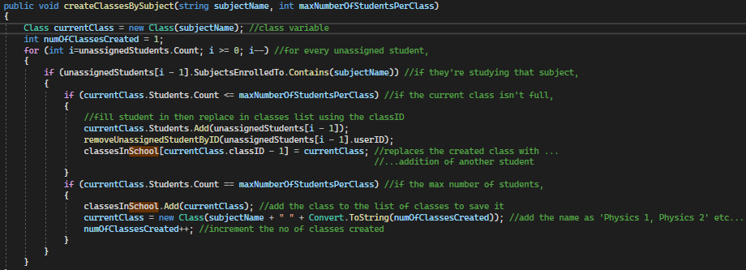

**Reviewing**

Usability Features

|  |  |  |
| --- | --- | --- |
| Element | Form used in | Feature |
| Dropdown menu | Testing UI | Presents the user with a list of pre-specified items. User can select what they require from it |
| Buttons | Testing UI | I can output testing/debugging information about the backend by clicking it. |

Usability Testing - Client Feedback (choosing subjects)  
Client was satisfied that users could perform such an action with few clicks.

Setting up the validation

|  |  |
| --- | --- |
| Element | Validation |
| dropDown | Can only be a specific value,  Setting the dropdownstyle to dropdownlist makes sure text cannot be entered into the field. The user can only select out of the available items. |

Testing the validation

|  |  |  |  |  |
| --- | --- | --- | --- | --- |
| Element | Input | Type | Output | Comments |
| drpSubTopics | Mouse click | Normal | Items were presented | A dropdown menu can’t be tested with erronous data. |

**Testing**  
Testing the prototype (Choosing subjects)

The ability to learn and practice topics was already practiced in the Subject section. Therefore it will not be included in the following test.

|  |  |  |
| --- | --- | --- |
| **TEST DATA** | **EXPECTED OUTCOME** | **RESULT** |
| Learner signs up and ENROLls onto a subject | The chosen subject is added to their array – and kept track of | Success |
| Teacher signs up and enrolls onto a subject | The chosen subject is added to their TeachesSubjects array | Success |
| Topics studied by students based on their selected subject | Topics studying OR TEACHING are listed and can be selected from a dropdown menu | Unsuccessful – the dropdown menu showed only physics content |
| Auto allocation of classes | Class is auto allocated | Unsuccessful – classesInSchool[currentClass.classID-1] was out of bounds for the starting condition |
| Auto allocation of classes | All unassigned students are moved to their respective classes | Unsuccessful – Some students remain untransferred as wrong class is referenced |

Reviewing errors and making amendments (Choosing subjects)

In response to the data obtained from testing, I had typed “Maths” instead of mathematics. In the subject class constructor, a topic is only added depending on the requested name of the subject, and the maths info is defined as mathematics. The fixed edition is shown below:

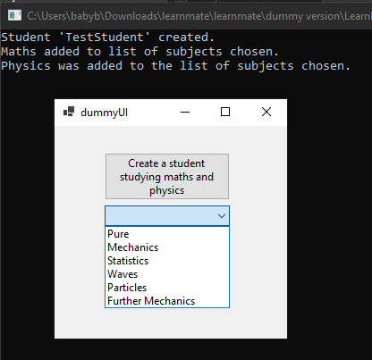

Next, to fix the out of bounds issue for the out of bounds error, I realised I hadn’t added currentClass to the list of ClassesInSchool before it was referencing it. And, for the wrong class referenced, I realised that classes could be added to the ClassesInSchool array. So a classID of 1, for example, may not be in place 0 in the array. To fix this, I found the position of the classID in the class array instead using the “indexOf()” function. The changes were implemented as shown below:

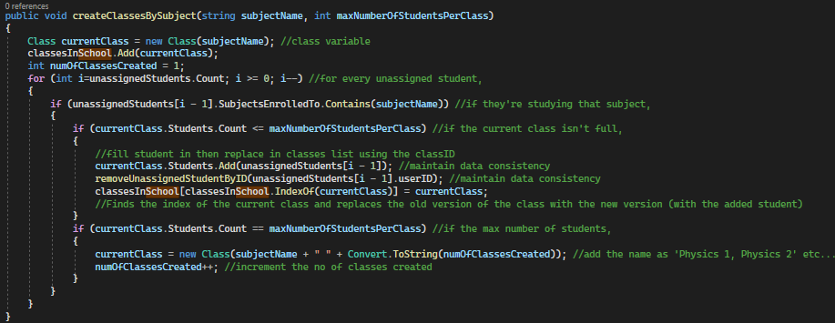

Prototype results compared to success criteria

|  |  |
| --- | --- |
| WHAT MUST BE INCLUDED | How it was met/Partially met |
| Data must be stored consistently across multiple entities | User was removed from unassigned students while being added to the class in school |
| Experience using the program should be high quality and represent that of in person. | Assigning a student to a class is like telling a student they’re part of a class when they first join the college. The act of transferral is replicated in person. |

**Developing Prototype 4***Prototype aim: “A student and teacher can affiliate with a school”*

**The process**Both students and teachers are members of a school, and while making the backend I added a memberofschool class which both of their classes inherit from. This stores a schoolID as previously shown. Therefore, during signup, they can affiliate with a school by typing in its institution code. Then, I created the function getIDbyInstitutionCode within backend.cs to pass to the addToSchool function, setting the returned ID as the school ID for that member of the school.

This process has already been shown in prototype 2, with the addToSchool() functions shown in the method below. 

I also intend to block members of a school from entering to the homepage if they haven’t added themselves to a school. I will do this when creating the forms in prototype 5.

**Reviewing**

Usability Testing - Client Feedback (Affiliation with school)  
Clients were satisfied that users are able to be affiliated with a school.

**Testing**  
Testing the prototype (Affiliation with school)

Blah

|  |  |  |
| --- | --- | --- |
| **TEST DATA** | **EXPECTED OUTCOME** | **RESULT** |
| Output school a student belongs to | Belongs to TyesSchool | Successful |
| Output school a teacher belongs to | Belongs to Tye’sSchool | Successful |
| Teacher signs up with no schools stored | Prompt asking creation of new school | Successful |
| Student signs up with no schools stored | Prompt saying they should refer to a teacher | Successful |
| Teacher (or student) enters wrong institution code during signup | Prompt stating the school doesn’t exist | sUCCESSFUL |
| Student or teacher presses sign up with the correct information | They are added to the corresponding school in the unassigned students list. Their school ID is set to the ID of the school they signed up to. | Successful |

Setting up the validation (Affiliation with school)

In the actual UI, an institution text field will be present for affiliation with a school.

|  |  |
| --- | --- |
| Element | Validation |
| txtInstitution | No spaces – an institution code will only consist of a single word of characters. |

Testing the validation

|  |  |  |  |
| --- | --- | --- | --- |
| Element | Input | Type | Output |
| txtInstitution | Ins code | Erronous |  |

Reviewing errors and making amendments (Affiliation with school)

All the tests returned successful. Although, Sarker gave me feedback of being able to affiliate with a school freely; A member of school can sign up and affiliate there, while they can also affiliate later on when they desire to instead of always being forced to affiliate during signup.

Prototype results compared to success criteria

|  |  |
| --- | --- |
| WHAT MUST BE INCLUDED | How it was met/Partially met |
| Data must be stored consistently across multiple entities | Affiliation with schools represents the in person connection between a student being part of a college. |

**Developing Prototype 5***Prototype aim: “Each essential form is created with a minimalistic UI, with actions linking to backend”*

Note that all validation of controls from previous testing (prototypes 1-4) are used here. The elements created are the same elements used from the testing UI and have the same functions. I will not be showing usability, usability testing, validation and validation testing for elements which have already been explained in the mentioned above prototypes. (e.g. validation and usability of txtUsername in the login form below won’t be explained as the usability and validation of txtUsername had already been mentioned in prototype 2 within the test UI). Only new elements will have usability and validation testing explained about them.

There will only be a review of the refined design under ‘**Reviewing’** after the creation of each form.

**The process – creating the designs**For each form, I have decided to further recreate its design, using each picture as a background image for that form.I did this by creating the background image for each form and Subform in Adobe Photoshop at home and Photopea:

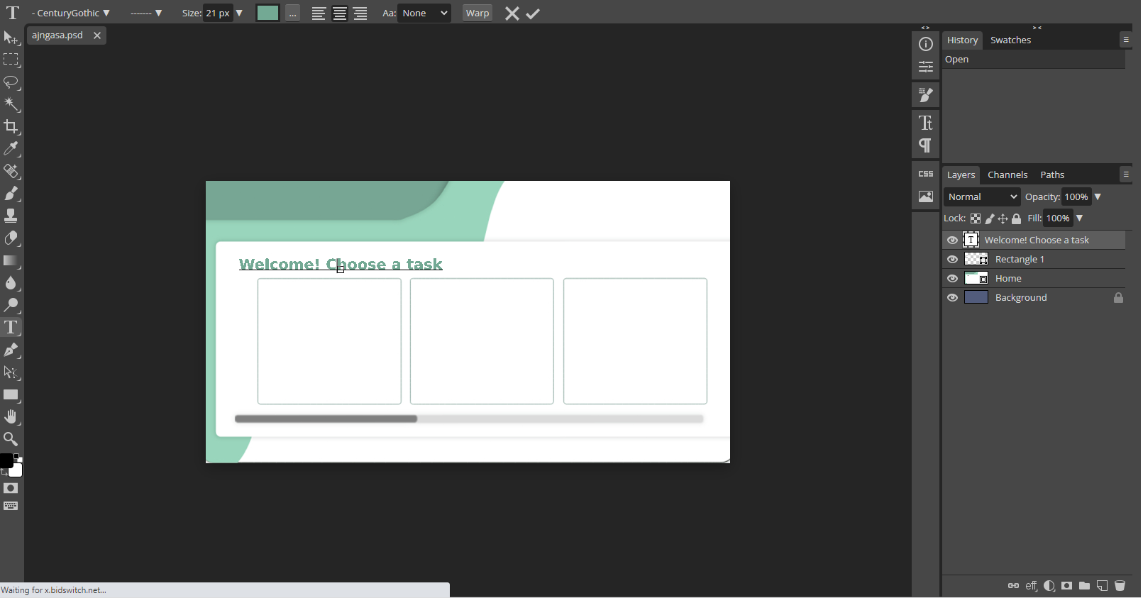

Considering the forms, I have decided to split my application into two main sections: Login and Container, with the login screen leading to the container form. I created these forms and every subForm in the solution explorer:  
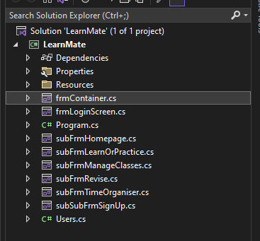

Starting witth the login form, I set the background image for frmLogin in it’s properties. In the login form, the background image has the buttons printed onto it, so I only had to create the labels to cover the begin and sign up button. In place of the username and password area, I added text boxes for input here. These controls act as a usability feature, as it is easy to detect the main actions by the bold background image control indications.

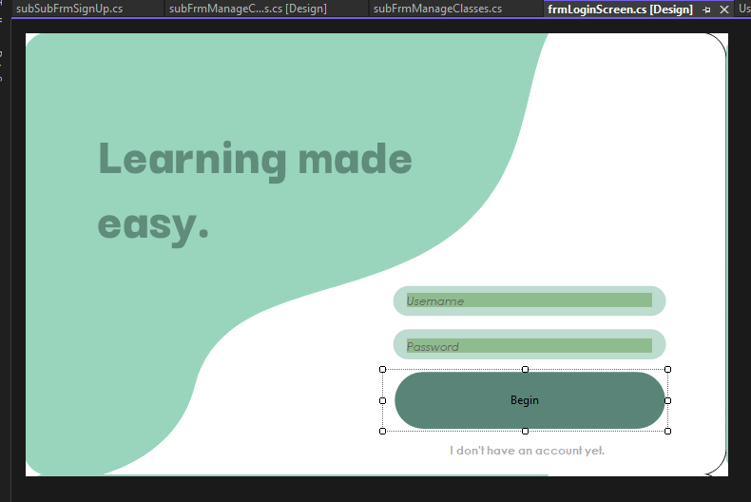

For each time a user loads up, the login screen will present a random inspirational quote:

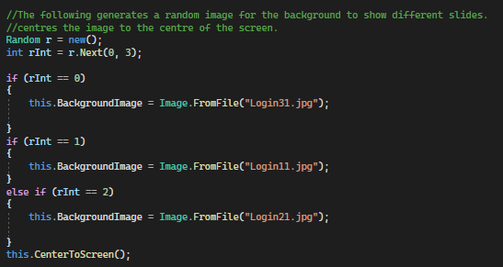

The login form is now complete.

Here is an example showing the use of naming conventions in my code when creating these controls:  
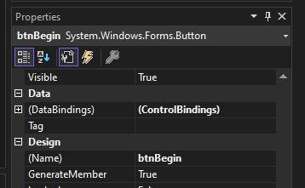

**Reviewing**

Usability and Testing

Usability Testing - Client Feedback (login form)  
My mother (former teacher) mentioned to make the begin button text bolder, and increase the contrast between the text boxes’ content and the background for those hard of seeing. I have made the text bold as follows: 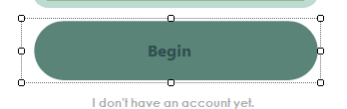

And for the colour scheme, I have sought an accessible colour pallet from the web, and compared results of combinations of different colours to see which is optimal for those with eyesight problems.

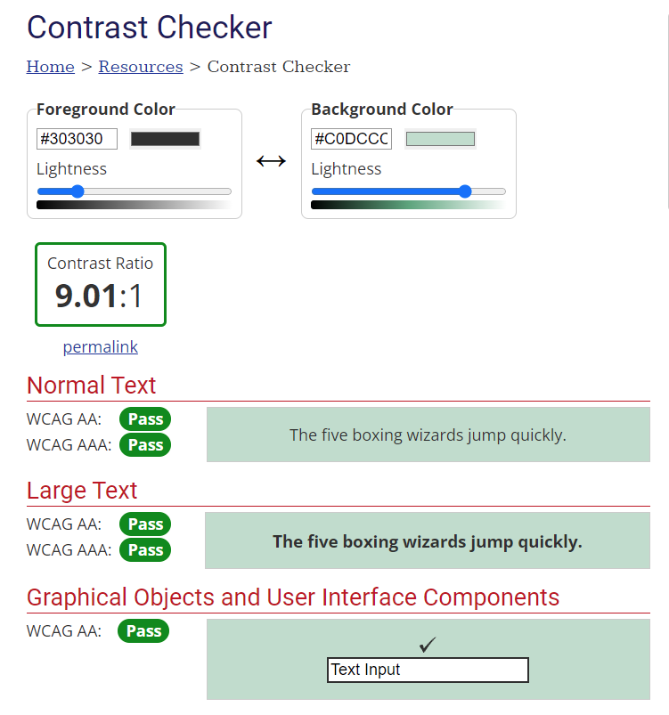

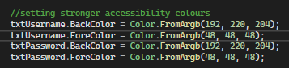

(I implemented the colours which passed the Contrast checker test into my application to support those with eye impairments).

I then created the Container form, with two main panels: The titlePanel holding the name of the current form and the Logo (both as labels), and the mainPanel, holding the active subform. The mainPanel contains a label showing no form for easier debugging if a subForm was unable to load into it.

Here is the refined design:

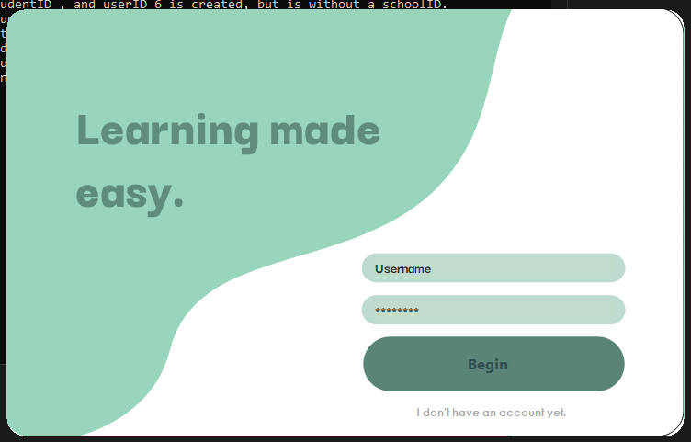

**Testing**

Usability Features - Client Feedback (login form)  
Usability features and usability testing for the controls in this form have already been complete. See prototype 2.

Validation Features and Validation Testing (login form)  
Validation and validation testing for the controls in this form have already been complete. See prototype 2.

**End of reviewing the login screen**

With the design finalised, I will connect it to the backend. Using the login function previously created, I have attatched ‘txtUsername’ and ‘txtPassword’ to represent the controls in the UI. This boolean value returned from the login function in backend will pass back to the frontend, which called it:

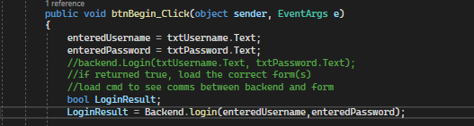

Then I implemented the login button logic, setting the current user information (as previously tested) ready for the container to use, to fill in its controls. If the user logging in is part of a school, their school information is stored in the current user information in backend.

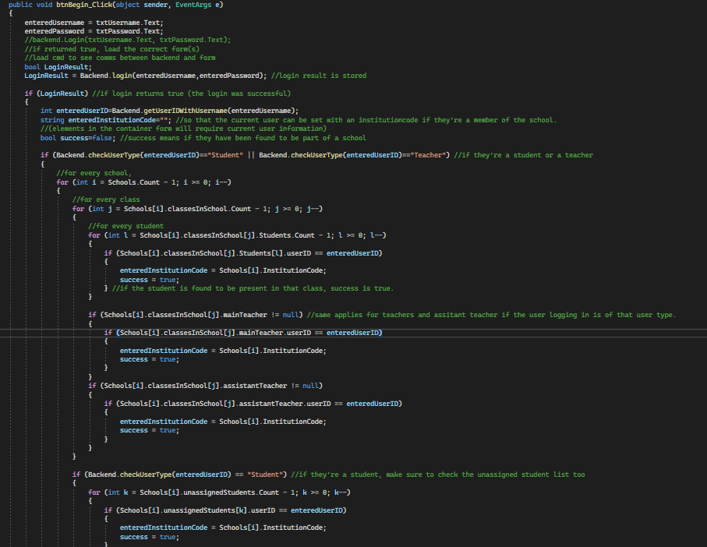

This is only a portion of this method, see the form code at the end for the full version.  
At the end of the above code, a new instance of frmContainer is created, with frmContainer’s elements (such as username label, current school label) being refreshed according to the current user’s information:

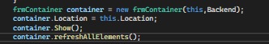

With the login button logic implemented, I added the logic to the sign up button. A new instance will be created, just like the container form shown above. The new instance brings up the sign up form. Signing up has been split into stages to reduce the visual complexity of the process.

First stage – where they input their user type, username and password:

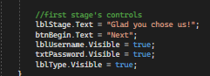

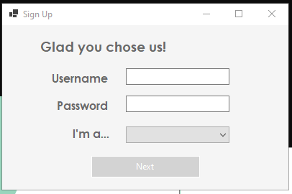

Use of naming conventions:

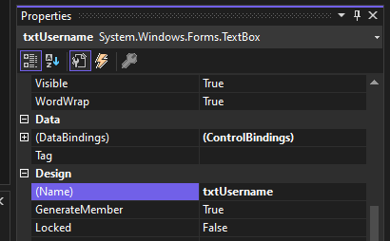

Second stage – if they’re a member of a school (selected user type of teacher or student), they enter their institution code:  
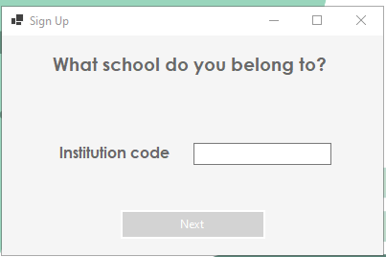  
I applied the previous feedback of having the option to affiliate with the school later, so an institution code isn’t required to be entered.

For the third stage (for members of a school) or second stage (for home learners), the user inputs their name in the sign in field:

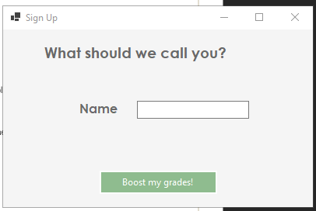

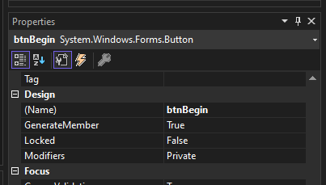

I have added the button as green to promote positivity and excitement for using learnmate for the first time.

Clicking the green start button

The logic behind the sign up function is shown in the final code. Here is a preview, with each part being explained in comments: 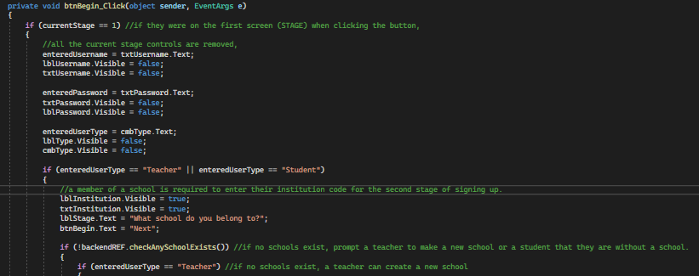

(continues)

Simply put, information the user entered is saved in variables, and is then passed to functions creating a new user of the type entered, with the attributes set depending on the information the user entered. Teachers can create new schools but students can’t. Students and teachers can go through the sign up process without having to be affiliated with a school, which is a response to the feedback I received previously.

**Reviewing – signup form**

Usability and Testing

Usability Features and Usability Testing - Client Feedback (sign up form)  
Usability features and usability testing for the controls in this form have already been complete. See prototype 2.

Validation Features and Validation Testing (sign up form)  
Validation and validation testing for the controls in this form have already been complete. See prototype 2.

Client Feedback on the design and amendments

“The contrast colours between the text box text and its background is too minimal.”

I have changed it to this:

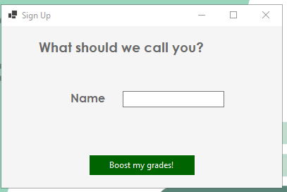

**End of reviewing for the sign up form**

**The process – container form**

Finishing the sign up process (or clicking the login button) creates a new instance of the container screen.  


The container is formed of two panels; the title panel and the main panel. It holds the current subform in the main panel and the title of the current subform in the title panel:

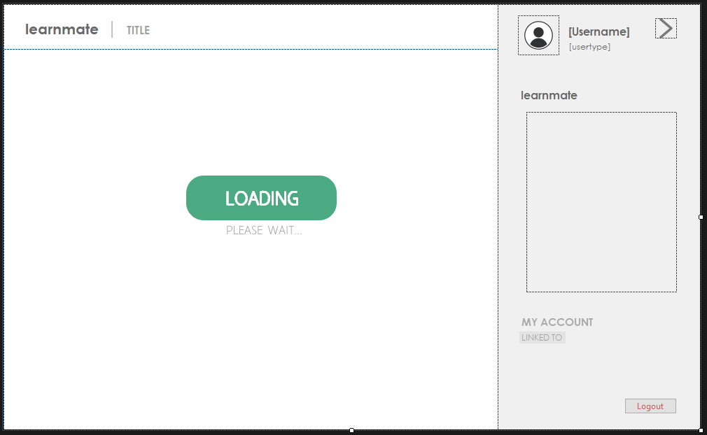

Client Feedback on the previous design

I received the feedback to make the back colour of the title panel white, due to the changing colours of each of the different forms. White fits with all of the colours used. I also had feedback that users should navigate different forms somehow.

I have made the back colour of the title panel white, while adding a hamburger menu linked to a collapsable panel holding key information:  
  
 I used icons from flaticon.com to represent each of the different forms, which will appear in the form panel (under “learnmate”) showing the navigation of all available forms:

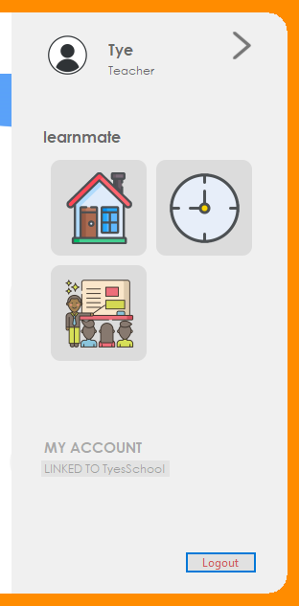

The available forms will depend on the type of user logged in. E.g. if they’re a teacher, they can access the ‘manage classes’ form.

The code to show available forms is as follows: 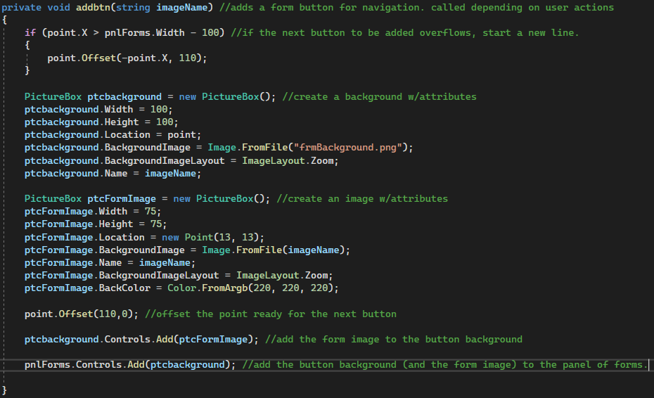

And the code to decide which button to add is as follows. It looks in the backend to see the current type of user logged in, and adds the buttons as required.

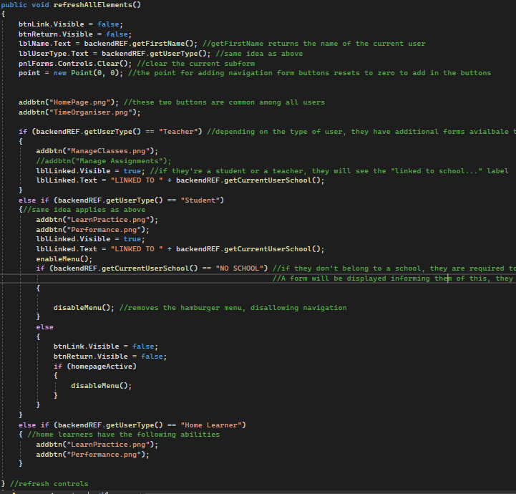

I then created the different sub forms to go inside the container form.

**The process – homepage form**

Firstly, I created the homepage. The design I chose reflects the aspects of other programs that I researched previously. I included a highly abstracted UI with fewer necessary controls and elements to verify most users can fluently use my application. Addiitonally, I implemented the use of green, presenting calmness and promotes motivation while the user browses throughout LearnMate, allowing students to learn with heightened concentration. I got this idea from Uplearn, as mentioend before. Other aspects of the homepage, I created myself, with a simplistic navigation for ease of use.

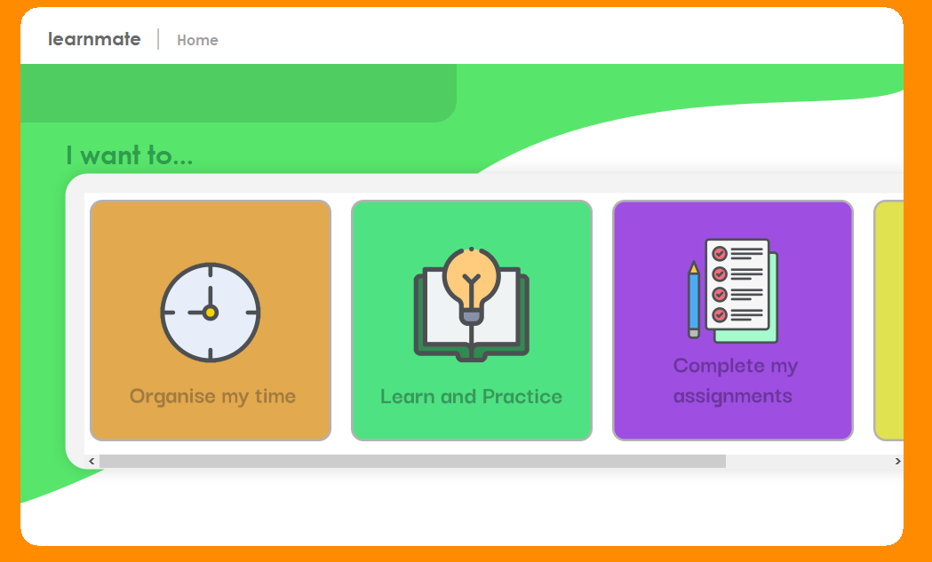

Depending on the current user’s type, different buttons are filled in. The act of creating a button is as follows:

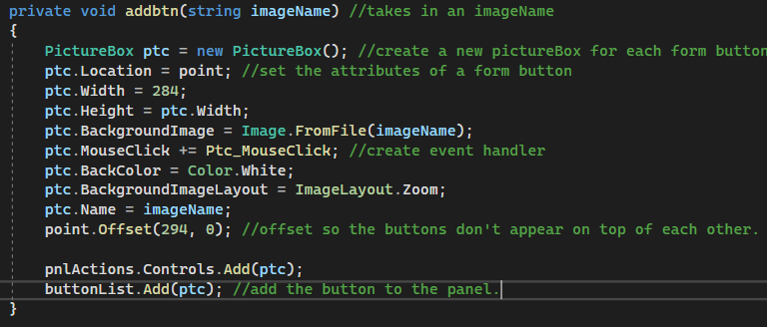

The imageName passed is exactly the name of each image in the directory of LearnMate.

Depending on the user’s type, they have different buttons added to the homepage. Just like the container’s form panel.

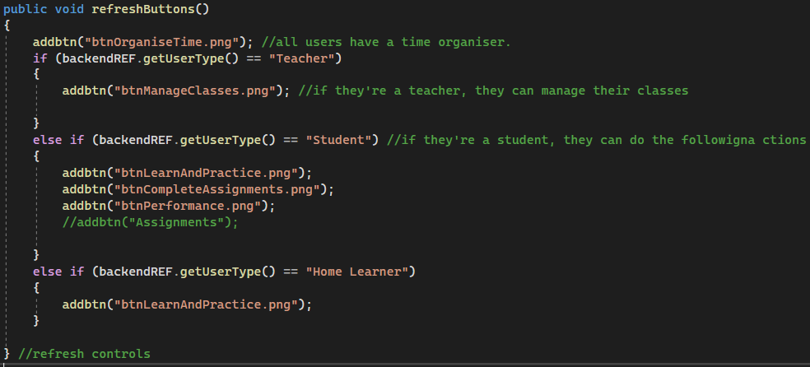

**Reviewing - homepage**

Usability and Testing

**Usability**

Usability Features (homepage)

|  |  |
| --- | --- |
| Element | Feature |
| Buttons (disguised pictureboxes) | Allows the user to click to navigate to a desired part of the app |

Usability Testing (homepage) – Client Feedback

The client was satisfied that buttons were distinct and easy to recognise.

Homepage results compared to success criteria

|  |  |
| --- | --- |
| WHAT MUST BE INCLUDED | How it was met/Partially met |
| Users are able to access different actions depending on their user type. | This was met. |

**End of the review for the homepage**

With many forms being developed, I simplified devleopment by thinking ahead and considering each form to be added in a modular fashion. I did this by allowing the container form to hold functions to load subForms into it, rather than each form manually opening and closing. This consistency of all forms being within the container will make a more pleasant user experience. With the homepage created, I created a function for the container to load the subform into the main panel: 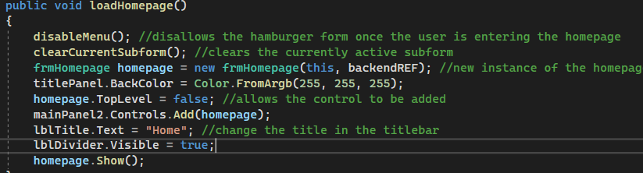

This will apply to all following sub forms.

Now that the homepage is complete, I can test the container to see if it loads in the homepage correctly.

**Reviewing - container**

Usability and Testing

**Usability**

Usability Features (container)

|  |  |
| --- | --- |
| Element | Feature |
| Buttons (btnLogout, btnCollapse) | I can output testing/debugging information about the backend by clicking it. |
| Labels (lblUserName, lblUserType, lblTitle) | Outputs the current user information so they are aware they’re currently logged in. |
| Panel | Displays all the current forms and actions they can navigate to / perform |

**Testing - container**  
Testing the container

|  |  |  |
| --- | --- | --- |
| **TEST DATA** | **EXPECTED OUTCOME** | **RESULT** |
| loadHomepage called | Homepage form loads |  |
| Form action buttons pressed | Corresponding form loads | Failure – they did not show. |

Reviewing errors and making amendments (container)

I had forgotten to add the event handler to the picture box. 

Container results compared to success criteria

|  |  |
| --- | --- |
| WHAT MUST BE INCLUDED | How it was met/Partially met |
| Users are able to access different actions depending on their user type. | This was met. |

**End of reviewing for the container**

**The process – time organiser form**

I then started designing the time organiser, I used an orange accent. The design reflects the aim “*represents a minimal design”* :

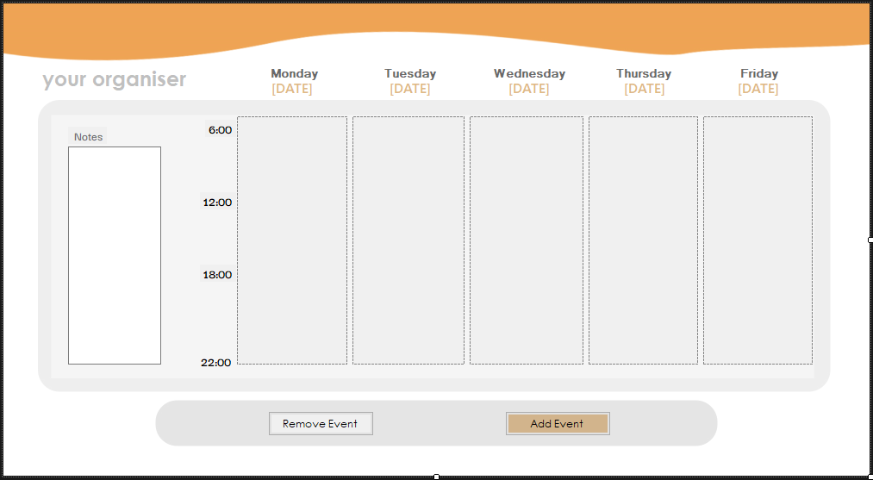

The Monday to Friday 6-10pm time scale was used instead of the 24hr typical one because that tends to be the typical time people dedicate to studying. Users can separate their home and work life further by having their weekends off allowing more peace of mind when their study life becomes overly stressful.

A function searches the day which the last Monday was, and fills the [DATE] labels with the corresponding week day data.   
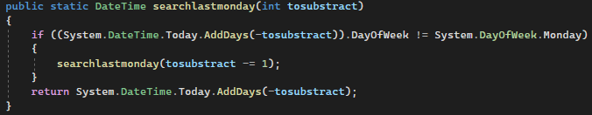

The viewing week can be changed through a simple combination of functions:  
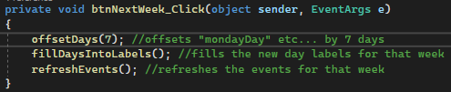

The notes text box retrieves data from the “notes” attribute I have added to the users class. Therefore, each user can store diary notes along with their timetable. The refreshAllElements() function within the subform fills in information accordingly if a change has been made or during the initial load up of that form. Events are filled in only if they’re existing in the currently viewing range of days.

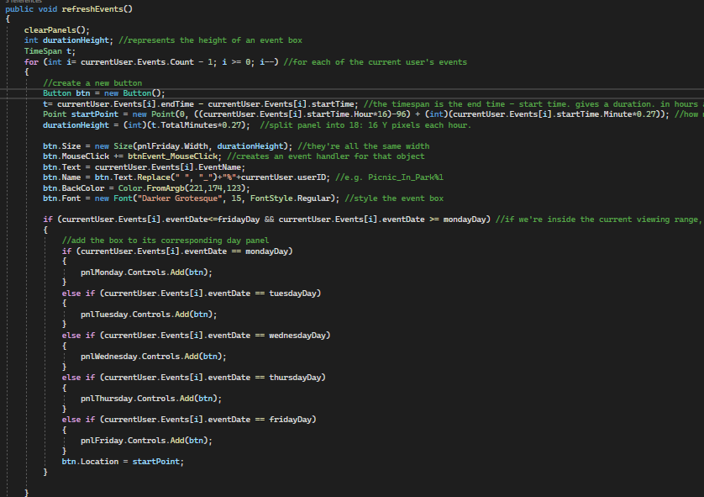

Users have their own note in the ‘Note’ section, where every user object has a “note” attribute. On load, the current user’s note is loaded into the text box. They can edit this directly in the text box, and it updates once they type something new:

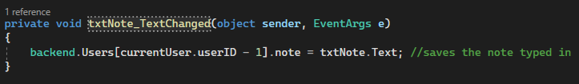

To add events into the calendar, I have created a subform named subFrmAddEvent:

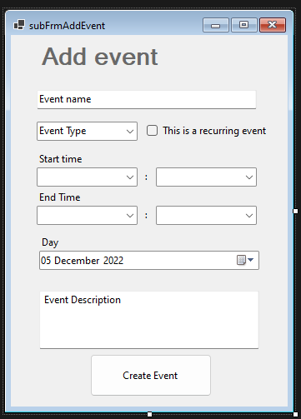

The user will enter the start and end time of the event they would like to enter, as well as the date the event occurs. Clicking create event will add an event to the current user’s object and refreshes the elements in the time organiser form.

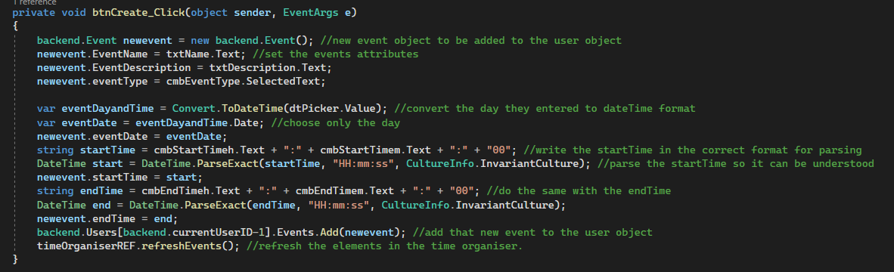

**Reviewing – time organiser**

Usability and Testing

**Usability**

Usability Features (time organiser)

|  |  |
| --- | --- |
| Element | Feature |
| Dropdown menu (cmbStartTime, cmbEndTime) | Presents the user with a list of pre-specified items. User can select what they require from it. |
| Buttons (btnCreate) | A clickable button |
| Text Boxes (txtNote, txtEventDescription etc) | The user can input text into a field. |
| Date Time picker | Allows the user to easily specify a date from a visual calendar. |
| Panels (pnlMonday, pnlTuesday etc) | Displays the events the user has for that specified day in the form of buttons. |
| Labels (lblMonday, lblMondayDay) | Provides information such as the days and the dates. |

**Testing – Time organiser**  
Testing the time organiser

|  |  |  |
| --- | --- | --- |
| **TEST DATA** | **EXPECTED OUTCOME** | **RESULT** |
| Creating an event | The event is added. | It didn’t show in the right place. |
| Removing an event | The event is removed. | Success |
| Adding an event beyond or before the current viewing area | The event is not shown in any of the day panels | Failure – not showing up |

Setting up the validation (time organiser)

|  |  |
| --- | --- |
| Element | Validation |
| cmbStart/EndTime | DropDownStyle = Dropdown to prevent the user from entering text: The only value it can have can be determined via a dropdown. |
| cmbStart/EndTime | Must be present |
| txtEventName | Must be present |
| txtEventName | No longer than 50 characters so the name doesn’t overflow the available space. |

Testing the validation (time organiser)

|  |  |  |  |
| --- | --- | --- | --- |
| Element | Input | Type | Output |
| cmbStart/EndTime | Click | Normal | Dropdown of items |
| txtEventName | X*100 | Extreme |  |
| txtEventName | [no input] | Erronous |  |

Reviewing errors and making amendments (time organiser)  
Evaluating the test results obtained, I noticed that there should have been an equals sign in the if statement deciding whether or not the event to fill to a panel in the current viewing area.



Usability Testing - Client Feedback (time organiser)  
Sarker suggested users should be able to view the description of each event by clicking an event button. I implemented it as follows, as a messageBox:



Time organiser results compared to success criteria

|  |  |
| --- | --- |
| WHAT MUST BE INCLUDED | How it was met/Partially met |
| Users can have a study timetable to keep them motivated | Users can add events to their calendar, having them visually represented. |

**End of review for the time organiser**

**The process – manage classes form**

With the homepage and time organiser complete, I want to focus on creating the manage classes form, which will be used by teachers. I created the design in stages as follows; here is the first stage: it shows the current classes.

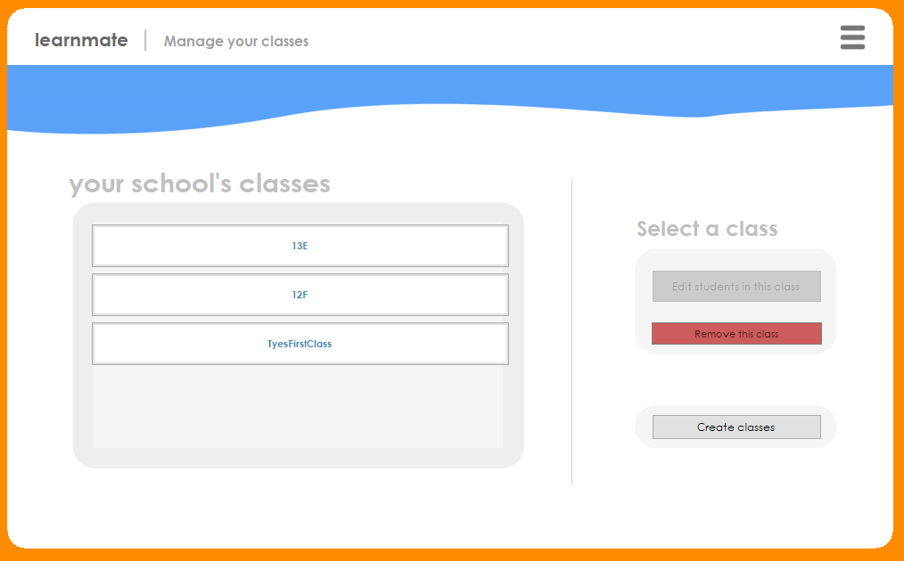

The next stage displays the students within the class. The classes in a teacher’s school are all displayed in a panel. The act of displaying a ‘class’ (button) is as follows:

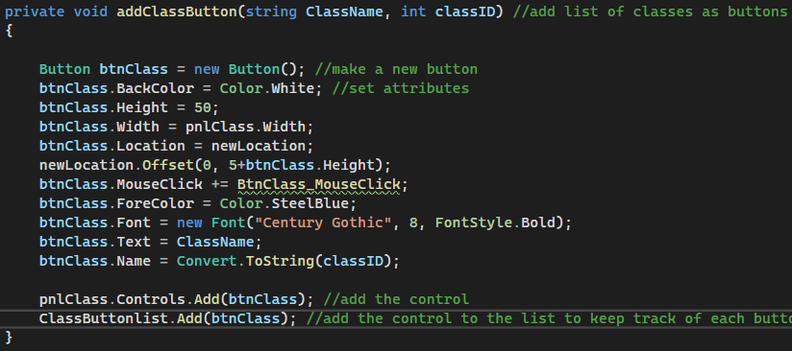

And the classes are displayed using the following function

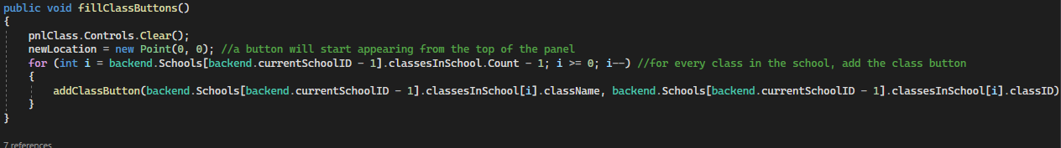

I applied my knowledge of modular programming for easier debugging to the visibility of the buttons depending on the stage the user is at:

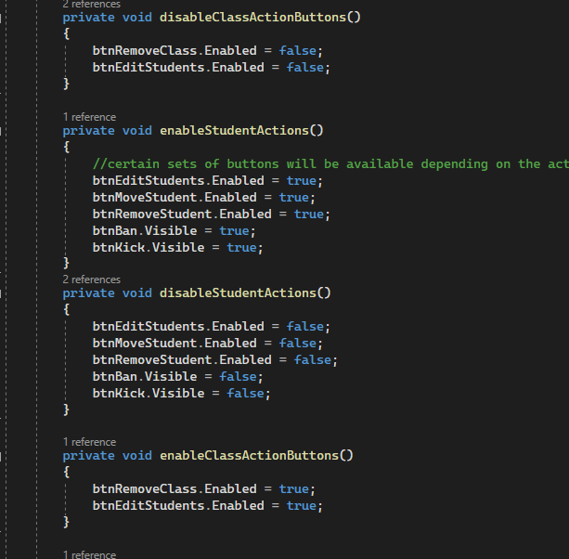

E.g., If they look within a class, it will disable the class action buttons and enable the student action buttons

Pressing ‘create class’ brings up the following menu:

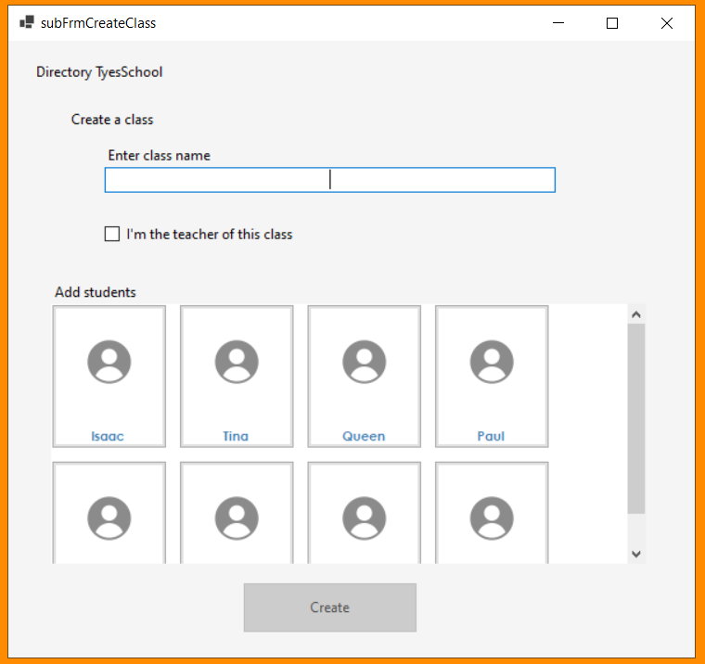

The same process used to display classes applies to displaying any student within the panel in this form. Unassigned students are without a class, so they be added to a class here. Students within classes can also be moved to this new class being created. Pressing create adds a new instance of the class and adds it to the list of classes in the school:

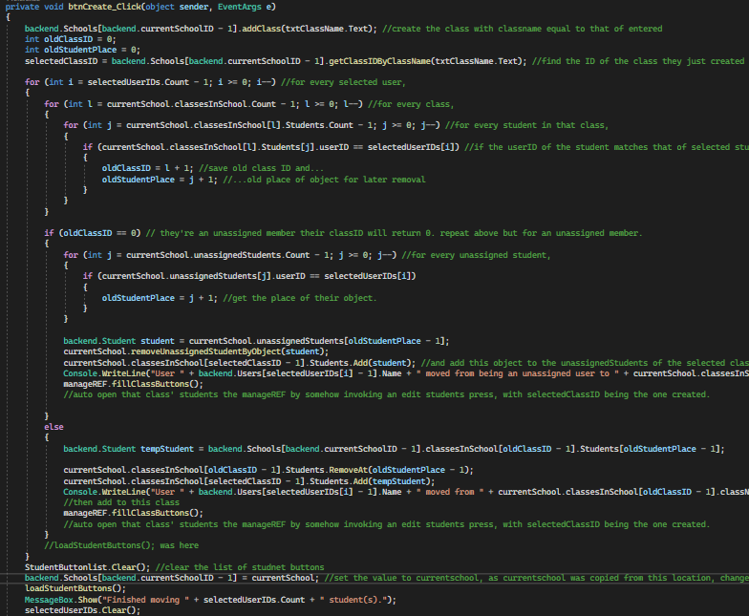

Essentially, this code says if the student is in a class already, move them to the new class. If they are unassigned, remove them from being unassigned and add them to the new class.

**Reviewing – creating a class subform**

**Usability and Testing**

**Usability**

Usability Features (subFrmCreateClass)

|  |  |
| --- | --- |
| Element | Feature |
| Buttons | Allows a user to click. |
| Scrollbar | Allows a user to view overflowing students by clicking and dragging. |
| Labels | Displays text to the user |
| Text Boxes | Allows the user to input text. |

Usability Testing (subfrmCreateClass)

Client stated the form contained all the controls needed.

Setting up the validation (subFrmCreateClass)

|  |  |
| --- | --- |
| Element | Validation |
| txtClassName | No longer than 50 characters, as that is the maximum limit for classnames to prevent overflow |
| txtClassname | Must be present |

Testing the validation

|  |  |  |  |
| --- | --- | --- | --- |
| Element | Input | Type | Output |
| txtClassName | [Typing X over 50 times] | Erronous |  |
| txtClassName | [No input] | Erronous |  |
| txtClassName | TestName | Normal | Worked as intended |

**End of review for the create class form**

Next, for within a class, students should be able to be added (/moved) to another class, or removed from that class.

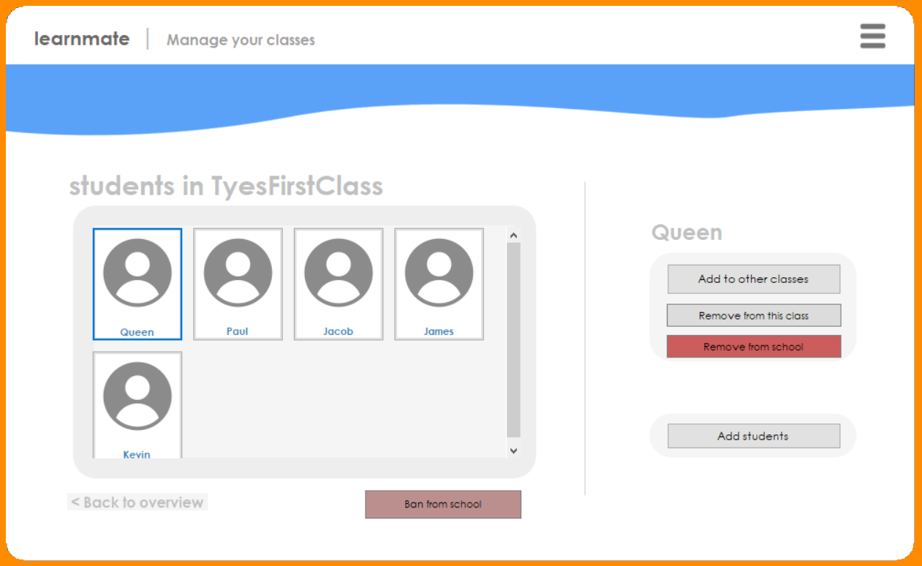

I allowed for the addition of a student to another class by creating another separate form, similar to the one previously shown:

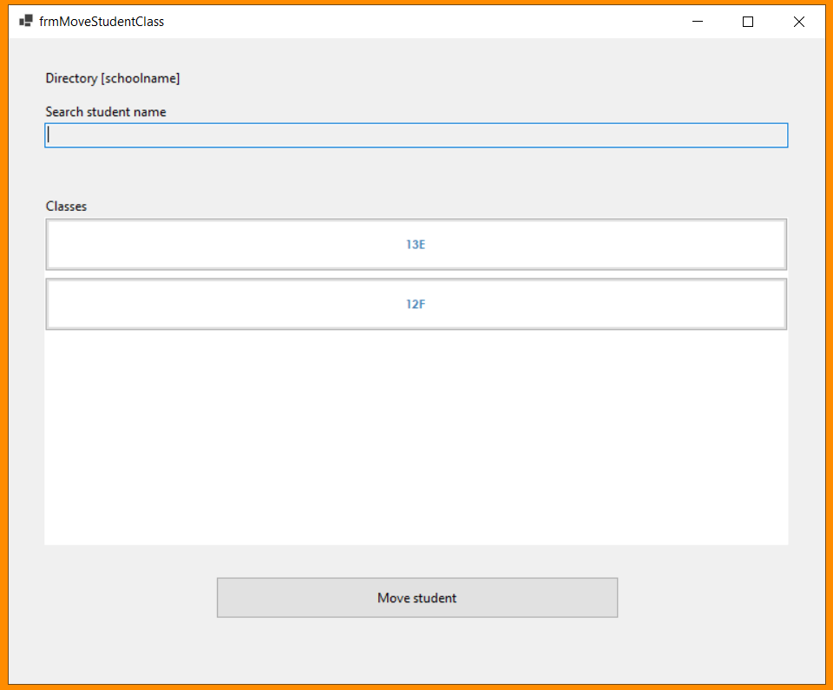

This form has the option to move the student to a class which they aren’t already a part of. The code for the movement is previously shown in the other subform. A student is removed from the class they were a part of and added to the specified class.

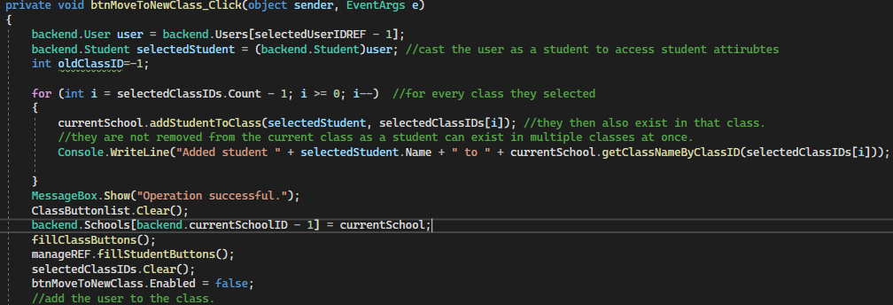

Usability and Testing

**Usability**

Usability Features (subFrmMoveStudentClass)

**This form has the exact same usability and validation features as subFrmCreateClass. See that section above.**

I have also allowed the ability for teachers to ban students who may be misbehaving and joining schools without permission. The act of banning a student from a school is as follows:

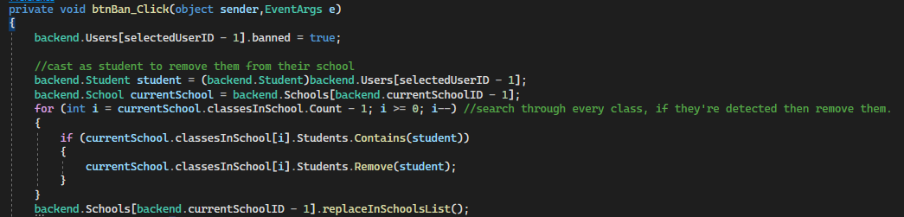

The banned student has their banned attribute set to true, and are removed from all classes they were a part of. They will also be presented with this screen when logging in:

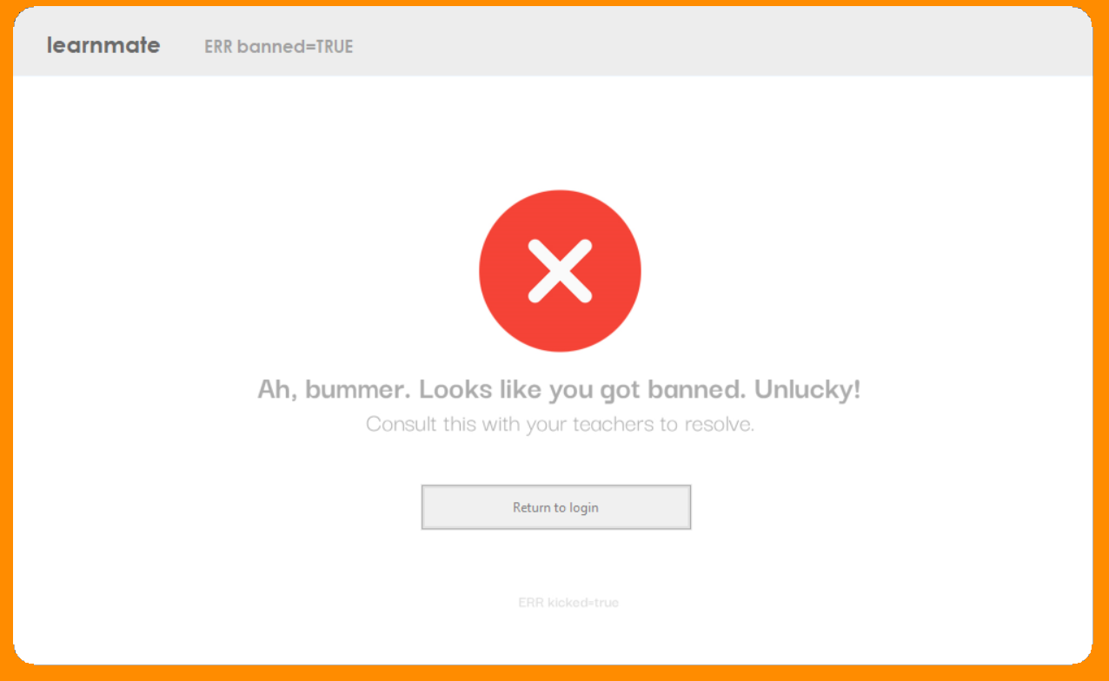

This is done by the container checking if the current user is banned or not after login, and if true, loadBanned() runs, loading this subform into the container.

**[START OF REVIEW FOR THE BANNED FORM]**

Usability Features (banned form)

|  |  |
| --- | --- |
| Element | Feature |
| Buttons (btnReturnToLogin) | A clickable button. |
| Labels | Displays text to the user |
| PictureBox | Displays an image to the user, visually indicating the surrounding content. |

**[END OF REVIEW FOR THE BANNED FORM]**

**[START OF REVIEW FOR THE MANAGE CLASSES FORM]**

Usability and Testing

**Usability**

Usability Features (managing classes)

|  |  |
| --- | --- |
| Element | Feature |
| Buttons (e.g. btnClass, btnEditStudents etc) | Presents the user with a list of pre-specified items. User can select what they require from it |
| Label (e.g. lblStudentName) | Shows retrieved or constant information to the user. |
| Picture box | Displays student icon so it is clear to the teacher that they are viewing students. |

Usability Testing - Client Feedback (managing classes)  
My mother (former teacher) said that the UI is a little hard to understand – the buttons aren’t clear enough. She also said there should be some visual indication that multiple students have been selected when clickiing them.

**Testing**  
Testing the prototype (managing classes)

|  |  |  |
| --- | --- | --- |
| **TEST DATA** | **EXPECTED OUTCOME** | **RESULT** |
| Loading of pre-existing classes | They appear in the panel | Successful |
| Loading of pre-existing students | They appear in the panel | Successful |
| Movement of a student | They are removed from their previous class and added to the specified one |  |
| Creation of a class | New class is created, and selected students in that class are also added to the new class |  |
| Creation of a class | Loading manage classes without being enrolled onto a school | Unsuccessful – can’t traverse through current classes. |

For the actual manage classes form itself, there are only buttons present. Therefore, no validation testing is needed here.

Reviewing errors and making amendments (login form)

In response to the client feedback of buttons not being clear enough, I decided to add a tooltip to the buttons to make the usability a lot better for everybody.

For a visual indication of selected students, I used a checkmark image and implemented it in the click event handler of a buton object:

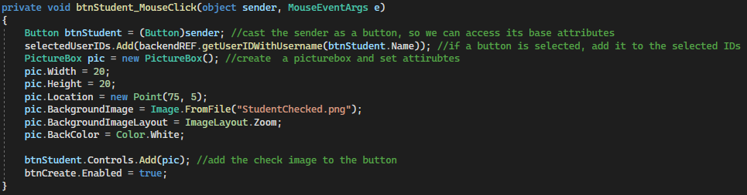

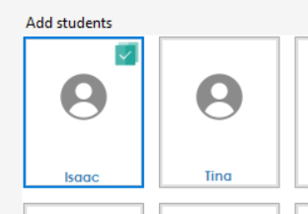

Also, to address the error of being unable to traverse through current classes, I have decided to only let members of schools use learnmate if they’re enrolled onto a school. I did this by creating another subform which will be presented upon logging into an account with no school. 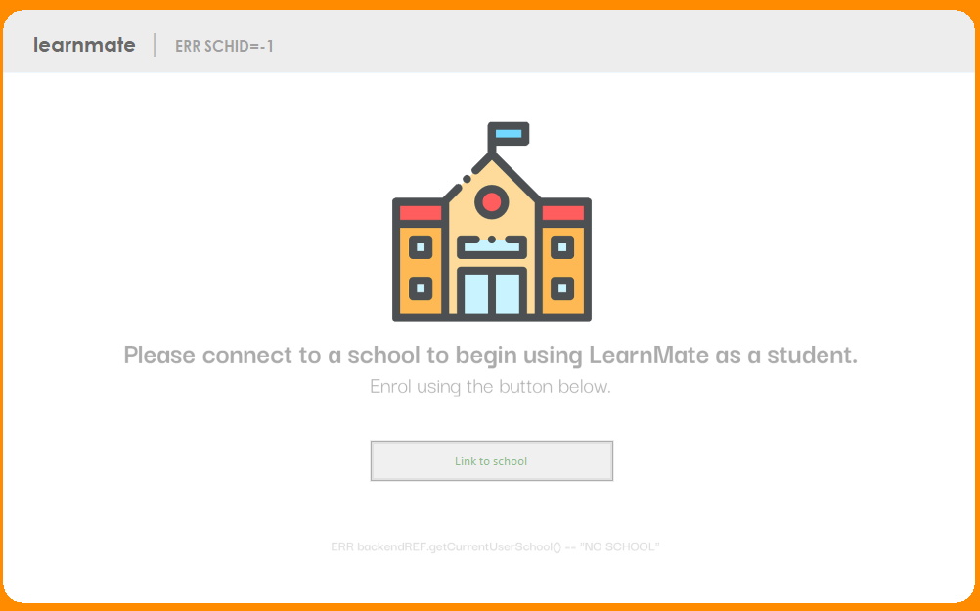

Clicking link to school brings up the following subform, where entering a valid institutionCode (using backend checkIfASchoolExists() function) returns the user back to the homeapge, and sets their schoolID to the corresponding school’s ID.

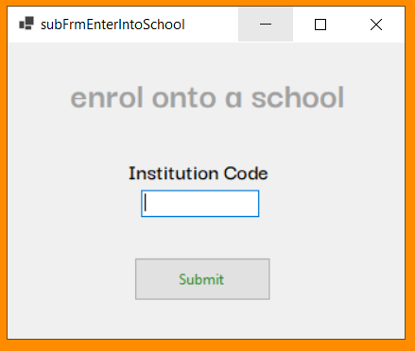

Usability Features (subFrmEnterIntoSchool)

|  |  |
| --- | --- |
| Element | Feature |
| Button | A clickable button |
| Text box | The user can input text into a field. |
| Labels | Outputs the current user information so they are aware they’re currently logged in. |

Prototype results compared to success criteria

|  |  |
| --- | --- |
| WHAT MUST BE INCLUDED | How it was met/Partially met |
| Experience using the program should be high quality and represent that of in person. | Users can move classes and be removed from the school just like they can in person. |

**[END OF REVIEW FOR THE MANAGE CLASSES FORM]**

**The process – learn and practice form**

For my next form, I am going to focus on students being able to learn and practice content. As previously mentioned, green promotes productivity and motivation, so the theme for this form will be green, with a personal greeting to the user.  
I split the learning process into steps. First, the backend needs to know which subjects the student is studying, so it can display it in the list of subjects.   
For this reason, I have implemented the requirement of choosing the subjects a user studies/teaches before they continue to the homepage. I will call this the ‘enrol form’.

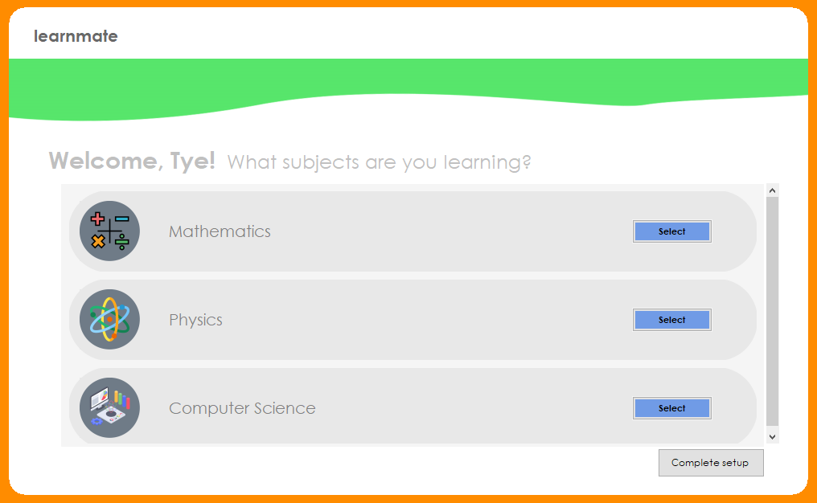

A problem I encountered with the greeting titles is that their name will not be a constant length. Therefore, I kept track of the end location of the welcome, [name] label, and set this as the starting point for the ‘what subjects…’ title.

**Reviewing – enrol form**

Usability and Testing (enrol form)

**Usability**

Usability Features (enrol form)

|  |  |
| --- | --- |
| Element | Feature |
| Labels | Displays information to the user |
| Buttons | A clickable area to select a subject by a visual indication |
| Picturebox | A visual indication explaining the surrounding controls |
| Scrollbar | Allows the user to view overflowing content. |

Usability Testing - Client Feedback (enrol form)  
One of my clients mentioned for the texts to be the same size, and for the colour to be darker to increase visibility.

**Testing**  
Testing the prototype ([proto name])

Blah

|  |  |  |
| --- | --- | --- |
| **TEST DATA** | **EXPECTED OUTCOME** | **RESULT** |
| Choosing a subject | Upon clicking complete setup, that subject is added to the subjectsChosen list for that user object. | Success |

Reviewing errors and making amendments (enrol form)

I increased the text size and made it bold, with a consistent font size:

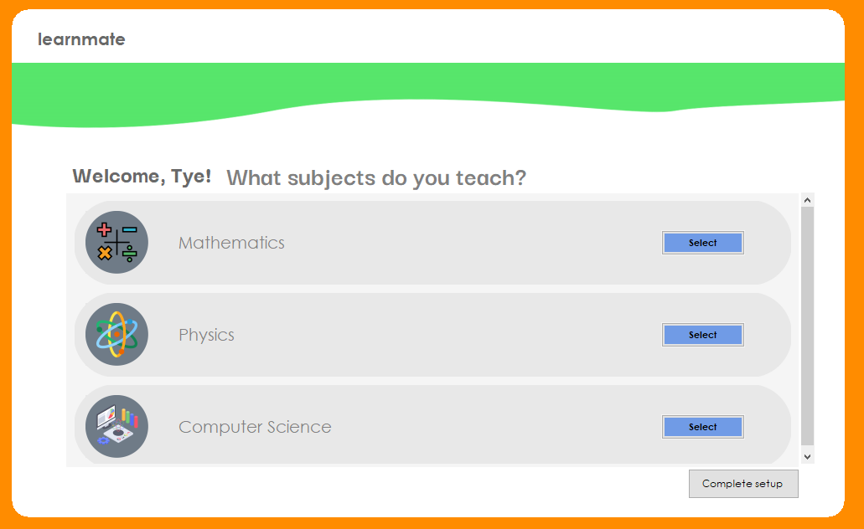

**End of review for the enrol form**

The subject(s) they then choose are saved by adding them to the list of subjectsEnrolledTo in their user object:

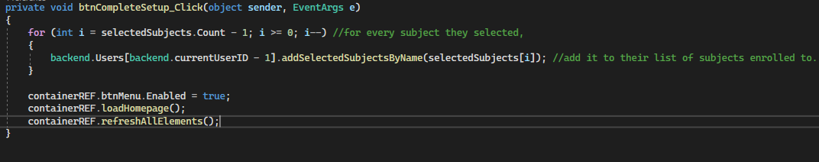

The first step is to choose the subject that they wish to study:

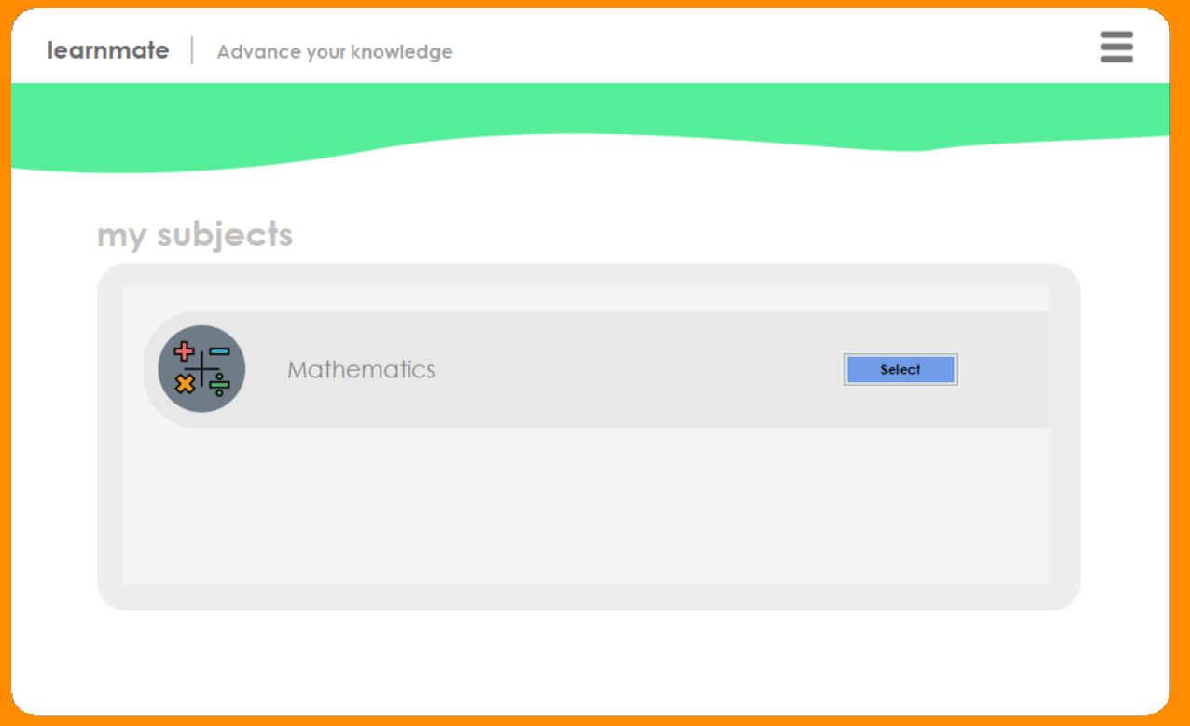

A subject button is defined as 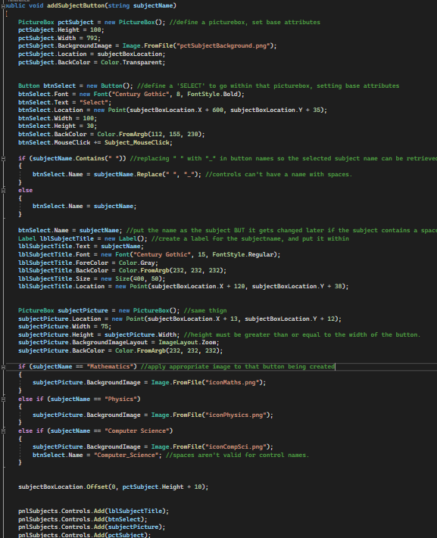

These subjects which the current user is enrolled to are ouputted by utilising the already created ‘subjectsEnrolledTo’ attribute for the current user:

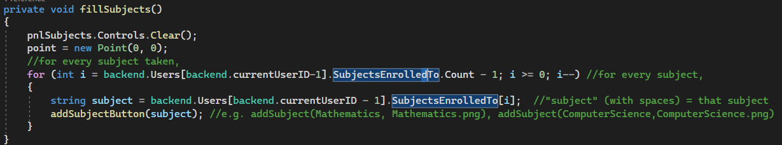

Once the subject is selected, the topics are filled in an identical manner.

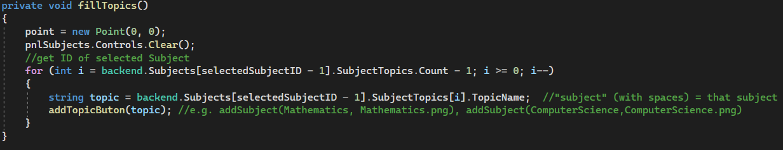

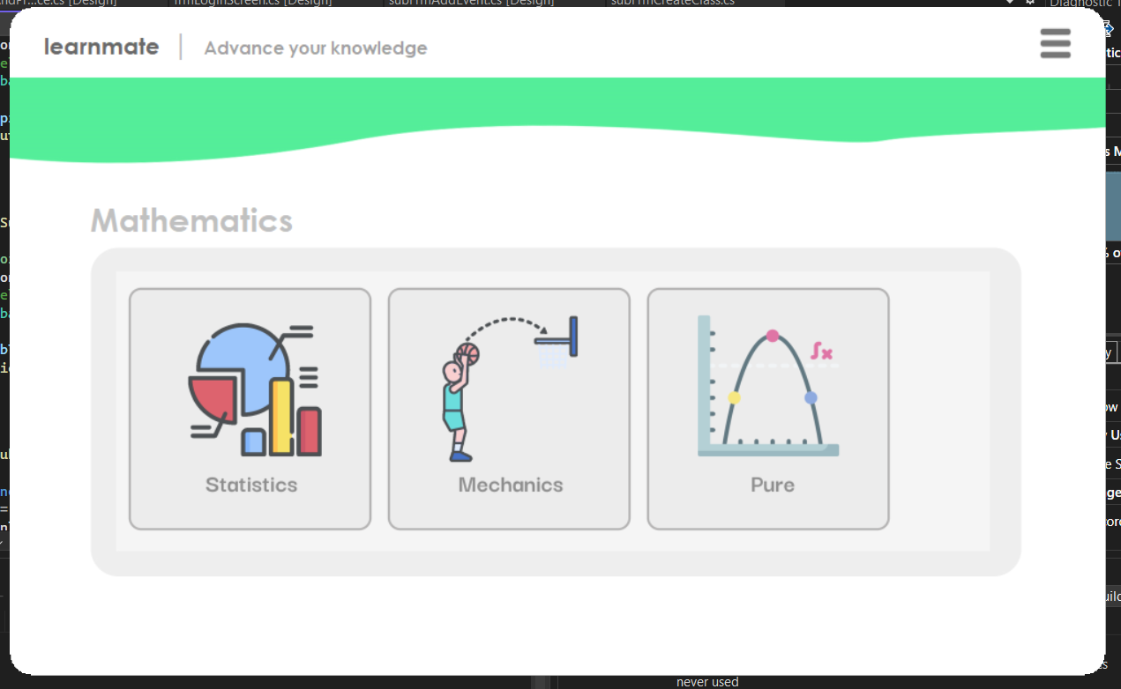

And same with the subtopics.

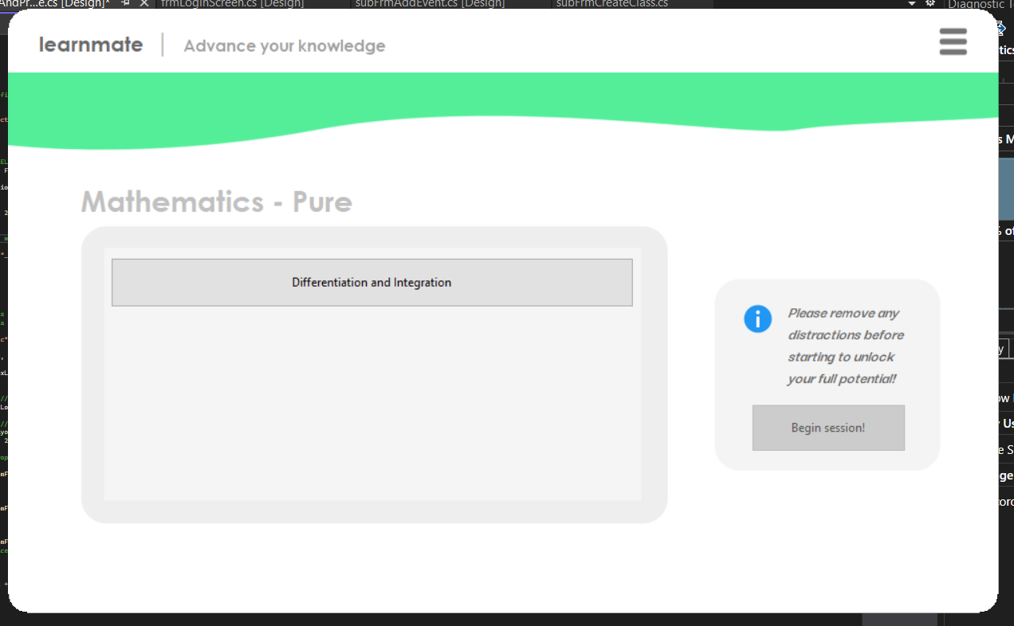

Upon clicking begin session, the learner traverses through microsessions associated with that topic within another form: the session form. How these microsessions were created was already mentioned in prototype 3, but to recap, each subtopic has 2 microsessions in it, with each consisting of a video file and two practice questions.

When clicking the begin session button,

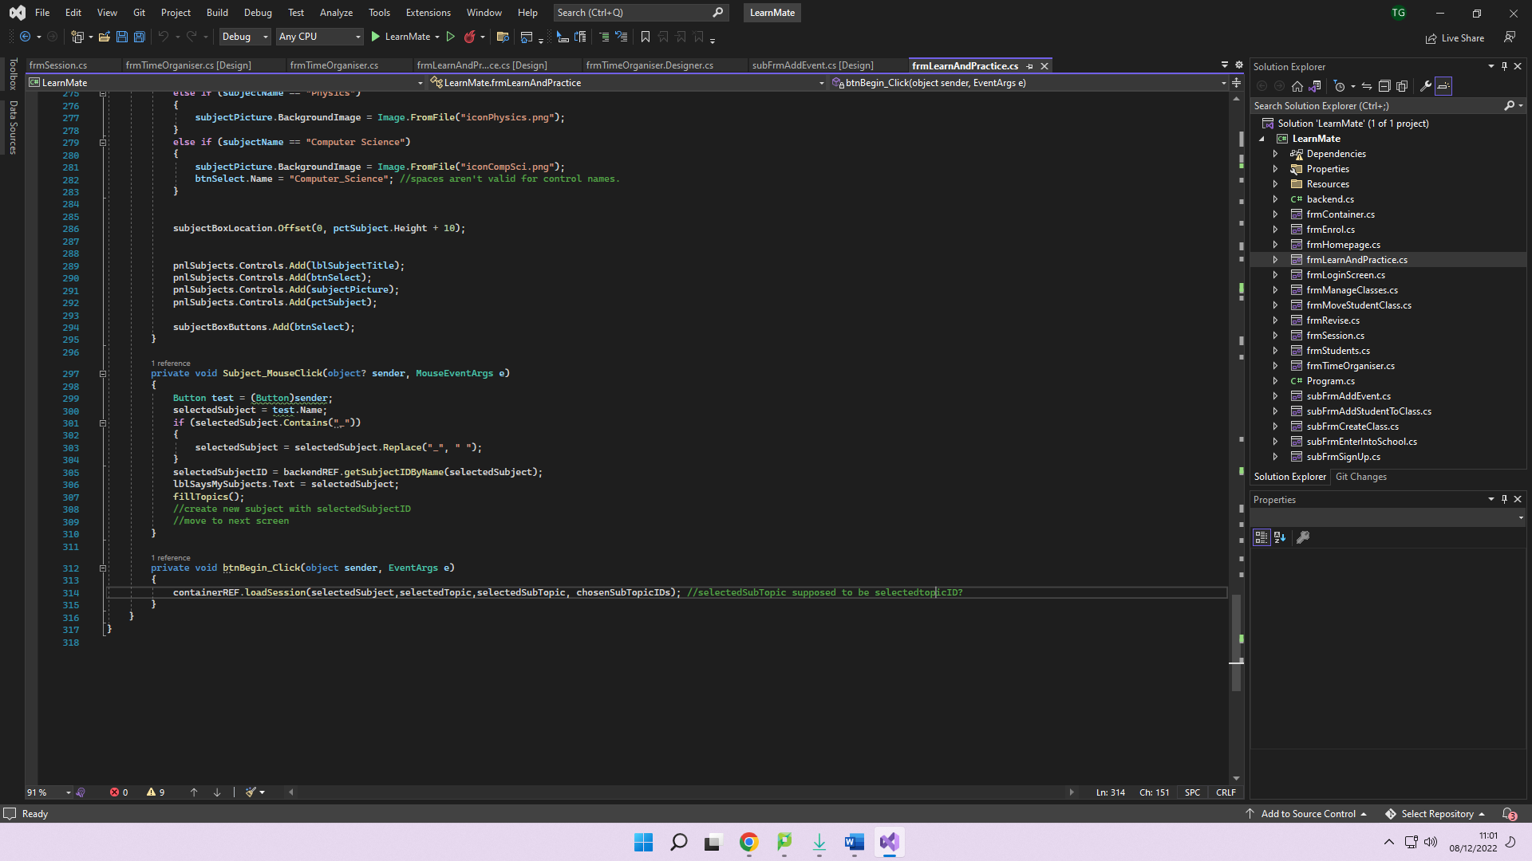

The container loads the session form into the mainPanel with the parameters of the chosen session. The microsessions are traversed and displayed in the session form as follows:

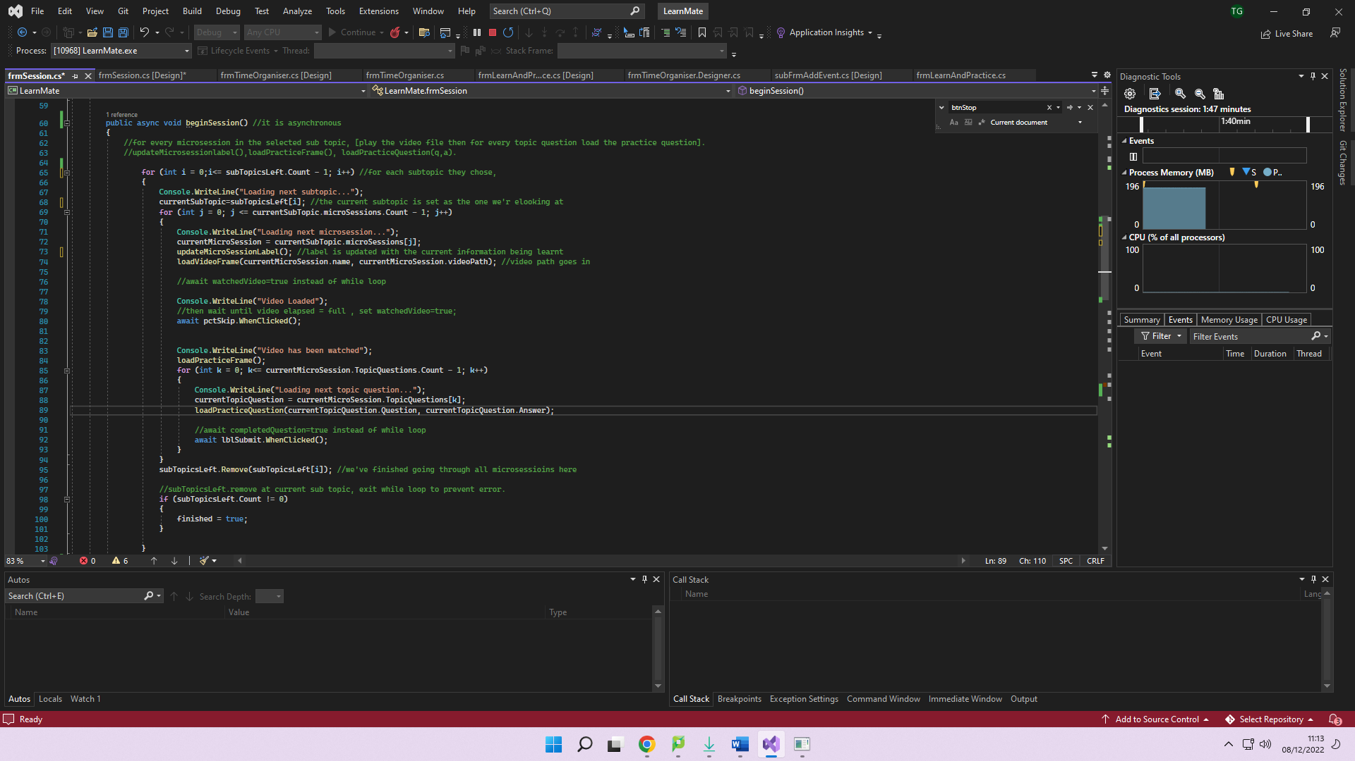

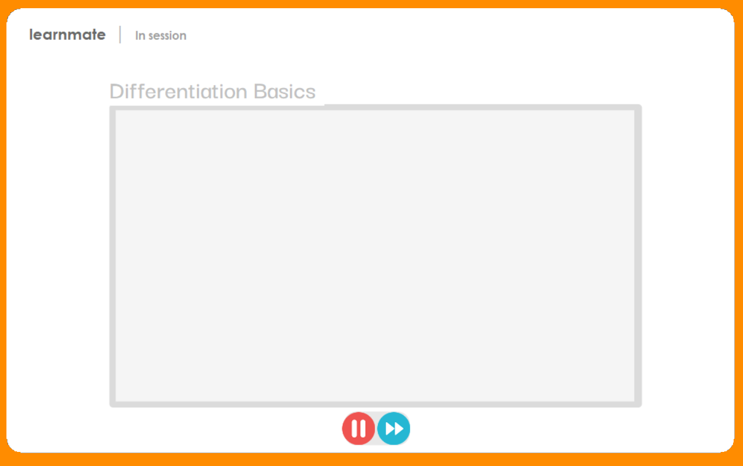

The aim is to display the video in the path specified within this container above. Unfortunately, I could not get this to work. This issue is mentioned further in the evaluation section.

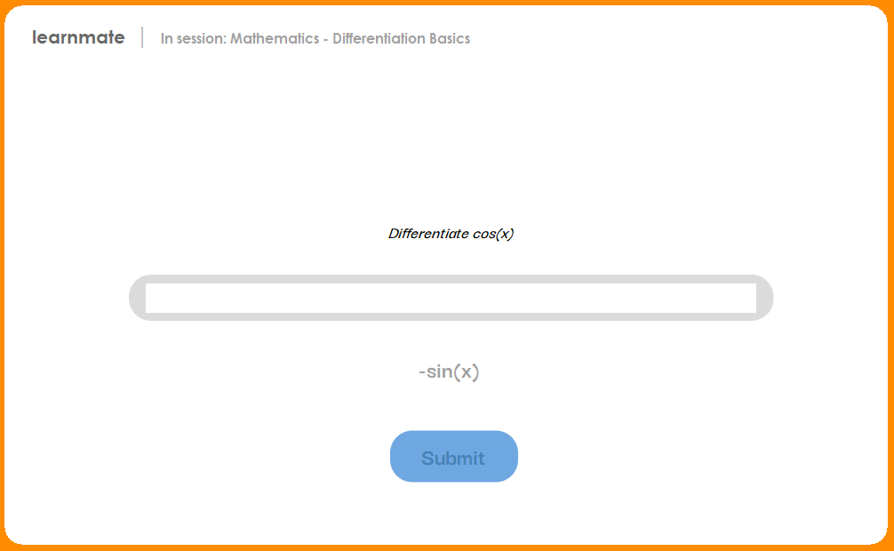

**Reviewing – session form**

Usability and Testing (session form)

**Usability**

Usability Features (session form)

|  |  |
| --- | --- |
| Element | Feature |
| Text Box | Presents the user with a list of pre-specified items. User can select what they require from it |
| Buttons | I can output testing/debugging information about the backend by clicking it. |
| Label | Displays information to the user |

Usability Testing - Client Feedback (session form)  
Sarker mentioned the title of the current microsession was too light compared to its background, and was hard to see.

**Testing**  
Testing the prototype (session form)

|  |  |  |
| --- | --- | --- |
| **TEST DATA** | **EXPECTED OUTCOME** | **RESULT** |
| A session being started | Displays a video, and then two practice questions | Successful |
| A Session being ended | User is brought back to the homepage | Unsuccessful – the end button was unresponsive. |

Setting up the validation (session form)

|  |  |
| --- | --- |
| Element | Validation |
| txtUserAnswer | No longer than 50 characters. |

Testing the validation

|  |  |  |  |
| --- | --- | --- | --- |
| Element | Input | Type | Output |
| txtUserAnswer | [input greater than 50 characters] | Erronous |  |

Reviewing errors and making amendments (login form)

I have darkened the current microsession name:

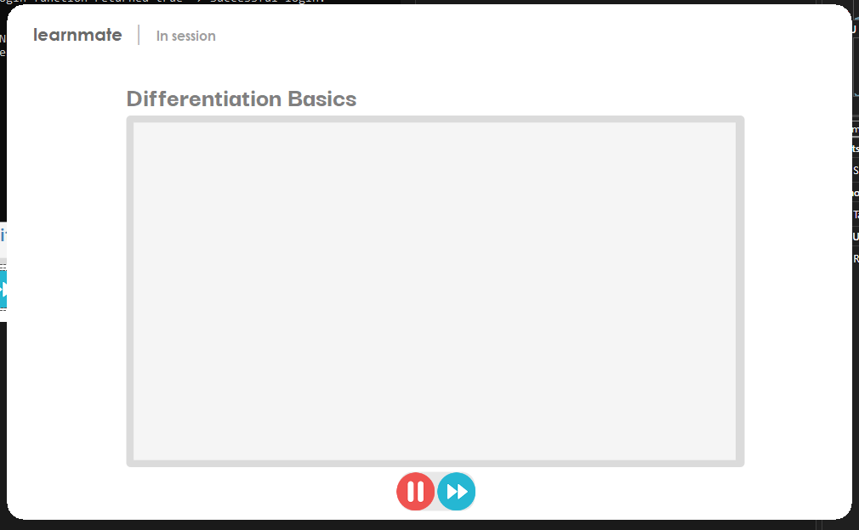

In response to the end button being unresponsive, Instead of using a while loop with “while (!finished)” in it, I just removed that and added the code to bring the user back to the homepage instead: 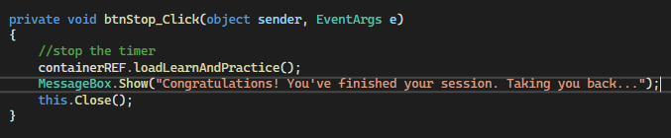

Prototype results compared to success criteria

|  |  |
| --- | --- |
| WHAT MUST BE INCLUDED | How it was met/Partially met |
| Effortless learning and practicing | Visual complexity is minimal, users can complete lessons in less than 5 mins, with little user input. |

With the session form complete, I can test the learn and practice form as a whole:

**Reviewing – learn and practice form**

Usability and Testing (learn and practice form)

**Usability**

Usability Features (learn and practice)

|  |  |
| --- | --- |
| Additional Elements since prototype 3 | Feature |
| PictureBox | Presents the user with a picture, able to be interacted with, acting like a clickable button. |
| Buttons | A user can click this to navigate to another part of the application |
| Labels | Displays information to the user. |

Usability Testing - Client Feedback (session form)  
The client liked the layout of this form.

**Testing**  
Testing and validating the prototype (session form)

**Validation and validation testing for the controls in this form and the functions behind them have already been complete. See prototype 3.**

Prototype results compared to success criteria

|  |  |
| --- | --- |
| WHAT MUST BE INCLUDED | How it was met/Partially met |
| Effortless learning and practicing | Visual complexity of each of the stages is low. Each set of controls is relatively close to each other so there is minimal relocation of viewing area when going between the stages. |

I have now completed all of the forms. I will carry out some final usability testing:

**Final review**

Usability and Testing – Final testing

**Usability**

**Testing**  
Testing the final solution

|  |  |  |
| --- | --- | --- |
| **TEST DATA** | **EXPECTED OUTCOME** | **RESULT** |
| Signing up | A new user object of the specified type is created in the backend. Current user details set to that of created | Success |
| Logging in | Current user details set to that of logged into | Success |
| Handling events in time organiser form | Adding of events should show up in the visible calendar week.  Events’ description can be viewed after event creation. | Unsuccessful – the same event description was outputted no matter which event was selected |
| Handling classes in manage classes form | Classes can be added, removed, and amended. | Successful |
| Managing students | Students can be added, removed from and moved to classes, along with being banned or kicked from the school if they misbehave | Successful |
| Learning and practicing a topic | Students can work through videos and practice questions | Successful |

Reviewing errors and making amendments (final testing)

For the problem with the duplicate event descriptions in the time organiser, I fixed this by setting the name of each button to be its event ID. This way, I can store the selected event ID as a global variable, accessible via the “view event information” button. It just needs to traverse through the current user events, searching for that event ID, and outputs that event’s description. 

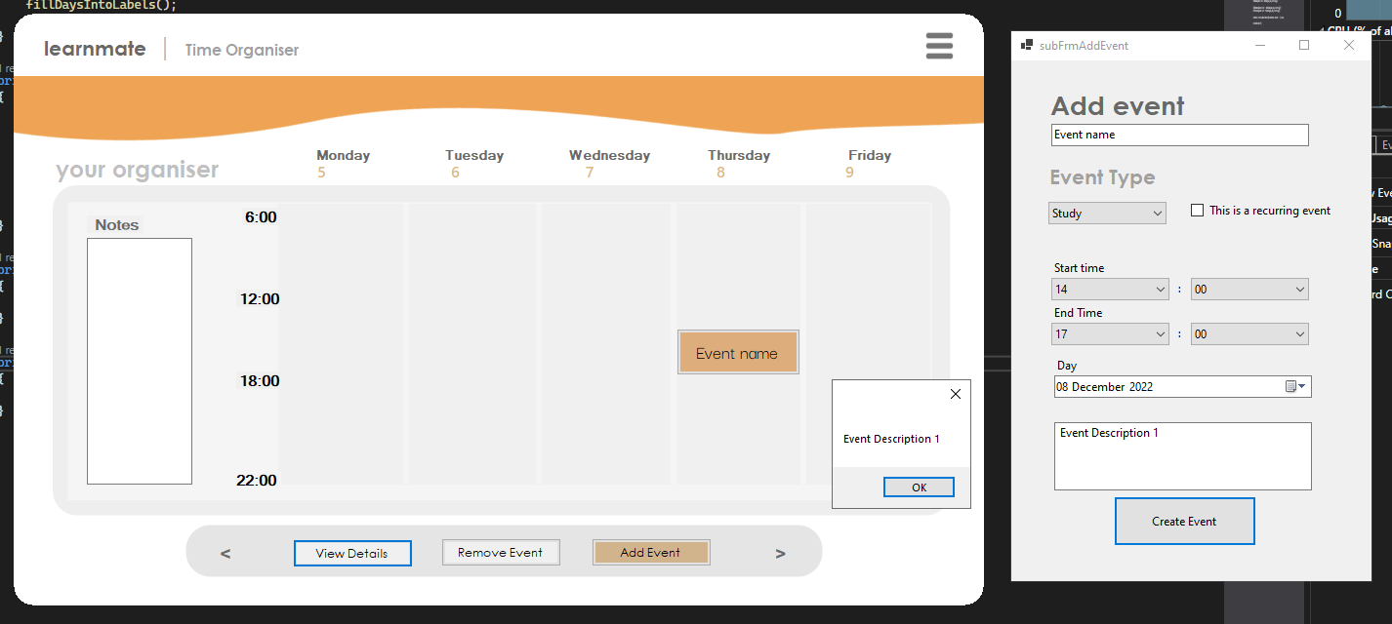

# Evaluation

A recap of the success criteria. An explanation for each criteria follows.

|  |  |  |
| --- | --- | --- |
| **Criteria** | **Justification** | **Met? Why?** |
| WHAT MUST BE INCLUDED | |
| Every type of account must be able to be created | Features available on the homepage after login must reflect the type of account logged into | Met |
| New and existing users can login using their Username, Password. Students can affiliate with schools using an institution code upon signup. | Users need a way of accessing the system while also applying protection to the data it contains. Their login information being unique verifies non permitted users are kept away from the software, and that a user does not log into the wrong account which may end up in compromised data. | Met – Login form gets input and checks against stored information. Members of a school are encouraged to link to a school to use learnmate smoothly. |
| Experience using the program should be high quality and represent that of in person. | Browsing learnmate must be enjoyable and inspiring to use. Browsing a non-aesthetically pleasing program easily becomes tiresome and boring to the user, and a key part of a revision software is making sure users can remain in the cycle of learning for the longest possible time span.  Also, the relation between teachers and students in the application must reflect that of in person, e.g., clicking into a class brings up students, like how by looking at a class you see its students | Met – aspects such as adding students to a class or using the study timetable reflects that of a user’s actions in person. A user will be more likely to continue using the app if it can help them guide themselves. |
| Users can have a study timetable to keep them motivated | Incorporating a calendar makes the experience using learnmate more all-in-one. Users are unlikely to deviate from the app and can plan around their education easier. | Partially met – Unable to add automated creation of study timetable |
| Each of the essential forms is created and can be navigated around | Without the main forms (time organiser, manage classes, learn & practice) there would be no purpose in learnmate | Met - via panel accessible via hamburger menu |
| Data must be stored consistently across multiple entities | Without this, data wouldn’t be updated everywhere leading to references of null objects within code and overall incorrect information being displayed. | Met – e.g. every time a user is added to a class, if they exist in the “unassigned students” list [aka, students who don’t belong to a class], then they are removed from it. |
| Users can access different actions depending on their user type. | A student shouldn’t be able to manage classes in their school. | Met – only certain form buttons are available depending on their stored user type. |
| **WHAT SHOULD BE INCLUDED** | |  |
| Design could be aesthetically pleasing | A minimalistic and intuitive application adds to the simplicity which is optimal for using such a complex application. This confirms that more of a variety of users, even those less technologically competent, can navigate around the software with ease. Eye-catching colours, shapes and overall design encourages an improved experience using Learnmate. | Met – I retrieved continuous usability feedback and applied my UI/UX skills |
| Simple navigation for non technical users | Allows more of a variety of users to access the software | Met |
| Runs lightweight | Ensures the program is usable on more of a variety of machines | Partially met - heavy code in places, inefficient. |
| **WHAT COULD BE INCLUDED** | |  |
| Retrieval of a summary of data | A teachers’ ability to save a summary of data entered to a text file | Not met |
| A Timer during practice exam questions | Beneficial as it mimics exam conditions but is difficult to implement. | Not met |
| Teachers would be able to manage students’ logins | If a student has forgotten their password, a Teacher can change it for them so they can access their account. | Not met |
| Students’ knowledge is tracked | Learnmate could recommend content to users based on what they don’t know. Teachers could tell learnmate their knowledge, and it would be automatically modified by completing practice questions. | Not met |
| WHAT WOULD BE INCLUDED | |  |
| Messaging system | Teachers and Students would be able to communicate with each other | Not met |

Evidence of met criteria  
**Every type of account must be able to be created**:

Users can sign up with a specified user type. A user object contains a ‘UserType’ attribute.

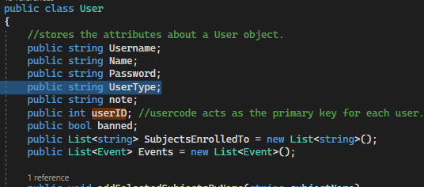

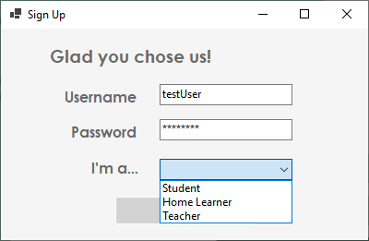

**New and existing users can login using their Username, Password. Students can affiliate with schools using an institution code upon signup:**

The login form provides the ability to login using their username and password. New users can sign up using the signup form shown above. If the user isn’t affiliated with a school, they’re required to enter an ins code and will be presented with a screen as shown.

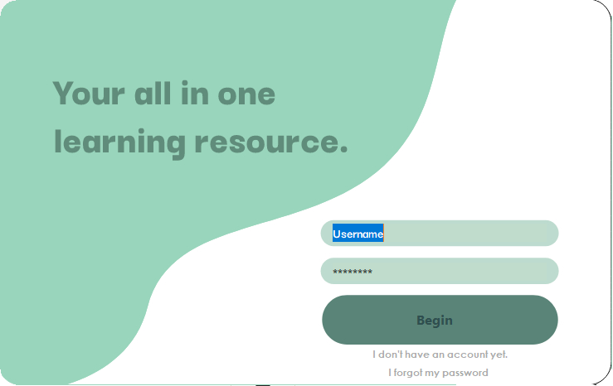

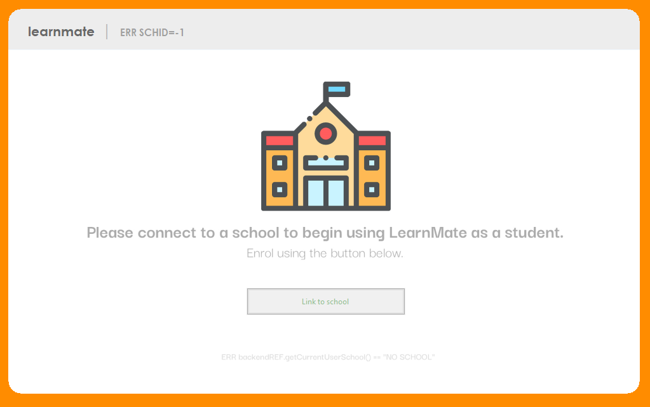

**Experience using the program should be high quality and represent that of in person:**

The usability of the application is of the best quality I can provide, via frequent communication with my stakeholders to make sure the application is enjoyable to use for a variety of users. Many aspects of the program represent in-person concepts, such as managing students in classes, e.g. adding a student to a class like which can be done in real life. Also, another example is the time organiser where users can plan events in their life within the application.

**Users can have a study timetable to keep them motivated:**The time organiser is every student and teacher’s personal calendar. This was included in this centralised resource so that users can separate their personal and study life, with LearnMate being their go-to for studying.

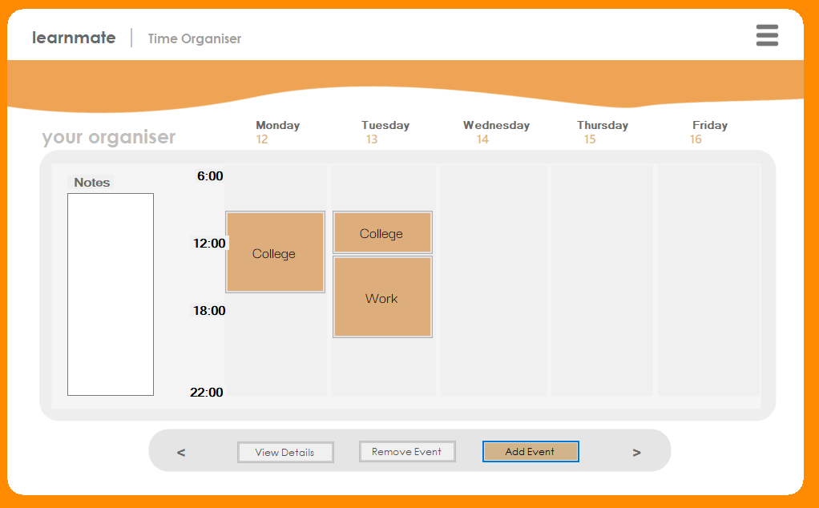

The Monday to Friday 6-10pm time scale was used instead of the 24hr typical one because that tends to be the typical time people dedicate to studying. Users can separate their home and work life further by having their weekends off allowing more peace of mind when their study life becomes overly stressful.

**Each of the essential forms is created and can be navigated around:**Essential forms include the homepage, learning and practicing form (and their subforms), managing classes (and their subforms). I had unfortunately run out of time to do the “complete my assignments” form. These forms just mentioned are shown before in this document. Simple navigation is used via the hamburger menu in the top right corner of any form:  
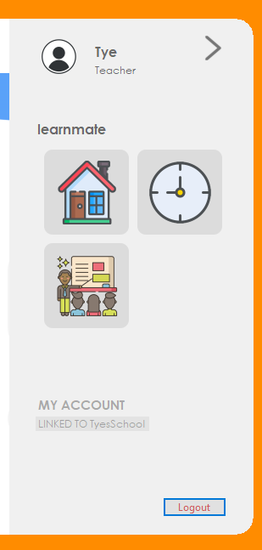

**Data must be stored consistently across multiple entities:**

Functions like “addStudentToClass” paired with “removeUnassignedStudent” represent the maintaining of data consistency. If a student exists in a class, then they are not in the “unassignedStudent” list. 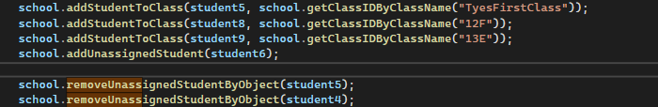

**Users can access different actions depending on their user type:**The homepage represents this criterion being met: 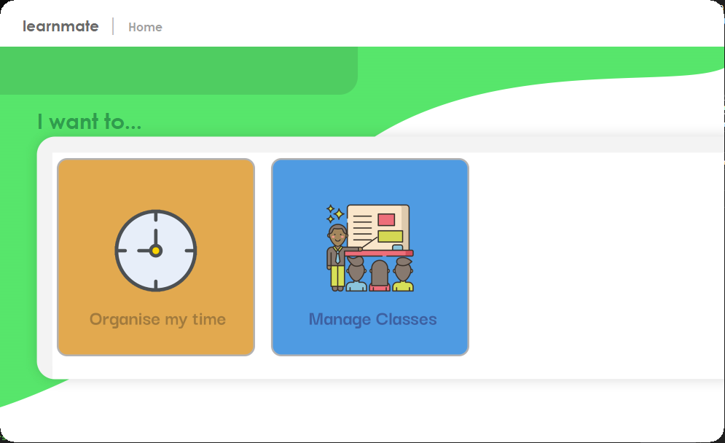

Users have a specific set of options depending on the type they selected at signup.

**Runs lightweight:**

**Simple navigation for non-technical users:**

Hamburger menu icons and homepage icons prevent clear indication of their actions. The navigation panel has low visual complexity too, as shown in an above screenshot.

Tooltips present information for those unsure of any control’s action.

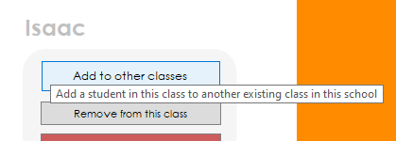

Also, there is a ‘How to use’ button on the homepage which will also show upon sign up.

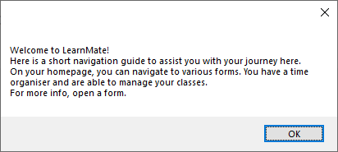

Usability Features

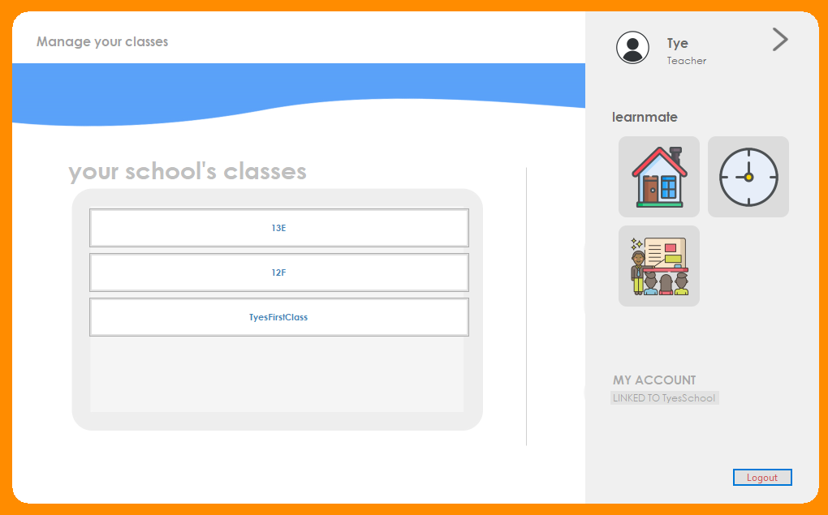**Buttons:**

Both the default button and picture boxes serve as buttons. The buttons are large and bold and have appropriate images/labels so the user knows what their purpose is. They also have tooltips associated with them in case the user is confused about their purpose.

**Text Boxes:**

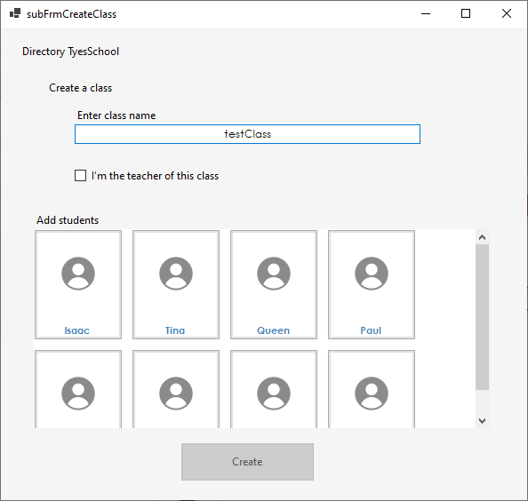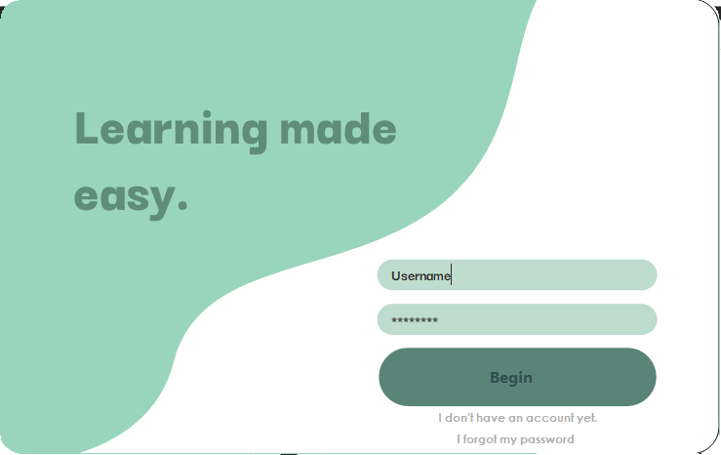

The user can input information into the system, which abides by the appropriate validation rules implemented. These text boxes are easy to use as they have a large span and are outlined clearly.

**Dropdowns:**

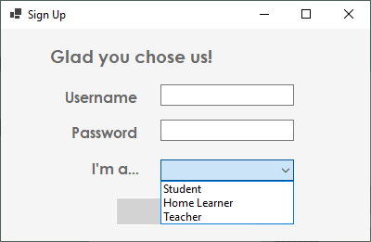

Allows the user to pick from a list of available options. The dropdowns I’ve implemented do not allow text entry, so that input always follows an expected entry. These dropdowns are easy to use as they are clearly recognizable from the hand cursor and the down arrow icon.

Limitations  
The first limitation I encountered was that my computer couldn’t import the necessary windows media player extension for adding videos in the learn and practice section. During learning and practicing, an issue would be that users don’t provide honest data to practice questions, and cheat or get distracted via their phones or another application. I have also noticed is that the UI is quite small and may cause eye strain for those hard of seeing. Students’ performance also isn’t tracked. And finally, the code sometimes runs slow in places, and therefore does not run lightweight in all areas.

Combatting these limitations  
In practice, there would be videos present using the video path attribute for each microsession. But if this couldn’t be done, the videos could be replaced with articles of text instead, which would be available for every user since it doesn’t need specific hardware requirements to display text but would be more tedious for the user.

To combat the distracted users issue, I have previously created a label notifying users to remove distractions before starting to reach their maximum potential.

Some aspects of the UI, aka sub forms are larger than the main UI which the container holds. For learning and practicing content, the video frame needs to be a lot bigger for comfortable viewing, so in practice, future support would provide a much larger UI (around 80% viewing area) when watching videos and answering practice questions.

Tracking of students’ performance can be complete with more time for development. I had already designed the performance and the assignments screens (shown below), but had ran out of time developing them.  
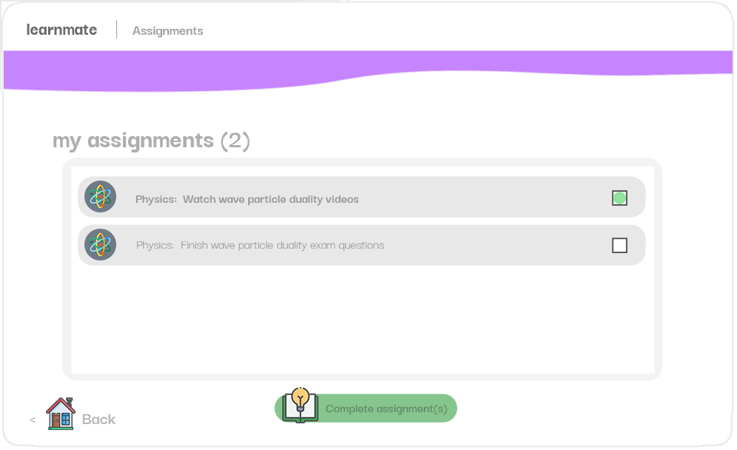

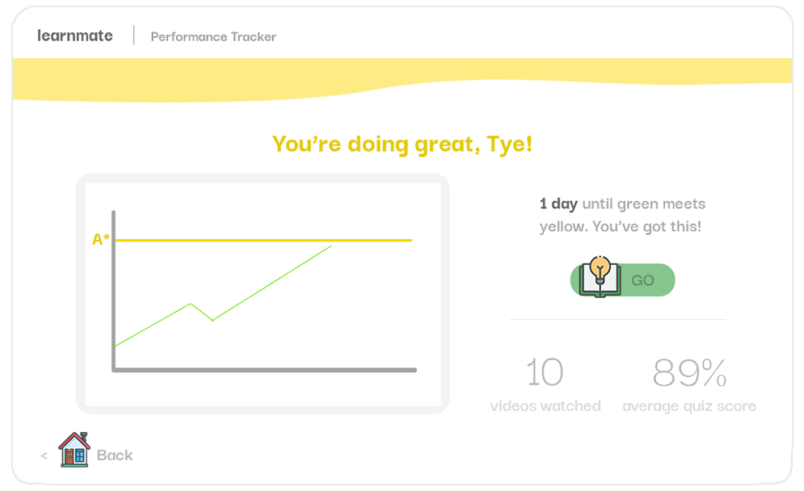

Inefficient code also shares the solution of more development time required to solve it. Many overcomplicated areas of the program can be simplified down with further support.

Maintenance  
My code is mostly commented, allowing other developers debugging and working on the project to have an easier workflow.

Due to my code consisting mostly of functions (since I used decomposition and applied it via modular programming), future support is made easier as these separate functions can be easily modified accordingly, compared to more difficult debugging if the program’s code wasn’t completed in a modular fashion. Having designed my program in separate components, the backend, and the frontend (forms), these can be easily dealt with separately.

Having all the data stored in the backend with the frontend getting information from it provides a central place to debug which will affect what each form displays. Therefore, the forms which I previously mentioned, the performance tracker and the complete assignments form, will be implemented much easier due to designing my program in this fashion.

During future development, for the assignments form, I would add a “set assignments” attribute for each class in a school, which would have a ‘name’ string as well as a ‘complete’ Boolean property. Any future forms which would be developed would be able to easily be created through simple modifications of the backend and controls in the created form referencing these aspects of the backend.

The use of IDs in the backend for each object accommodates for larger volumes of data, as traversing through each object when searching for a criteria will take a short amount of time, since only the ID needs to be referenced. The linear search of every user when logging in would be replaced with a more efficient searching algorithm for larger volumes of data, e.g. a binary search.

# Final code

**Database**

Backend.cs

|  |
| --- |
| using System;  using System.Collections.Generic;  using System.Linq;  using System.Text;  using System.Threading.Tasks;  using System.Windows.Forms;  using System.Diagnostics;  using System.Runtime.InteropServices;  using System.Net.NetworkInformation;  using static LearnMate.backend;  using System.Xml.Linq;  using System.Net;  using static System.Windows.Forms.VisualStyles.VisualStyleElement.StartPanel;  using System.Drawing.Text;  using System.Runtime.CompilerServices;  using System.Drawing;  //using Newtonsoft.Json;  //using Newtonsoft.Json.Linq;  using System.Security.AccessControl;  using System.Diagnostics.Metrics;  using Microsoft.VisualBasic.ApplicationServices;  using static LearnMate.backend.School;  namespace LearnMate  {  public class backend  {  [DllImport("kernel32.dll", EntryPoint = "AllocConsole", SetLastError = true, CharSet = CharSet.Auto, CallingConvention = CallingConvention.StdCall)]  private static extern int AllocConsole();//to open the console window for debugging  public static string errorReason;  public static string diagnosis;  public static string message;  public static bool verified;  public static DateTime currentWeekCommencing; //=get the date of the current week commencing  public static int currentUserID = 0;  public static string currentUserName;  public static string currentUserType;  public static string currentName;  public static string currentSchoolName;  public static int currentSchoolID;  public static List<User> Users = new List<User>(); //load all pre-existing Users into this list.  public static List<School> Schools = new List<School>(); //load all pre-existing Schools into this list.  public static List<Subject> Subjects = new List<Subject>();  //once json is made, remove the createQuestionSets process in backend constructor.  //testing login functionality with a test teacher.  //backend constructor. serialise all pre-existing data from JSON to the corresponding objects.  public backend()  {  ////THE FOLLOWING LOADS ALL JSON CONTENT INTO THE LISTS SHOWN ABOVE UPON FIRST CALL.  AllocConsole();  //THE FOLLOWING IS TEST DATA USED TO TEST THE APPLICATION.  backend.Subject subject = new backend.Subject("Mathematics");  backend.Subject subject2 = new backend.Subject("Physics");  backend.Subject subject3 = new backend.Subject("Computer Science");  Teacher testTeacher = new Teacher("Username", "Password", "Tye");  Student student = new Student("User1", "Pass", "Kevin");  Student student2 = new Student("User2", "Pass", "James");  Student student3 = new Student("User3", "Pass", "Jacob");  Student student4 = new Student("User4", "Password", "Paul");  Student student5 = new Student("User5", "Pass", "Queen");  Student student6 = new Student("User6", "Pass", "Henry");  Student student7 = new Student("User7", "Pass", "Martha");  Student student8 = new Student("User8", "Pass", "Tina");  Student student9 = new Student("User9", "Pass", "Isaac");  School school = new School("TyesSchool", "abc");  school.addClass("TyesFirstClass"); //automatically adds to classesInSchool.  Class tyesClass = school.getClassObjectByClassID(school.getClassIDByClassName("TyesFirstClass")); //an example of declaring a class object. see how to update below.  school.addClass("12F");  Class tyesClass2 = school.getClassObjectByClassID(school.getClassIDByClassName("12F"));  school.addClass("13E");  Class tyesClass3 = school.getClassObjectByClassID(school.getClassIDByClassName("13E"));  school.addStudentToClass(student, school.getClassIDByClassName("TyesFirstClass")); //adding a student to a class OR adding a student as an unassigned member gives the student an assigned school  school.addStudentToClass(student2, school.getClassIDByClassName("TyesFirstClass"));  school.addStudentToClass(student3, school.getClassIDByClassName("TyesFirstClass"));  school.addStudentToClass(student4, school.getClassIDByClassName("TyesFirstClass"));  school.addStudentToClass(student5, school.getClassIDByClassName("TyesFirstClass"));  school.addStudentToClass(student8, school.getClassIDByClassName("12F"));  school.addStudentToClass(student9, school.getClassIDByClassName("13E"));  school.addUnassignedStudent(student6);  school.removeUnassignedStudentByObject(student5);  school.removeUnassignedStudentByObject(student4);  school.removeUnassignedStudentByObject(student3);  school.removeUnassignedStudentByObject(student2);  school.removeUnassignedStudentByObject(student);  school.removeUnassignedStudentByObject(student8);  school.removeUnassignedStudentByObject(student9);  //END OF TEST DATA.  }  public class Subject //a subject object. new subjects can be easily added in the future  {  public string SubjectName; //essential attributes of a subject  public List<Topic> SubjectTopics = new List<Topic>(); //a list of topics of type topic.  public int subjectID; //a unique id  public Subject(string subjectName) //CONSTRUCTOR: depending on the subject created, make the instance have certain subjectTopics.  {  SubjectName = subjectName;  subjectID= Subjects.Count + 1;  if (subjectName == "Mathematics") //if a new subject called "Mathematics" was requested to be instantiated,  {  //CREATE MICROSESSIONS, ADD THEM TO TOPICS, ADD THE TOPICS TO SUBTOPICS, ADD SUBTOPICS TO TOPICS, ADD THE TOPICS TO SUBJECT.  //MICROSESSIONS  microSession mc = new microSession(); //for maths pure - differentiation and integration  mc.name = "Differentiation Basics";  microSession mc2 = new microSession();  mc2.name = "Integration Basics";  microSession mc3 = new microSession(); //for maths mechanics  microSession mc4 = new microSession();  microSession mc5 = new microSession(); //for maths stats  microSession mc6 = new microSession();  //TOPIC QUESTIONS IN EACH MICROSESSION  TopicQuestion tc = new TopicQuestion("Differentiate cos(x)", "-sin(x)");  mc.addTopicQuestion(tc);  TopicQuestion tc2 = new TopicQuestion("What is differentiation?", "Rate of change");  mc.addTopicQuestion(tc2);  mc.videoPath = ""; //differentiation video  TopicQuestion tc3 = new TopicQuestion("What is meant by integration?", "Area under curve");  mc2.addTopicQuestion(tc3);  TopicQuestion tc4 = new TopicQuestion("Integrate sin(x).", "-cos(x)");  mc2.addTopicQuestion(tc4);  mc2.videoPath = ""; //integration video  //MECHANICS  TopicQuestion tc5 = new TopicQuestion("MechanicsQ1", "Answer");  mc3.addTopicQuestion(tc5);  TopicQuestion tc6 = new TopicQuestion("MechanicsQ2", "mathsA4");  mc3.addTopicQuestion(tc6);  mc3.videoPath = "";  TopicQuestion tc7 = new TopicQuestion("MechanicsQ3", "mathsA3");  mc4.addTopicQuestion(tc7);  TopicQuestion tc8 = new TopicQuestion("MechanicsQ4", "mathsA4");  mc4.addTopicQuestion(tc8);  mc4.videoPath = "";  //STATS (ew)  TopicQuestion tc9 = new TopicQuestion("If the test statistic is within the critical region, what do we do to H 0?", "Reject");  mc5.addTopicQuestion(tc9);  TopicQuestion tc10 = new TopicQuestion("StatisticsQ2", "mathsA4");  mc5.addTopicQuestion(tc10);  mc5.videoPath = "";  TopicQuestion tc11 = new TopicQuestion("StatisticsQ3", "mathsA3");  mc6.addTopicQuestion(tc11);  TopicQuestion tc12 = new TopicQuestion("StatisticsQ4", "mathsA4");  mc6.addTopicQuestion(tc12);  mc6.videoPath = "";      //SUBTOPICS  subTopic st = new subTopic(); //maths pure  subTopic st2 = new subTopic(); //maths mechanics  subTopic st3 = new subTopic(); //maths statistics  st.SubTopicName = "Differentiation and Integration";  st.addMicroSession(mc); //add multiple microsessions  st.addMicroSession(mc2);  st2.SubTopicName = "Projectile Motion";  st2.addMicroSession(mc3);  st2.addMicroSession(mc4);  st3.SubTopicName = "Hypothesis Testing";  st3.addMicroSession(mc5);  st3.addMicroSession(mc6);  //TOPICS  Topic topic = new Topic();  Topic topic2 = new Topic();  Topic topic3 = new Topic();  topic.topicID = 1;  topic2.topicID = 2;  topic3.topicID = 3;  topic.TopicName = "Pure";  topic.addSubtopic(st);  topic2.TopicName = "Mechanics";  topic2.addSubtopic(st2);  topic3.TopicName = ("Statistics");  topic3.addSubtopic(st3);  SubjectTopics.Add(topic);  SubjectTopics.Add(topic2);  SubjectTopics.Add(topic3);  } else if (subjectName == "Physics") //ANNOTATIONS APPLY AS ABOVE.  {  //M  microSession mc = new microSession(); //for statics - moments  microSession mc2 = new microSession(); //for statics - scalars and vectors  microSession mc3 = new microSession(); //for further mechanics - circular motion  microSession mc4 = new microSession(); //for further mechanics - simple harmonic motion  microSession mc5 = new microSession(); //for thermal physics - the gas laws  microSession mc6 = new microSession(); //for thermal physics - kinetic theory  TopicQuestion tc = new TopicQuestion("What is the resultant moment for an object in equilibrium?", "Zero.");  mc.addTopicQuestion(tc);  TopicQuestion tc2 = new TopicQuestion("What is a moment?", "Turning effect");  mc.addTopicQuestion(tc2);  mc.videoPath = "";    TopicQuestion tc3 = new TopicQuestion("What is meant by a scalar quantity?", "Such with magnitude only.");  mc2.addTopicQuestion(tc3);  TopicQuestion tc4 = new TopicQuestion("Name the vector quantity of speed.", "Velocity");  mc2.addTopicQuestion(tc4);  mc2.videoPath = "";  TopicQuestion tc5 = new TopicQuestion("Where is acceleration acting for an object in circular motion?", "Center");  mc3.addTopicQuestion(tc5);  TopicQuestion tc6 = new TopicQuestion("What trajectory would an object go if it were released during orbit?", "Line");  mc3.addTopicQuestion(tc6);  mc3.videoPath = "";  TopicQuestion tc7 = new TopicQuestion("State the conditions required for simple harmonic motion.", "Acceleration proportional to displacement.");  mc4.addTopicQuestion(tc7);  TopicQuestion tc8 = new TopicQuestion("Where is acceleration at its maximum?", "Amplitude");  mc4.addTopicQuestion(tc8);  mc4.videoPath = "";  TopicQuestion tc9 = new TopicQuestion("What law does an ideal gas follow?", "Boyle");  mc5.addTopicQuestion(tc9);  TopicQuestion tc10 = new TopicQuestion("GasQ2", "Ans");  mc5.addTopicQuestion(tc10);  mc5.videoPath = "";  TopicQuestion tc11 = new TopicQuestion("State the acronym you're recommended to remember regarding assumptions about the kinetic theory model.", "RAVED");  mc6.addTopicQuestion(tc11);  TopicQuestion tc12 = new TopicQuestion("What does 'E' in the acronym stand for?", "Elastic");  mc6.addTopicQuestion(tc12);  mc6.videoPath = "";  subTopic st = new subTopic();  subTopic st2 = new subTopic();  subTopic st3 = new subTopic();  st.SubTopicName = "Statics";  st.addMicroSession(mc); //add multiple microsessions  st.addMicroSession(mc2);  st2.SubTopicName = "Circular and Simple Harmonic Motion";  st2.addMicroSession(mc3);  st2.addMicroSession(mc4);  st3.SubTopicName = "Gas laws and Kinetic theory";  st3.addMicroSession(mc5);  st3.addMicroSession(mc6);  Topic topic = new Topic();  Topic topic2 = new Topic();  Topic topic3 = new Topic();  Topic topic4 = new Topic();  Topic topic5 = new Topic();  Topic topic6 = new Topic();  topic.TopicName = "Dynamics";  topic.addSubtopic(st);  topic2.TopicName = "Further Mechanics";  topic2.addSubtopic(st2);  topic3.TopicName = ("Thermal Physics");  topic3.addSubtopic(st3);  topic4.TopicName = ("Waves");  topic5.TopicName = ("Electricity");  topic6.TopicName = ("Thermal Physics");  SubjectTopics.Add(topic);  SubjectTopics.Add(topic2);  SubjectTopics.Add(topic3);  }  else if (subjectName == "Computer Science") //ANNOTATIONS APPLY AS ABOVE.  {  microSession mc = new microSession(); //for contemp. processors - vonn neuman and harvard architecture  microSession mc3 = new microSession(); //for Data strucures - data types and boolearn algebra  microSession mc4 = new microSession();  TopicQuestion tc = new TopicQuestion("HarvardQ", "Ans");  mc.addTopicQuestion(tc);  TopicQuestion tc2 = new TopicQuestion("VonnQ", "Ans");  mc.addTopicQuestion(tc2);  mc.videoPath = "";  TopicQuestion tc5 = new TopicQuestion("DataTypesQ", "Ans");  mc3.addTopicQuestion(tc5);  TopicQuestion tc6 = new TopicQuestion("DataTypesQ2", "Ans");  mc3.addTopicQuestion(tc6);  mc3.videoPath = "";  TopicQuestion tc7 = new TopicQuestion("BooleanQ.", "Ans");  mc4.addTopicQuestion(tc7);  TopicQuestion tc8 = new TopicQuestion("BooleanQ2", "Ans");  mc4.addTopicQuestion(tc8);  mc4.videoPath = "";  subTopic st = new subTopic();  subTopic st2 = new subTopic();  st.SubTopicName = "Harvard Architecture";  st.addMicroSession(mc); //add multiple microsessions  st2.SubTopicName = "Data Types and Boolean Algebra";  st2.addMicroSession(mc3);  st2.addMicroSession(mc4);  Topic topic = new Topic();  Topic topic2 = new Topic();  topic.TopicName = "Contemporary Processors";  topic.addSubtopic(st);  topic2.TopicName = "Data Structures";  topic2.addSubtopic(st2);  SubjectTopics.Add(topic);  SubjectTopics.Add(topic2);  }  Subjects.Add(this);  }  public int getTopicIDByName(string topicName) //selectedTopic in learn and practice form will need to have kept track of.  //the selected topic returns the name of the topic, and the topic ID is needed to then learn information about that topic.  {  int index = -1;  for (int i = SubjectTopics.Count - 1; i >= 0; i--)  {  if (SubjectTopics[i].TopicName == topicName)  {  index = i + 1;  }  }  return index;  }  public int getSubTopicIDByName(string subTopicName,int TopicID) //same annotation as above.  {  int index = -1;  for (int i = SubjectTopics[TopicID-1].subTopics.Count - 1; i >= 0; i--)  {  if (SubjectTopics[TopicID - 1].subTopics[i].SubTopicName == subTopicName)  {  index = i + 1;  }  }  return index;  }  }  public class Topic //a new topic  {  public string TopicName; //has essential attributes name, subtopics and an ID  public List<subTopic> subTopics = new List<subTopic>();  public int topicID;  public void addSubtopic(subTopic st) //add a subtopic to a topic  {  subTopics.Add(st);  }  }  public class subTopic //annotated as above.  {  public string SubTopicName;  public int subtopicID;  public List<microSession> microSessions = new List<microSession>();  public void addMicroSession(microSession mc)  {  microSessions.Add(mc);  }  }  public class microSession //annotated as above.  {  public string name;  public string videoPath;  public List<TopicQuestion> TopicQuestions = new List<TopicQuestion>(); //then traverse through questions.  public void addTopicQuestion(TopicQuestion topicQuestion)  {  TopicQuestions.Add(topicQuestion);  }  }  public class TopicQuestion //a topic question  {  public int topicQuestionID; //will have essential attributes  public string Question;  public string Answer;  public TopicQuestion(string q, string a) //a new instance has a question and an answer string  {  Question = q;  Answer = a;  }  }  public class User  {  //stores the attributes about a User object.  public string Username;  public string Name;  public string Password;  public string UserType;  public string note;  public int userID; //usercode acts as the primary key for each user.  public bool banned;  public List<string> SubjectsEnrolledTo = new List<string>();  public List<Event> Events = new List<Event>();    public void addSelectedSubjectsByName(string subjectName)  {  SubjectsEnrolledTo.Add(subjectName);  }    public void addEvent(Event eventObject)  {  Events.Add(eventObject);  }  //creates a new user with user attributes  public User(string _Username, string _Password, string _Name, string _userType) //THIS DOES NOT GET CALLED...  {  //if the user belongs to a school, School.addUser(UserCode, institutionCode)  //else  Username = _Username;  Password = _Password;  Name = _Name;  UserType = _userType;  } //CREATES A NEW USER  public User()  {  //since I don't explicitly invoke a call to the Users constructor when creating a User-derived object, it essentially calls a parameterless function from Users. therefore, this constructor is needed  } //CREATES A NEW USER THATS A MEMBER OF A SCHOOL  }  public class Event  {  public int eventID;  public bool studyEvent;  public string EventName;  public string EventDescription;  public DateTime startTime;  public DateTime endTime;  public DateTime eventDate;  }  public class School //to save, list of schools only.  {  public string InstitutionCode; //primary key  public int schoolID;  public string SchoolName;  public List<Class> classesInSchool = new List<Class>(); //has members can be retrieved by traversing through the classes.  //we want below to be added to 'classesInSchool' asap, to remove the need of having to update everywhere after every modification of an attribute.  public List<Student> unassignedStudents = new List<Student>();  public List<Teacher> unassignedTeachers = new List<Teacher>();  public School(string schName, string insCode)  {  SchoolName = schName;  InstitutionCode = insCode;  schoolID = Schools.Count + 1;  addToSchoolsList();    Console.WriteLine("New school " + schName + " created with institution code " + insCode + ", schoolID " + schoolID + ". Is without teachers, students or classes.");  } //NEW SCHOOL WITHOUT TEACHERS, STUDENTS OR CLASSES  public void replaceInSchoolsList() //any change to a school is copied to the list of schools.  {  Schools[schoolID - 1] = this;  }  public Class getClassObjectByClassID(int classID) //allows the object to have actions eprformed by just an ID  {  return (classesInSchool[classID - 1]);  }  public void removeUnassignedStudentByObject(Student student)  {  for (int i = unassignedStudents.Count - 1; i >= 0; i--)  {  if (unassignedStudents[i] == student)  {  unassignedStudents.RemoveAt(i);  replaceInSchoolsList();  }  }  }  public void addStudentToClass(Student student, int classID)  {  classesInSchool[classID - 1].Students.Add(student);  //then when called, call removefromunassigned, replaceinstudentslist when done.  for (int i = unassignedStudents.Count - 1; i >= 0; i--)  {  if (unassignedStudents[i] == student)  {  unassignedStudents.RemoveAt(i);  replaceInSchoolsList();  }  }  }  public void addClass(string className)  {  //add the class to classesinschool.  Class _class = new Class(className);  _class.classID = classesInSchool.Count + 1; //class is already added. say 3 classes, initiate the second,  classesInSchool.Add(_class);  replaceInSchoolsList();  }  public int getClassIDByClassName(string className)  {  int classID=-1;  for (int i = classesInSchool.Count - 1; i >= 0; i--)  {  if (classesInSchool[i].className == className)  {  classID = i + 1;  }  }  return classID;  }  public string getClassNameByClassID(int classID)  {  string className = classesInSchool[classID - 1].className;  return className;  }  public void addUnassignedStudentByUserID(int userID) //adds a teacher or student object to unassignedMembers ready to be added to their classes.  {  Student student = (Student)Users[userID - 1];  unassignedStudents.Add(student);  replaceInSchoolsList();  }  public void addUnassignedStudent(Student student) //adds a teacher or student object to unassignedMembers ready to be added to their classes.  {  unassignedStudents.Add(student);  replaceInSchoolsList();  }  public void removeUnassignedTeacherByUserID(int userID)  {  Teacher teacher = (Teacher)Users[userID - 1];  unassignedTeachers.Remove(teacher);  replaceInSchoolsList();  }  void addToSchoolsList()  {  Schools.Add(this);  }  public void removeClass(int classID)  {  for (int j = classesInSchool[classID-1].Students.Count - 1; j >= 0; j--) //for every student in that class,  {  classesInSchool[classID-1].Students[j].removeFromSchool(); //run the function that removes them from a school (sets schoolID to -1)  }  classesInSchool.Remove(classesInSchool[classID - 1]); //then remove the class from the list of classes in that school.  replaceInSchoolsList();  //then call setCurrentUser to see how the current user is affected by it.  }  public void removeSchool()  {  for (int i = classesInSchool.Count - 1; i >= 0; i--) //for every class in the school,  {  for (int j = classesInSchool[i].Students.Count - 1; j >= 0; j--) //for every student in each class,  {  classesInSchool[i].Students[j].removeFromSchool(); //run the function that removes a student from a school (sets schoolID to -1) this is all that matters  //then call setCurrentUser.  }  }  Schools.Remove(this); //if a school is removed, all its classes are removed.  //then call setCurrentUser to see how the current user is affected by it.  }  }  public class HomeLearner : User //a home learner derives from a user  {  public HomeLearner(string _Username, string _Password, string _Name)  {  Username = _Username; //set essential attributes upon instantiation  Password = _Password;  Name = _Name;  UserType = "Home Learner";  userID = Users.Count+1;  addToUsersList();  Console.WriteLine("New Home Learner " + Name + " (" + Username + ") " + "created with userID "+userID);  //let the debugger know what's just happened in backend.  }  public void replaceInUsersList() //for data consistency  {  Users[userID - 1] = this;  }  public void addToUsersList() //add to the users list  {  Users.Add(this);  }  }  public class MemberOfSchool : User //memeber of school derives from user  {  public int schoolID;  }  //stores the attributes about a Teacher object.  public class Teacher : MemberOfSchool //a teacher derives from a member of school  {  public List<int> TeachesClasses = new List<int>(); //a teacher teaches classes  public Teacher(string _Username, string _Password, string _Name)  {  Username = _Username; //a teacher has essential attributes  Password = _Password;  Name = _Name;  UserType = "Teacher";  //add this teacher to the list of teachers  userID = Users.Count+1;  addToUsersList();  Console.WriteLine("New Teacher (and User) " + Name + " (" + Username + ") " + ", and userID " + userID + ", but without a schoolID.");  } //NEW TEACHER WITHOUT A SCHOOLID  public void replaceInUsersList() //update functions need to be used as school class uses students, teachers and users lists.  {  Users[userID - 1] = this;  }  public void addToUsersList() //add the teacher to the list of users  {  Users.Add(this);  }  }  public class Student : MemberOfSchool //a student derives from amember of a school.  {  public List<practiceModule>AssignmentModules = new List<practiceModule>();  //Here is the option to add a Student without the classes they belong to.  public Student(string _Username, string _Password, string _Name)  {  Username = _Username; //a student has essential attributes  Password = _Password;  Name = _Name;  UserType = "Student";  userID = Users.Count + 1;  addToUsersList();    Console.WriteLine("New Student (and User) " + Name + " (" + Username + ") " + " with studentID "+ ", and userID " + userID + " is created, but is without a schoolID.");  } //NEW STUDENT WITHOUT A SCHOOLID OR CLASSES BELONGING TO  public void removeFromSchool() //when kicked from a class  {  schoolID = -1;  replaceInUsersList();  }  public void replaceInUsersList() //maintain data consistency  {  Users[userID - 1] = this;  }  public void addToUsersList() //add the user to the list of users  {  Users.Add(this);  }  }  public class Class //a class within a school  {  public string className; //has essential attributes  public int classID; //only set by the school object.  public List<Student> Students = new List<Student>();  public Teacher mainTeacher;  public Teacher assistantTeacher;  public Class(string _className)  {  className = _className;  //other properties will be modified by the school's methods.  }  }  public class practiceModule //assignments consist of practice modules  {  public string topicName;  public practiceModule()  {  //not complete within this project's time scale.  }  }  public int getSubjectIDByName(string subjectName) //gets the subject information the user clicked in the form. (elements send off the subject name and we need an id for this to learn the respective content)  {  int index = -1;  for (int i = Subjects.Count - 1; i >= 0; i--)  {  if (Subjects[i].SubjectName == subjectName)  {  index = i + 1;  }  }  return index;  }  public int getUserIDWithUsername(string username) //login function needs to know what user is being referenced by the user which was typed in.  {  int index = -1;  for (int i = Users.Count - 1; i >= 0; i--) //LINEAR SEARCH: for every user,  {  if (Users[i].Username == username) //if their username is as entered, return the ID as that position +1 as ID is a count  {  index = i + 1;  return index;  }  }  return index;  }  public string getUsernameWithUserID(int userID) //sepf explanatory.  {  return (Users[userID - 1].Username); //returns the username of that user  }  public string getCurrentUserName() //the username is passed here from either the login form's text box OR the signup form's text box. You'll need this for  {  return currentUserName;  Console.WriteLine("getUserName was called and returned " + currentUserName);  }  public string getCurrentUserName() //the username is passed here from either the login form's text box OR the signup form's text box. You'll need this for  {  return currentUserName;  Console.WriteLine("getUserName was called and returned " + currentUserName);  }  public string getFirstName() //the enrol page and the panel will use this to display the user information  {  string[] separatedNames = currentName.Split(" ");  return (separatedNames[0]);  Console.WriteLine("getName was called and returned " + separatedNames[0]);  }  public string getUserType() //the enrol page and the panel will use this to display the user information  {  return currentUserType;  Console.WriteLine("getUserType was called and returned " + currentUserType);  }  public string checkUserType(int userID) //the enrol page and the panel will use this to display the user information  {  return(Users[userID - 1].UserType);  }  public bool login(string username, string password)  {  Console.WriteLine("\nLogin was called..."); //debuggers will be aware of this  bool value = false;  //while the program starts, all user objects are copied to the Users list. this is a temporary measure since obviously it puts data at risk.  for (int i = Users.Count - 1; i >= 0; i--) //for every user,  {  if (Users[i].Username == username) //if the username matches that of entered,  {  if (Users[i].Password == password) //if the username's password matches that of entered in the UI  {  Console.WriteLine("User '"+username +"' matches with their stored password '" + Users[i].Password + "', login function returned true => Successful login.");  value = true; //so that it returns true to the sender, allowing a login  }  else  {  Console.WriteLine("User '"+username +"' exists but '"+password+ "' doesn't match with their stored password: '" + Users[i].Password +"'. => Unsuccessful login.");  }  }    }  if (value == false)  {  Console.WriteLine("User '"+username+ "' doesn't exist in Users list. => Unsuccessful login.\n");  }  return value;  }  public void logout()  {  }  public void setCurrentUserWithSchool(int userID, string insCode) //call if there are schools and if they entered an ins code.  {  Console.WriteLine("\nsetCurrentUser was called in backend...");  currentUserID = Users[userID-1].userID; //sets the current user infomration. if someone logs out then logs back in, the current user information is overwritten.  currentUserName = Users[userID-1].Username;  currentUserType = Users[userID-1].UserType;  currentName = Users[userID-1].Name;  currentSchoolName = Schools[getSchoolID(insCode) - 1].SchoolName;  currentSchoolID = Schools[getSchoolID(insCode) - 1].schoolID;  //TRACKING FOR DEBUGGERS  Console.WriteLine("currentUserName set to " + currentUserName + ", currentUserID set to " + currentUserID + ", currentName set to " + currentName + ", \ncurrentUserType set to " + currentUserType+", currentSchoolID set to"+currentSchoolID+", currentSchoolName set to "+currentSchoolName);  }  public void setCurrentUser(int userID) //SAME AS ABOVE BUT FOR USERS WITHOUT A SCHOOL  {  Console.WriteLine("\nsetCurrentUser was called in backend...");  currentUserID = Users[userID - 1].userID;  currentUserName = Users[userID - 1].Username;  currentUserType = Users[userID - 1].UserType;  currentName = Users[userID - 1].Name;  currentSchoolName = "NONE";  currentSchoolID = -1;  Console.WriteLine("currentUserName set to " + currentUserName + ", currentUserID set to " + currentUserID + ", currentName set to " + currentName + ", currentUserType set to " + currentUserType);  }  public bool checkAnySchoolExists()  {  bool value = false;  if (Schools.Count >= 1) //checks if a school exists.  {  value = true;  }  return value;  }  public bool checkASchoolexists(string insCode) //checks if a specified school exists by comparing institution codes via linear search  {  bool exists = false;  for (int i = Schools.Count - 1; i >= 0; i--)  {  if (Schools[i].InstitutionCode == insCode)  {  exists = true;  }  }  return exists;  }  public string getCurrentUserSchool() //the panel will use this to display the user information  {  if (currentSchoolID == -1)  {  return "NO SCHOOL";  }  return currentSchoolName;  }  public int getSchoolID(string institutionCode) //gets the school ID of the current user. used in manage classes and moving students, as well as UI in panel  {  int index = -1;  for (int i = Schools.Count - 1; i >= 0; i--)  {  if (Schools[i].InstitutionCode == institutionCode)  {  index = i + 1;  return index;  }  }  return index;  }  }  } |

**Forms**

frmLogin.cs

|  |
| --- |
| using System;  using System.Collections.Generic;  using System.ComponentModel;  using System.Data;  using System.Drawing;  using System.Linq;  using System.Text;  using System.Threading.Tasks;  using System.Windows.Forms;  using System.Runtime.InteropServices;  using System.Diagnostics;  using Newtonsoft.Json;  using static LearnMate.backend;  namespace LearnMate  {  public partial class frmLoginScreen : Form  {  backend Backend = new backend(); //only instantiation of the database.  //Foreign code for the round borders, no borders and form drag.  public const int WM_NCLBUTTONDOWN = 0xA1;  public const int HT_CAPTION = 0x2;  public string enteredUsername;  public string enteredPassword;  [System.Runtime.InteropServices.DllImport("user32.dll")]  public static extern int SendMessage(IntPtr hWnd, int Msg, int wParam, int lParam);  [System.Runtime.InteropServices.DllImport("user32.dll")]  public static extern bool ReleaseCapture();  [DllImport("Gdi32.dll", EntryPoint = "CreateRoundRectRgn")]  private static extern IntPtr CreateRoundRectRgn  (  int nLeftRect, // x-coordinate of upper-left corner  int nTopRect, // y-coordinate of upper-left corner  int nRightRect, // x-coordinate of lower-right corner  int nBottomRect, // y-coordinate of lower-right corner  int nWidthEllipse, // width of ellipse  int nHeightEllipse // height of ellipse  );  //end foreign code.  public frmLoginScreen()  {  InitializeComponent();  //Sets the round borders  this.FormBorderStyle = FormBorderStyle.None;  Region = System.Drawing.Region.FromHrgn(CreateRoundRectRgn(0, 0, Width, Height, 40, 40));  //setting stronger accessibility colours  txtUsername.BackColor = Color.FromArgb(192, 220, 204);  txtUsername.ForeColor = Color.FromArgb(48, 48, 48);  txtPassword.BackColor = Color.FromArgb(192, 220, 204);  txtPassword.ForeColor = Color.FromArgb(48, 48, 48);  //The following generates a random image for the background to show different slides.  //centres the image to the centre of the screen.  Random r = new();  int rInt = r.Next(0, 3);  if (rInt == 0)  {  this.BackgroundImage = Image.FromFile("Login31.jpg");  }  if (rInt == 1)  {  this.BackgroundImage = Image.FromFile("Login11.jpg");  }  else if (rInt == 2)  {  this.BackgroundImage = Image.FromFile("Login21.jpg");  }  this.CenterToScreen();  }  public void btnBegin_Click(object sender, EventArgs e)  {  enteredUsername = txtUsername.Text;  enteredPassword = txtPassword.Text;  //backend.Login(txtUsername.Text, txtPassword.Text);  //if returned true, load the correct form(s)  //load cmd to see comms between backend and form  bool LoginResult;  LoginResult = Backend.login(enteredUsername,enteredPassword); //login result is stored  if (LoginResult) //if login returns true (the login was successful)  {  int enteredUserID=Backend.getUserIDWithUsername(enteredUsername);  string enteredInstitutionCode=""; //so that the current user can be set with an institutioncode if they're a member of the school.  //(elements in the container form will require current user information)  bool success=false; //success means if they have been found to be part of a school    if (Backend.checkUserType(enteredUserID)=="Student" || Backend.checkUserType(enteredUserID)=="Teacher") //if they're a student or a teacher  {  //for every school,  for (int i = Schools.Count - 1; i >= 0; i--)  {  //for every class  for (int j = Schools[i].classesInSchool.Count - 1; j >= 0; j--)  {  //for every student  for (int l = Schools[i].classesInSchool[j].Students.Count - 1; l >= 0; l--)  {  if (Schools[i].classesInSchool[j].Students[l].userID == enteredUserID)  {  enteredInstitutionCode = Schools[i].InstitutionCode;  success = true;  } //if the student is found to be present in that class, success is true.  }  if (Schools[i].classesInSchool[j].mainTeacher != null) //same applies for teachers and assitant teacher if the user logging in is of that user type.  {  if (Schools[i].classesInSchool[j].mainTeacher.userID == enteredUserID)  {  enteredInstitutionCode = Schools[i].InstitutionCode;  success = true;  }  }  if (Schools[i].classesInSchool[j].assistantTeacher != null)  {  if (Schools[i].classesInSchool[j].assistantTeacher.userID == enteredUserID)  {  enteredInstitutionCode = Schools[i].InstitutionCode;  success = true;  }  }  }  if (Backend.checkUserType(enteredUserID) == "Student") //if they're a student, make sure to check the unassigned student list too  {  for (int k = Schools[i].unassignedStudents.Count - 1; k >= 0; k--)  {  if (Schools[i].unassignedStudents[k].userID == enteredUserID)  {  enteredInstitutionCode = Schools[i].InstitutionCode;  success = true;  }  }  }  else  {  for (int k = Schools[i].unassignedTeachers.Count - 1; k >= 0; k--) //same goes for if they're poitentially an unassigned teacher.  {  if (Schools[i].unassignedTeachers[k].userID == enteredUserID)  {  enteredInstitutionCode = Schools[i].InstitutionCode;  success = true;  }  }  }  }  if (success) //if they were found to be a part of a school,  {  Backend.setCurrentUserWithSchool(enteredUserID, enteredInstitutionCode); //tell the backend to set the current user's school information as required.  //This is so that elements such as "my school" in the panel show their current school.  }  else  {  Backend.setCurrentUser(enteredUserID);  }  }  else  {  Backend.setCurrentUser(enteredUserID);  }  //create a new instance of the container  frmContainer container = new frmContainer(this,Backend);  container.Location = this.Location;  container.Show();  container.refreshAllElements();  this.Hide();  }  else  {  MessageBox.Show("Incorrect login.");  }  }  private void LoginScreen_MouseDown(object sender, MouseEventArgs e)  {  if (e.Button == MouseButtons.Left) //allows for dragging of form by clicking and holding anywhere on the login form.  {  ReleaseCapture();  SendMessage(Handle, WM_NCLBUTTONDOWN, HT_CAPTION, 0);  }  }  private void lblSignUp_Click(object sender, EventArgs e)  {  frmContainer container = new frmContainer(this,Backend); //create a new instance of the container, signupform and set their positons relative to the current form.  subFrmSignUp SignUpForm = new subFrmSignUp(this,container,Backend);  SignUpForm.StartPosition = FormStartPosition.CenterScreen;  SignUpForm.Show();  }  private void btnBegin_MouseEnter(object sender, EventArgs e)  {  Cursor = Cursors.Hand; //change the cursor depending on whatr contorl it goes into or leaves. same with below  }  private void btnBegin_MouseLeave(object sender, EventArgs e)  {  Cursor = Cursors.Default;  }  private void lblSignUp_MouseEnter(object sender, EventArgs e)  {  Cursor = Cursors.Hand;  }  private void lblSignUp_MouseLeave(object sender, EventArgs e)  {  Cursor = Cursors.Default;  }  private void btnChangePassword_Click(object sender, EventArgs e)  {  }  }  } |

frmTimeOrganiser.cs

|  |
| --- |
| using System;  using System.Collections.Generic;  using System.ComponentModel;  using System.Data;  using System.Drawing;  using System.Linq;  using System.Text;  using System.Threading.Tasks;  using System.Windows.Forms;  namespace LearnMate  {  public partial class frmTimeOrganiser : Form  {  backend backendREF; //reference to backend  backend.User currentUser = backend.Users[backend.currentUserID - 1]; //reference to the current user object  public DateTime dt = new DateTime();  DateTime now = DateTime.Now;  DateTime mondayDay; //day variables  DateTime tuesdayDay;  DateTime wednesdayDay;  DateTime thursdayDay;  DateTime fridayDay;  DateTime maxDay;  Button selectedEventButton; //used in event handler for event clicking  int selectedEventID;  public frmTimeOrganiser(backend _backend)  {  InitializeComponent();  //divide the panels into 18 Y pixels per hour meaning each half hour is 9Y pixels.  //retrieve current week info  //fill current week info  backendREF = _backend;  DateTime currentStartDate = searchlastmonday((int)DateTime.Now.DayOfWeek); //current start day of the week is the last monday.  mondayDay = currentStartDate; //fill days accordingly from last monday  tuesdayDay = currentStartDate.AddDays(1);  wednesdayDay = currentStartDate.AddDays(2);  thursdayDay = currentStartDate.AddDays(3);  fridayDay = currentStartDate.AddDays(4);  maxDay = currentStartDate.AddDays(4);  lblMondayDate.Text = mondayDay.Day.ToString(); //add these days to the labels  lblTuesdayDate.Text = tuesdayDay.Day.ToString();  lblWednesdayDate.Text = wednesdayDay.Day.ToString();  lblThursdayDate.Text = thursdayDay.Day.ToString();  lblFridayDate.Text = fridayDay.Day.ToString();  txtNote.Text=backend.Users[currentUser.userID - 1].note; //fill the user's note in  refreshEvents(); //refresh the elements to show this change.  }  public static DateTime searchlastmonday(int tosubstract)  {  if ((System.DateTime.Today.AddDays(-tosubstract)).DayOfWeek != System.DayOfWeek.Monday)  {  searchlastmonday(tosubstract -= 1);  }  return System.DateTime.Today.AddDays(-tosubstract);  }  public void offsetDays(int offset) //for viewing forwards or backwards a week  {  mondayDay = mondayDay.AddDays(offset);  tuesdayDay = tuesdayDay.AddDays(offset);  wednesdayDay = wednesdayDay.AddDays(offset);  thursdayDay=thursdayDay.AddDays(offset);  fridayDay = fridayDay.AddDays(offset);  }  public void fillDaysIntoLabels() //does exactly that  {  lblMondayDate.Text = mondayDay.Day.ToString();  lblTuesdayDate.Text = tuesdayDay.Day.ToString();  lblWednesdayDate.Text = wednesdayDay.Day.ToString();  lblThursdayDate.Text = thursdayDay.Day.ToString();  lblFridayDate.Text = fridayDay.Day.ToString();  }  public void refreshEvents()  {  clearPanels();  int durationHeight; //represents the height of an event box  TimeSpan t;  for (int i= currentUser.Events.Count - 1; i >= 0; i--) //for each of the current user's events  {  if (currentUser.Events[i].eventDate<=fridayDay && currentUser.Events[i].eventDate >= mondayDay) //if we're inside the current viewing range,  {  //create a new button  Button btn = new Button();  t = currentUser.Events[i].endTime - currentUser.Events[i].startTime; //the timespan is the end time - start time. gives a duration. in hours and minutes.  Point startPoint = new Point(0, ((currentUser.Events[i].startTime.Hour * 16) - 96) + (int)(currentUser.Events[i].startTime.Minute * 0.27)); //how many hours * 16, how many minutes * 0.27  durationHeight = (int)(t.TotalMinutes * 0.27); //split panel into 18: 16 Y pixels each hour.  btn.Size = new Size(pnlFriday.Width, durationHeight); //they're all the same width  btn.Text = currentUser.Events[i].EventName;  btn.Name = Convert.ToString(i+1); //the event ID  btn.MouseClick += btnEvent_MouseClick; //creates an event handler for that object  btn.BackColor = Color.FromArgb(221, 174, 123);  btn.Font = new Font("Darker Grotesque", 15, FontStyle.Regular); //style the event box  //add the box to its corresponding day panel  if (currentUser.Events[i].eventDate == mondayDay)  {  pnlMonday.Controls.Add(btn);  }  else if (currentUser.Events[i].eventDate == tuesdayDay)  {  pnlTuesday.Controls.Add(btn);  }  else if (currentUser.Events[i].eventDate == wednesdayDay)  {  pnlWednesday.Controls.Add(btn);  }  else if (currentUser.Events[i].eventDate == thursdayDay)  {  pnlThursday.Controls.Add(btn);  }  else if (currentUser.Events[i].eventDate == fridayDay)  {  pnlFriday.Controls.Add(btn);  }  btn.Location = startPoint;  }  }  }  private void btnEvent_MouseClick(object sender, MouseEventArgs e) //for when a user selects an event  {  btnRemoveEvent.Enabled = true;  btnView.Enabled = true;  selectedEventButton = (Button)sender; //cast the sender as a button as the event name is the event ID  selectedEventID = Convert.ToInt16(selectedEventButton.Name);    }  public void clearPanels()  {  pnlFriday.Controls.Clear();  pnlMonday.Controls.Clear();  pnlThursday.Controls.Clear();  pnlTuesday.Controls.Clear();  pnlWednesday.Controls.Clear();  }  private void btnAddEvent_Click(object sender, EventArgs e)  {  subFrmAddEvent add = new subFrmAddEvent(this);  add.Location = this.Location;  add.Show();  }  private void btnNextWeek_Click(object sender, EventArgs e)  {  offsetDays(7); //offsets "mondayDay" etc... by 7 days  fillDaysIntoLabels(); //fills the new day labels for that week  refreshEvents(); //refreshes the events for that week  }  private void btnPrevWeek_Click(object sender, EventArgs e)  {  offsetDays(-7);  fillDaysIntoLabels();  refreshEvents();  }  private void btnRemoveEvent_Click(object sender, EventArgs e)  {  //error because i looked at the name of the remove button not the selected event  //find the name of the event,  //the user ID of the current user -> the event ID  refreshEvents();  }  private void txtNote_TextChanged(object sender, EventArgs e)  {  backend.Users[currentUser.userID - 1].note = txtNote.Text; //saves the note typed in  }  private void btnView_Click(object sender, EventArgs e)  {  MessageBox.Show(backend.Users[currentUser.userID - 1].Events[selectedEventID-1].EventDescription); //shows the event description of the selected event  }  }  } |

frmManageClasses.cs

|  |
| --- |
| using System;  using System.Collections.Generic;  using System.ComponentModel;  using System.Data;  using System.Drawing;  using System.Drawing.Text;  using System.Linq;  using System.Security.Cryptography.Pkcs;  using System.Text;  using System.Threading.Tasks;  using System.Windows.Forms;  using static System.Net.Mime.MediaTypeNames;  using Image = System.Drawing.Image;  namespace LearnMate  {  public partial class frmManageClasses : Form  {  //create references and state variables to be used  public backend backendREF;  public int selectedClassID;  public int selectedUserID;  public List<Button>ClassButtonlist=new List<Button>();  public List<Button> StudentButtonlist = new List<Button>();  public Point newLocation = new Point(0, 0);  public frmManageClasses(backend backend)  {  InitializeComponent();  backendREF = backend;  pnlClass.AutoScroll = true; //create scrollbar for the class/student panel  }  public void fillClassButtons()  {  pnlClass.Controls.Clear();  newLocation = new Point(0, 0); //a button will start appearing from the top of the panel  for (int i = backend.Schools[backend.currentSchoolID - 1].classesInSchool.Count - 1; i >= 0; i--) //for every class in the school, add the class button  {  addClassButton(backend.Schools[backend.currentSchoolID - 1].classesInSchool[i].className, backend.Schools[backend.currentSchoolID - 1].classesInSchool[i].classID);  }  }  public void fillStudentButtons()  {  pnlClass.Controls.Clear();  newLocation = new Point(0, 0);  for (int i = backend.Schools[backend.currentSchoolID - 1].classesInSchool[selectedClassID - 1].Students.Count - 1; i >= 0; i--)  {  addStudentButton(backend.Schools[backend.currentSchoolID - 1].classesInSchool[selectedClassID - 1].Students[i].Name, backend.Schools[backend.currentSchoolID - 1].classesInSchool[selectedClassID - 1].Students[i].Username); //resize according to amount.  }  }  private void addClassButton(string ClassName, int classID) //add list of classes as buttons  {  Button btnClass = new Button(); //make a new button  btnClass.BackColor = Color.White; //set attributes  btnClass.Height = 50;  btnClass.Width = pnlClass.Width;  btnClass.Location = newLocation;  newLocation.Offset(0, 5+btnClass.Height);  btnClass.MouseClick += BtnClass_MouseClick;  btnClass.ForeColor = Color.SteelBlue;  btnClass.Font = new Font("Century Gothic", 8, FontStyle.Bold);  btnClass.Text = ClassName;  btnClass.Name = Convert.ToString(classID);  pnlClass.Controls.Add(btnClass); //add the control  ClassButtonlist.Add(btnClass); //add the control to the list to keep track of each button  }  private void addStudentButton(string FirstName,string username) //add list of classes as buttons  {  //int i is the number of classes the teacher is responsible for. example, 4  Button btnStudent = new Button();  btnStudent.BackColor = Color.White;  btnStudent.Height = 125;  btnStudent.Width = 100;  if (newLocation.X > pnlClass.Width-100)  {  newLocation.Offset(-newLocation.X, 125 + 10);  }  btnStudent.Location = newLocation;  newLocation.Offset(100+10, 0);  btnStudent.MouseClick += BtnStudent_MouseClick;  btnStudent.ForeColor = Color.SteelBlue;  btnStudent.Font = new Font("Century Gothic", 8, FontStyle.Bold);  btnStudent.Text = FirstName;  btnStudent.Name = username;  PictureBox pic = new PictureBox();  pic.Location = new Point(10, 10);  pic.Width = 100-20;  pic.Height = 100-20; //height must be greater than or equal to the width of the button.  pic.BackgroundImageLayout = ImageLayout.Zoom;  pic.BackgroundImage = Image.FromFile("student.png");  //pic.MouseEnter  btnStudent.Controls.Add(pic);  btnStudent.TextAlign = ContentAlignment.BottomCenter;    pnlClass.Controls.Add(btnStudent);  StudentButtonlist.Add(btnStudent);  }  private void BtnStudent_MouseClick(object sender, MouseEventArgs e)  {  Button test = (Button)sender; //event handler for student button, getting their user ID with the name of the user.  selectedUserID = backendREF.getUserIDWithUsername(test.Name);  enableStudentActions();  lblClassName.Text = test.Text;  }  private void BtnClass_MouseClick(object sender, MouseEventArgs e)  {  Button test = (Button)sender;  selectedClassID = Convert.ToInt32(test.Name); //find class ID by username  //backendREF.get  enableClassActionButtons();  lblClassName.Text = test.Text;  }  private void disableClassActionButtons()  {  btnRemoveClass.Enabled = false;  btnEditStudents.Enabled = false;  }  private void enableStudentActions()  {  //certain sets of buttons will be available depending on the active view. e.g. they have the option to modify students in classes if they're within the class view.  btnEditStudents.Enabled = true;  btnMoveStudent.Enabled = true;  btnRemoveStudent.Enabled = true;  btnBan.Visible = true;  btnKick.Visible = true;  }  private void disableStudentActions()  {  //same applies as above, and for all below methods.  btnEditStudents.Enabled = false;  btnMoveStudent.Enabled = false;  btnRemoveStudent.Enabled = false;  btnBan.Visible = false;  btnKick.Visible = false;  }  private void enableClassActionButtons()  {  btnRemoveClass.Enabled = true;  btnEditStudents.Enabled = true;  }  private void disableAllActions()  {  disableClassActionButtons();  disableStudentActions();  }  private void showStudentActionButtons()  {  btnAddStudent.Visible = true;  btnRemoveStudent.Visible = true;  btnMoveStudent.Visible = true;  btnBan.Visible = true;  }  private void hideStudentActionButtons()  {  btnAddStudent.Visible = false;  btnRemoveStudent.Visible = false;  btnMoveStudent.Visible = false;  btnBan.Visible = false;  }  private void hideClassActionButtons()  {  btnEditStudents.Visible = false;  btnRemoveClass.Visible = false;  btnAddClass.Visible = false;  }  private void showClassActionButtons()  {  btnEditStudents.Visible = true;  btnRemoveClass.Visible = true;  btnAddClass.Visible = true;  }  private void frmManageClasses_Shown(object sender, EventArgs e)  {  fillClassButtons(); //on first view, the classes will be displayed  disableAllActions();  btnBack.Visible = false;  }  private void btnEditStudents_Click(object sender, EventArgs e)  {  lblCurrentView.Text = "students in "+lblClassName.Text;  pnlClass.Controls.Clear();  showStudentActionButtons();  hideClassActionButtons();  disableStudentActions();  ClassButtonlist.Clear();  lblClassName.Text = "select a student";  fillStudentButtons();    btnBack.Visible = true;  }  private void btnBack_Click(object sender, EventArgs e)  {  btnBack.Visible = false;  lblCurrentView.Text = "classes in your school";  pnlClass.Controls.Clear();  StudentButtonlist.Clear();  fillClassButtons();  hideStudentActionButtons();  showClassActionButtons();  disableClassActionButtons();  lblClassName.Text = "select a class";  }  private void btnAddStudent_Click(object sender, EventArgs e)  {  subFrmAddStudentToClass addStudent = new subFrmAddStudentToClass(backendREF,selectedClassID,this); //add student form is instantiated  addStudent.Location = this.Location;  addStudent.Show();  }  private void btnRemoveStudent_Click(object sender, EventArgs e)  {  backend.User user = backend.Users[selectedUserID - 1];  backend.Student student = (backend.Student)user; //cast the user as a teacher  backend.Schools[backend.currentSchoolID - 1].classesInSchool[selectedClassID - 1].Students.Remove(student);  backend.Schools[backend.currentSchoolID - 1].addUnassignedStudentByUserID(selectedUserID);  backend.Schools[backend.currentSchoolID - 1].replaceInSchoolsList(); //maintain data consistency  fillStudentButtons(); //refresh student buttons showing the change.  }  private void btnKick_Click(object sender, EventArgs e)  {  //removes a user from the school, requiring them to re-enroll  backend.Student student = (backend.Student)backend.Users[selectedUserID - 1];  for (int i = backend.Schools[backend.currentSchoolID - 1].classesInSchool.Count - 1; i >= 0; i--) //searches through every class and removes the student if present  {  if (backend.Schools[backend.currentSchoolID - 1].classesInSchool[i].Students.Contains(student))  {  backend.Schools[backend.currentSchoolID - 1].classesInSchool[i].Students.Remove(student);  }  }  backend.Schools[backend.currentSchoolID - 1].replaceInSchoolsList();  fillStudentButtons();  }  private void btnBan_Click(object sender,EventArgs e)  {  backend.Users[selectedUserID - 1].banned = true;  //cast as student to remove them from their school  backend.Student student = (backend.Student)backend.Users[selectedUserID - 1];  backend.School currentSchool = backend.Schools[backend.currentSchoolID - 1];  for (int i = currentSchool.classesInSchool.Count - 1; i >= 0; i--) //search through every class, if they're detected then remove them.  {  if (currentSchool.classesInSchool[i].Students.Contains(student))  {  currentSchool.classesInSchool[i].Students.Remove(student);  }  }  backend.Schools[backend.currentSchoolID - 1].replaceInSchoolsList();  fillStudentButtons();  }  private void btnAddClass_Click(object sender, EventArgs e)  {  subFrmCreateClass createClass = new subFrmCreateClass(backendREF, this); //new instance of create class form  createClass.Location = this.Location;  createClass.Show();  }  private void btnMoveStudent_Click(object sender, EventArgs e)  {  frmMoveStudentClass addStudent = new frmMoveStudentClass(this,backendREF, selectedUserID,selectedClassID); //new instance of the add a student form  addStudent.Location = this.Location;  addStudent.Show();  }  }  } |

frmHomepage.cs

|  |
| --- |
| using System;  using System.Collections.Generic;  using System.ComponentModel;  using System.Data;  using System.Drawing;  using System.Drawing.Text;  using System.Linq;  using System.Text;  using System.Threading.Tasks;  using System.Windows.Forms;  namespace LearnMate  {  public partial class frmHomepage : Form  {  public Point point = new Point(0, 0);  List<PictureBox> buttonList = new List<PictureBox>();  public frmContainer containerREF;  public backend backendREF;  public frmHomepage(frmContainer container, backend backend)  {  InitializeComponent();  //initial scrollbar and colour values, and references  lblCurrentView.ForeColor = Color.FromArgb(48, 156, 77);  pnlActions.AutoScroll = true;  pnlActions.AutoScrollPosition = new Point(0, pnlActions.Height+100);  containerREF = container;  backendREF = backend;  refreshButtons();  }  //TO ADD A BUTTON TO PNLACTIONS, USE addButton(Colour, Text).  private void addbtn(string imageName) //takes in an imageName  {  PictureBox ptc = new PictureBox(); //create a new pictureBox for each form button  ptc.Location = point; //set the attributes of a form button  ptc.Width = 284;  ptc.Height = ptc.Width;  ptc.BackgroundImage = Image.FromFile(imageName);  ptc.MouseClick += Ptc_MouseClick; //create event handler  ptc.BackColor = Color.White;  ptc.BackgroundImageLayout = ImageLayout.Zoom;  ptc.Name = imageName;  point.Offset(294, 0); //offset so the buttons don't appear on top of each other.  pnlActions.Controls.Add(ptc);  buttonList.Add(ptc); //add the button to the panel.  }  private void Ptc_MouseClick(object? sender, MouseEventArgs e)  {  PictureBox test = (PictureBox)sender;  if (test.Name=="btnOrganiseTime.png") //load the corresponding form depending on the name of the button  {  containerREF.loadTimeOrganiser();  }  else if (test.Name=="btnManageClasses.png")  {  containerREF.loadManageClasses();  }  else if (test.Name == "btnLearnAndPractice.png")  {  containerREF.loadLearnAndPractice();  }  }  public void refreshButtons()  {  addbtn("btnOrganiseTime.png"); //all users have a time organiser.  if (backendREF.getUserType() == "Teacher")  {  addbtn("btnManageClasses.png"); //if they're a teacher, they can manage their classes  }  else if (backendREF.getUserType() == "Student") //if they're a student, they can do the followigna ctions  {  addbtn("btnLearnAndPractice.png");  addbtn("btnCompleteAssignments.png");  addbtn("btnPerformance.png");  //addbtn("Assignments");  }  else if (backendREF.getUserType() == "Home Learner")  {  addbtn("btnLearnAndPractice.png");  }  } //refresh controls  //find out how to run functions in container based on the action buttons clicked in the homepage form  }  } |

frmLearnAndPractice.cs

|  |
| --- |
| using Microsoft.VisualBasic.Devices;  using System;  using System.Collections.Generic;  using System.ComponentModel;  using System.Data;  using System.Drawing;  using System.Linq;  using System.Runtime.InteropServices;  using System.Text;  using System.Threading.Tasks;  using System.Windows.Forms;  using static System.Net.Mime.MediaTypeNames;  using Image = System.Drawing.Image;  namespace LearnMate  {  public partial class frmLearnAndPractice : Form  {  //references and variables  frmContainer containerREF;  backend backendREF;  public Point point = new Point(0, 0);  List<PictureBox> topicList = new List<PictureBox>();  public List<Button> subjectBoxButtons = new List<Button>();  public string selectedSubject;  public int selectedSubjectID;  public string selectedTopic;  public int selectedTopicID;  public string selectedSubTopic;  public int selectedSubTopicID;  public Point subjectBoxLocation = new Point(10, 10);  public List<int> chosenSubTopicIDs = new List<int>();  public frmLearnAndPractice(frmContainer container, backend backend)  {  InitializeComponent();  containerREF = container;  backendREF = backend;  fillSubjects(); //form starts on stage 1: picking their subject.  }  private void fillSubjects() //subjects are filled by traversing through the subjects list in the backend.  {  pnlSubjects.Controls.Clear();  point = new Point(0, 0);  //for every subject taken,  for (int i = backend.Users[backend.currentUserID-1].SubjectsEnrolledTo.Count - 1; i >= 0; i--) //for every subject,  {  string subject = backend.Users[backend.currentUserID - 1].SubjectsEnrolledTo[i]; //"subject" (with spaces) = that subject  addSubjectButton(subject); //e.g. addSubject(Mathematics, Mathematics.png), addSubject(ComputerScience,ComputerScience.png)  }  }  private void fillTopics() //same with topics as subjects  {  point = new Point(0, 0);  pnlSubjects.Controls.Clear();  //get ID of selected Subject  for (int i = backend.Subjects[selectedSubjectID - 1].SubjectTopics.Count - 1; i >= 0; i--)  {  string topic = backend.Subjects[selectedSubjectID - 1].SubjectTopics[i].TopicName; //"subject" (with spaces) = that subject  addTopicButon(topic); //e.g. addSubject(Mathematics, Mathematics.png), addSubject(ComputerScience,ComputerScience.png)  }  }  private void fillSubTopics() //same with subtopics as subjects  {  point = new Point(0, 0);  pnlSubjects.Controls.Clear();  //get ID of selected Subject  for (int i = backend.Subjects[selectedSubjectID - 1].SubjectTopics[selectedTopicID-1].subTopics.Count - 1; i >= 0; i--)  {  string subTopic = backend.Subjects[selectedSubjectID - 1].SubjectTopics[selectedTopicID - 1].subTopics[i].SubTopicName; //"subject" (with spaces) = that subject  addSubTopicButton(subTopic); //e.g. addSubject(Mathematics, Mathematics.png), addSubject(ComputerScience,ComputerScience.png)  }  }  private void addSubTopicButton(string subtopicName)  {  Button btn = new Button();  btn.Location = point;  btn.Width = pnlSubjects.Width-10;  btn.Height = 50;  btn.MouseClick += SubTopic_MouseClick;  btn.Text = subtopicName;  if (subtopicName.Contains(" "))  {  btn.Name = subtopicName.Replace(" ", "_");  }  else  {  btn.Name = subtopicName;  } //the image to be shown depends on the button's name (i know, bad implementation but i didn't know how else to do it.), this name will be fed into the add button function, using the image name with a _ replacing spaces.  pnlSubjects.Controls.Add(btn);  point.Offset(0, 60);  }  private void SubTopic_MouseClick(object? sender, MouseEventArgs e)  {  //subtopic event handler.  Button btn = (Button)sender;  btnBegin.Enabled = true;  selectedSubTopic = btn.Text;  if (selectedSubTopic.Contains("_"))  {  selectedSubTopic = selectedSubject.Replace("_", " ");  }  PictureBox pic = new PictureBox();  selectedSubTopicID = backend.Subjects[selectedSubjectID - 1].getSubTopicIDByName(selectedSubTopic,selectedTopicID);  if (!chosenSubTopicIDs.Contains(selectedSubTopicID))  {  chosenSubTopicIDs.Add(selectedSubTopicID);  pic.Width = 30;  pic.Height = 30;  pic.Location = new Point(450, 10);  pic.BackgroundImage = Image.FromFile("StudentChecked.png");  pic.BackgroundImageLayout = ImageLayout.Zoom;  pic.BackColor = Color.Transparent;  btn.Controls.Add(pic);  }  else  {  chosenSubTopicIDs.Remove(selectedSubTopicID);  btn.Controls.Clear();  }  }  private void addTopicButon(string topicName)  {  //same with addTopicButton as with addSubTopicButton  PictureBox ptc = new PictureBox();  ptc.Location = point;  ptc.Width = 230;  ptc.Height = ptc.Width;  ptc.MouseClick += Topic_MouseClick;  ptc.BackColor = Color.Transparent;  ptc.BackgroundImageLayout = ImageLayout.Zoom;    if (topicName.Contains(" "))  {  ptc.Name = topicName.Replace(" ", "_"); //controls can't have a name with spaces.  }  else  {  ptc.Name = topicName;  }  //IF IT LOOKS LIKE THERE ARE NO BUTTONS, THE BUTTONS ARE THERE BUT THEY DON#T HAVE A PICTURE.  if (topicName == "Pure")  {  ptc.BackgroundImage = Image.FromFile("btnMathsPure.png"); //icon pure  }  else if (topicName == "Mechanics")  {  if (selectedSubject == "Physics")  {  ptc.BackgroundImage = Image.FromFile("btnPhysicsMechanics.png"); //icon physics mechanics  }  else  {  ptc.BackgroundImage = Image.FromFile("btnMathsMechanics.png"); //icon maths mechanics  }  }  else if (topicName == "Statistics")  {  ptc.BackgroundImage = Image.FromFile("btnMathsStatistics.png");  }  else if (topicName == "Dynamics")  {  ptc.BackgroundImage = Image.FromFile("btnDynamics.png");  }  else if (topicName == "Further Mechanics")  {  ptc.BackgroundImage = Image.FromFile("btnFurtherMechanics.png");  }  else if (topicName == "Thermal Physics")  {  ptc.BackgroundImage = Image.FromFile("btnThermalPhysics.png");  }  else  {  ptc.BackgroundImage = Image.FromFile("btnNoPicture.png");  }  Label topicTitle = new Label();  topicTitle.Text = topicName;  topicTitle.Font = new Font("Century Gothic", 15, FontStyle.Regular);  topicTitle.ForeColor = Color.Gray;  topicTitle.BackColor = Color.FromArgb(232, 232, 232);  topicTitle.Size = new Size(400, 50);  topicTitle.Location = new Point(subjectBoxLocation.X + 120, subjectBoxLocation.Y + 38);  point.Offset(235, 0);  pnlSubjects.Controls.Add(ptc);  topicList.Add(ptc);  }  private void Topic_MouseClick(object? sender, MouseEventArgs e)  {  PictureBox test = (PictureBox)sender;  selectedTopic = test.Name; //e.g. Computer Science, Mathematics  if (selectedTopic.Contains("_"))  {  selectedTopic = selectedTopic.Replace("_", " ");  }  selectedTopicID = backend.Subjects[selectedSubjectID - 1].getTopicIDByName(selectedTopic);  this.BackgroundImage = Image.FromFile("learnstage2.jpg"); //the choose topics and go background image  pnlSubjects.Size = new Size(535, 248);  pnlNotification.Location = new Point(721, 226);  pnlNotification.Visible = true;    btnBegin.Enabled = false;  lblSaysMySubjects.Text = selectedSubject+" - "+selectedTopic;  fillSubTopics();  //move to learn session  }  public void addSubjectButton(string subjectName)  {  PictureBox pctSubject = new PictureBox(); //define a picturebox, set base attributes  pctSubject.Height = 100;  pctSubject.Width = 792;  pctSubject.BackgroundImage = Image.FromFile("pctSubjectBackground.png");  pctSubject.Location = subjectBoxLocation;  pctSubject.BackColor = Color.Transparent;  Button btnSelect = new Button(); //define a 'SELECT' to go within that picturebox, setting base attributes  btnSelect.Font = new Font("Century Gothic", 8, FontStyle.Bold);  btnSelect.Text = "Select";  btnSelect.Location = new Point(subjectBoxLocation.X + 600, subjectBoxLocation.Y + 35);  btnSelect.Width = 100;  btnSelect.Height = 30;  btnSelect.BackColor = Color.FromArgb(112, 155, 230);  btnSelect.MouseClick += Subject_MouseClick;  if (subjectName.Contains(" ")) //replacing " " with "_" in button names so the selected subject name can be retrieved by simply just reversing this  {  btnSelect.Name = subjectName.Replace(" ", "_"); //controls can't have a name with spaces.  }  else  {  btnSelect.Name = subjectName;  }  btnSelect.Name = subjectName; //put the name as the subject BUT it gets changed later if the subject contains a space  Label lblSubjectTitle = new Label(); //create a label for the subjectname, and put it within  lblSubjectTitle.Text = subjectName;  lblSubjectTitle.Font = new Font("Century Gothic", 15, FontStyle.Regular);  lblSubjectTitle.ForeColor = Color.Gray;  lblSubjectTitle.BackColor = Color.FromArgb(232, 232, 232);  lblSubjectTitle.Size = new Size(400, 50);  lblSubjectTitle.Location = new Point(subjectBoxLocation.X + 120, subjectBoxLocation.Y + 38);  PictureBox subjectPicture = new PictureBox(); //same thign  subjectPicture.Location = new Point(subjectBoxLocation.X + 13, subjectBoxLocation.Y + 12);  subjectPicture.Width = 75;  subjectPicture.Height = subjectPicture.Width; //height must be greater than or equal to the width of the button.  subjectPicture.BackgroundImageLayout = ImageLayout.Zoom;  subjectPicture.BackColor = Color.FromArgb(232, 232, 232);  if (subjectName == "Mathematics") //apply appropriate image to that button being created  {  subjectPicture.BackgroundImage = Image.FromFile("iconMaths.png");  }  else if (subjectName == "Physics")  {  subjectPicture.BackgroundImage = Image.FromFile("iconPhysics.png");  }  else if (subjectName == "Computer Science")  {  subjectPicture.BackgroundImage = Image.FromFile("iconCompSci.png");  btnSelect.Name = "Computer_Science"; //spaces aren't valid for control names.  }  subjectBoxLocation.Offset(0, pctSubject.Height + 10);  pnlSubjects.Controls.Add(lblSubjectTitle);  pnlSubjects.Controls.Add(btnSelect);  pnlSubjects.Controls.Add(subjectPicture);  pnlSubjects.Controls.Add(pctSubject);  subjectBoxButtons.Add(btnSelect);  }  private void Subject_MouseClick(object? sender, MouseEventArgs e)  {  Button test = (Button)sender;  selectedSubject = test.Name;  if (selectedSubject.Contains("_"))  {  selectedSubject = selectedSubject.Replace("_", " ");  }  selectedSubjectID = backendREF.getSubjectIDByName(selectedSubject);  lblSaysMySubjects.Text = selectedSubject;  fillTopics();  //create new subject with selectedSubjectID  //move to next screen  }  private void btnBegin_Click(object sender, EventArgs e)  {  containerREF.loadSession(selectedSubject,selectedTopic,selectedSubTopic, chosenSubTopicIDs); //selectedSubTopic supposed to be selectedtopicID?  }  }  } |

frmSession.cs

|  |
| --- |
| using System;  using System.Collections.Generic;  using System.ComponentModel;  using System.Data;  using System.Drawing;  using System.Linq;  using System.Text;  using System.Threading.Tasks;  using System.Windows.Forms;  namespace LearnMate  {  public partial class frmSession : Form  {  public string currentMCName,currentSubjectName,currentSubTopicName,currentTopicName;  public int currentSubjectID,currentSubTopicID,currentTopicID;  public List<backend.subTopic> subTopicsLeft = new List<backend.subTopic>();  public List<int> subTopicIDsChosen;  public backend.Subject currentSubject;  public backend.subTopic currentSubTopic;  public backend.microSession currentMicroSession;  public backend.TopicQuestion currentTopicQuestion;  public bool finished = false;  backend backendREF;  frmContainer containerREF;  public bool watchedVideo;  public bool completedQuestion;  public frmSession(backend backend, frmContainer container, string _currentSubjectName, string _currentTopic,string _currentSubTopic,List<int>chosenSubTopicIDs)  {  InitializeComponent();  currentSubjectName = _currentSubjectName;  currentSubjectID = backend.getSubjectIDByName(_currentSubjectName);  currentSubject = backend.Subjects[currentSubjectID - 1];  backendREF = backend;  containerREF = container;  currentSubTopicName = _currentSubTopic;  currentTopicName = _currentTopic;  currentTopicID = currentSubject.getTopicIDByName(currentTopicName);  currentSubTopicID = currentSubject.getSubTopicIDByName(currentSubTopicName,currentTopicID);  subTopicIDsChosen = chosenSubTopicIDs;  for (int i = subTopicIDsChosen.Count - 1; i>=0; i--)  {  subTopicsLeft.Add(backend.Subjects[currentSubjectID - 1].SubjectTopics[currentTopicID-1].subTopics[i]);  }  beginSession();  }  public async void beginSession() //it is asynchronous  {  //for every microsession in the selected sub topic, [play the video file then for every topic question load the practice question].  //updateMicrosessionlabel(),loadPracticeFrame(), loadPracticeQuestion(q,a).  for (int i = 0;i<= subTopicsLeft.Count - 1; i++) //for each subtopic they chose,  {  Console.WriteLine("Loading next subtopic...");  currentSubTopic=subTopicsLeft[i]; //the current subtopic is set as the one we'r elooking at  for (int j = 0; j <= currentSubTopic.microSessions.Count - 1; j++)  {  Console.WriteLine("Loading next microsession...");  currentMicroSession = currentSubTopic.microSessions[j];  updateMicroSessionLabel(); //label is updated with the current information being learnt  loadVideoFrame(currentMicroSession.name, currentMicroSession.videoPath); //video path goes in  //await watchedVideo=true instead of while loop  Console.WriteLine("Video Loaded");  //then wait until video elapsed = full , set watchedVideo=true;  await pctSkip.WhenClicked();  Console.WriteLine("Video has been watched");  loadPracticeFrame();  for (int k = 0; k<= currentMicroSession.TopicQuestions.Count - 1; k++)  {  Console.WriteLine("Loading next topic question...");  currentTopicQuestion = currentMicroSession.TopicQuestions[k];  loadPracticeQuestion(currentTopicQuestion.Question, currentTopicQuestion.Answer);  //await completedQuestion=true instead of while loop  await lblSubmit.WhenClicked();  }  }  subTopicsLeft.Remove(subTopicsLeft[i]); //we've finished going through all microsessioins here  //subTopicsLeft.remove at current sub topic, exit while loop to prevent error.  }  endSession(false);  //stop timer here  }  public void checkVideoWatched()  {  watchedVideo = true;  //put actual code which checks the duration of the video compared to its proper duration  }  public void updateMicroSessionLabel()  {  containerREF.lblTitle.Text="In session: "+currentSubjectName + " - " + currentMicroSession.name;//curentSubject+currentMicroSession  }  private void pctSkip_Click(object sender, EventArgs e)  {  watchedVideo = true;  }  public void loadPracticeQuestion(string question, string answer)  {  lblQuestion.Text = question;  lblAnswer.Text= answer;  }  public void loadVideoFrame(string videoTitle, string videoPath)  {  //sets controls to be visible or not and shows the current video information.  pnlControls.Visible = true;  lblVideoTitle.Visible = true;  lblQuestion.Visible = false;  txtAnswer.Visible = false;  lblAnswer.Visible = false;  btnSubmit.Visible = false;  lblVideoTitle.Text = videoTitle;    lblVideoTitle.Text = videoTitle;  this.BackgroundImage = Image.FromFile("[video]LMsessionBkg.jpg");  }  private void btnSubmit_Click(object sender, EventArgs e)  {  //consider the answer in txtAnswer  }  private void btnStop_Click(object sender, EventArgs e)  {  //stop the timer  endSession(true);  }  private void endSession(bool forced)  {  containerREF.loadLearnAndPractice(); //load the learn and practice form back in  this.Close(); //and close the session form.  if (!forced) //if a forced end, don't congratulate them.  {  MessageBox.Show("Congratulations! You've finished your session. Taking you back...");  }  }  public void loadPracticeFrame()  {  pnlControls.Visible = false;  lblVideoTitle.Visible = false;  lblQuestion.Visible = true;  txtAnswer.Visible = true;  lblAnswer.Visible = true;  btnSubmit.Visible = true;  updateMicroSessionLabel();  this.BackgroundImage = Image.FromFile("practiceQuestion.jpg");  }  }  //foreign code for await functions. (waits for a user to perform an event before next line is run)  public static class Utils  {  public static Task WhenClicked(this Control target)  {  var tcs = new TaskCompletionSource<object>();  EventHandler onClick = null;  onClick = (sender, e) =>  {  target.Click -= onClick;  tcs.TrySetResult(null);  };  target.Click += onClick;  return tcs.Task;  }  }  } |

subFrmAddStudents.cs

|  |
| --- |
| using System;  using System.Collections.Generic;  using System.ComponentModel;  using System.Configuration;  using System.Data;  using System.Drawing;  using System.Linq;  using System.Text;  using System.Threading.Tasks;  using System.Windows.Forms;  namespace LearnMate  {  public partial class subFrmAddStudentToClass : Form  {  public Point newLocation = new Point(0, 0);  backend backendREF;  frmManageClasses manageREF;  public List<Button> StudentButtonlist = new List<Button>();  public List<int> selectedUserIDs = new List<int>();  public int selectedClassIDREF;  public string searchingName;  public subFrmAddStudentToClass(backend backend, int selectedClassID, frmManageClasses manage)  {  InitializeComponent();  backendREF = backend;  selectedClassIDREF = selectedClassID;  lblDirectory.Text="Directory "+backendREF.getCurrentUserSchool();//should maybe be get current class' school? shouldn't matter unless admins are created  loadStudentButtons();  pnlStudents.AutoScroll = true;  manageREF = manage;  btnMoveToThisClass.Enabled = false ;  }  public void loadStudentButtons()  {  pnlStudents.Controls.Clear();  //for every class, for every student and for every unassigned member with usertype student, add student button of that name.  newLocation = new Point(0, 0);  for (int i = backend.Schools[backend.currentSchoolID - 1].classesInSchool.Count - 1; i >= 0; i--) //for every class,  {  if (i != selectedClassIDREF-1)  {  for (int j = backend.Schools[backend.currentSchoolID - 1].classesInSchool[i].Students.Count - 1; j >= 0; j--) //for every student in that class,  {  addStudentButton(backend.Schools[backend.currentSchoolID - 1].classesInSchool[i].Students[j].Name, backend.Schools[backend.currentSchoolID - 1].classesInSchool[i].Students[j].Username); //output their name  }  }  }  for (int k = backend.Schools[backend.currentSchoolID - 1].unassignedStudents.Count - 1; k >= 0; k--) //for every unassigned member in that school,  {  addStudentButton(backend.Schools[backend.currentSchoolID - 1].unassignedStudents[k].Name, backend.Schools[backend.currentSchoolID - 1].unassignedStudents[k].Username); //add a button if they're a student.  }  }  private void addStudentButton(string FirstName, string username) //add list of classes as buttons  {  //int i is the number of classes the teacher is responsible for. example, 4  Button btnStudent = new Button();  btnStudent.BackColor = Color.White;  btnStudent.Height = 125;  btnStudent.Width = 100;  if (newLocation.X > pnlStudents.Width - 100)  {  newLocation.Offset(-newLocation.X, 125 + 10);  }  btnStudent.Location = newLocation;  newLocation.Offset(100 + 10, 0);  btnStudent.MouseClick += BtnStudent_MouseClick;  btnStudent.ForeColor = Color.SteelBlue;  btnStudent.Font = new Font("Century Gothic", 8, FontStyle.Bold);  btnStudent.Text = FirstName;  btnStudent.Name = username;      PictureBox pic = new PictureBox();  pic.Location = new Point(30, 30);  pic.Width = 60 - 20;  pic.Height = 60 - 20; //height must be greater than or equal to the width of the button.  pic.BackgroundImageLayout = ImageLayout.Zoom;  pic.BackgroundImage = Image.FromFile("student.png");  //pic.MouseEnter  btnStudent.Controls.Add(pic);  btnStudent.TextAlign = ContentAlignment.BottomCenter;  pnlStudents.Controls.Add(btnStudent);  if (!StudentButtonlist.Contains(btnStudent))  {  StudentButtonlist.Add(btnStudent);  }  }  private void BtnStudent_MouseClick(object sender, MouseEventArgs e)  {  Button test = (Button)sender;  selectedUserIDs.Add(backendREF.getUserIDWithUsername(test.Name));  PictureBox pic = new PictureBox();  pic.Width = 20;  pic.Height = 20;  pic.Location = new Point(75, 5);  pic.BackgroundImage = Image.FromFile("StudentChecked.png");  pic.BackgroundImageLayout = ImageLayout.Zoom;  pic.BackColor = Color.White;    test.Controls.Add(pic);  btnMoveToThisClass.Text = "Move student(s)";  btnMoveToThisClass.Enabled = true;  }  private void btnMoveToThisClass_Click(object sender, EventArgs e)  {  int oldClassID=0;  int oldStudentPlace = 0;  backend.School currentSchool = backend.Schools[backend.currentSchoolID - 1];  //for every class, if username is present among students, oldClassID=that class ID.  //put a for loop in the list of each selected user ID  for (int i = selectedUserIDs.Count - 1; i >= 0; i--)  {  for (int l = currentSchool.classesInSchool.Count - 1; l >= 0; l--) //for every class,  {  if (l != selectedClassIDREF - 1)  {  for (int j = currentSchool.classesInSchool[l].Students.Count - 1; j >= 0; j--) //for every student in that class,  {  if (currentSchool.classesInSchool[l].Students[j].userID == selectedUserIDs[i]) //if the userID of the student matches that of selected student id  {  oldClassID = l + 1; //save old class ID and...  oldStudentPlace = j + 1; //...old place of object for later removal  }  }  }  }  if (oldClassID == 0) // they're an unassigned member their classID will return 0. repeat above but for an unassigned member.  {  for (int j = currentSchool.unassignedStudents.Count - 1; j >= 0; j--) //for every unassigned student,  {  if (currentSchool.unassignedStudents[j].userID == selectedUserIDs[i])  {  oldStudentPlace = j + 1; //get the place of their object for later removal.  }  }  backend.Student student = backend.Schools[backend.currentSchoolID - 1].unassignedStudents[oldStudentPlace - 1];  currentSchool.removeUnassignedStudentByObject(student);  currentSchool.classesInSchool[selectedClassIDREF - 1].Students.Add(student); //and add this object to the unassignedStudents of the selected class in the currently selected school  Console.WriteLine("User " + backend.Users[selectedUserIDs[i] - 1].Name + " moved from being an unassigned user to " + backend.Schools[backend.currentSchoolID - 1].classesInSchool[selectedClassIDREF - 1].className);  manageREF.fillStudentButtons();  }  else  {  backend.Student tempStudent = currentSchool.classesInSchool[oldClassID - 1].Students[oldStudentPlace - 1];  currentSchool.classesInSchool[oldClassID - 1].Students.RemoveAt(oldStudentPlace - 1);  currentSchool.classesInSchool[selectedClassIDREF - 1].Students.Add(tempStudent);  Console.WriteLine("User " + backend.Users[selectedUserIDs[i] - 1].Name + " moved from " + backend.Schools[backend.currentSchoolID - 1].classesInSchool[oldClassID - 1].className + " to " + backend.Schools[backend.currentSchoolID - 1].classesInSchool[selectedClassIDREF - 1].className);  //then add to this class  manageREF.fillStudentButtons();  }  //loadStudentButtons(); was here  }  StudentButtonlist.Clear();  loadStudentButtons();  if (StudentButtonlist.Count == 0)  {  this.Hide();  }  MessageBox.Show("Finished moving "+selectedUserIDs.Count+" student(s).");  selectedUserIDs.Clear();  btnMoveToThisClass.Enabled = false;  backend.Schools[backend.currentSchoolID - 1] = currentSchool;  //find old class, remove  }  }  } |

subFrmAddEvent.cs

|  |
| --- |
| using System;  using System.Collections.Generic;  using System.ComponentModel;  using System.Data;  using System.Drawing;  using System.Globalization;  using System.Linq;  using System.Text;  using System.Threading.Tasks;  using System.Windows.Forms;  using static System.Windows.Forms.VisualStyles.VisualStyleElement.TaskbarClock;  namespace LearnMate  {  public partial class subFrmAddEvent : Form  {  public backend backendREF;  frmTimeOrganiser timeOrganiserREF;  public subFrmAddEvent(frmTimeOrganiser tm)  {  InitializeComponent();  //just fill by date comparison to current date.  timeOrganiserREF = tm;  }  private void txtDescription_TextChanged(object sender, EventArgs e)  {  if (txtName.Text.Contains("%"))  {  MessageBox.Show("% sign isn't allowed.");  txtName.Text.Replace("%", "");  }  }  private void btnCreate_Click(object sender, EventArgs e)  {  backend.Event newevent = new backend.Event(); //new event object to be added to the user object  newevent.EventName = txtName.Text; //set the events attributes  newevent.EventDescription = txtDescription.Text;  newevent.eventID = backend.Users[backend.currentUserID - 1].Events.Count; //play with this bit if it doesnt work  if (Convert.ToString(cmbEventType.SelectedItem) == "Study")  {  newevent.studyEvent = true;  }  var eventDayandTime = Convert.ToDateTime(dtPicker.Value); //convert the day they entered to dateTime format  var eventDate = eventDayandTime.Date; //choose only the day  newevent.eventDate = eventDate;  string startTime = cmbStartTimeh.Text + ":" + cmbStartTimem.Text + ":" + "00"; //write the startTime in the correct format for parsing  DateTime start = DateTime.ParseExact(startTime, "HH:mm:ss", CultureInfo.InvariantCulture); //parse the startTime so it can be understood  newevent.startTime = start;  string endTime = cmbEndTimeh.Text + ":" + cmbEndTimem.Text + ":" + "00"; //do the same with the endTime  DateTime end = DateTime.ParseExact(endTime, "HH:mm:ss", CultureInfo.InvariantCulture);  newevent.endTime = end;  backend.Users[backend.currentUserID-1].Events.Add(newevent); //add that new event to the user object  timeOrganiserREF.refreshEvents(); //refresh the elements in the time organiser.  }  }  } |

subFrmEnterIntoSchool.cs

|  |
| --- |
| using System;  using System.Collections.Generic;  using System.ComponentModel;  using System.Data;  using System.Drawing;  using System.Linq;  using System.Text;  using System.Threading.Tasks;  using System.Windows.Forms;  using static LearnMate.backend;  namespace LearnMate  {  public partial class subFrmEnterIntoSchool : Form  {  backend backendREF; //references  frmContainer containerREF;  public subFrmEnterIntoSchool(backend backend, frmContainer container)  {  InitializeComponent();  backendREF = backend;  containerREF = container;  }  private void btnSubmit_Click(object sender, EventArgs e)  {  if (!backendREF.checkASchoolexists(txtInstitution.Text)) //if the institution code they entered DOESN'T exist,  {  MessageBox.Show("That school doesn't exist. Ask a teacher to set one up for you!"); //show an error  }  else  {  //else create a new school variable representing that of entered  School school = Schools[backendREF.getSchoolID(txtInstitution.Text) - 1];  //get current student  backend.User user = backend.Users[currentUserID - 1];  backend.Student student = (backend.Student)user;  student.schoolID = Schools[backendREF.getSchoolID(txtInstitution.Text) - 1].schoolID;  student.replaceInUsersList();  school.unassignedStudents.Add(student);  school.replaceInSchoolsList();  backendREF.setCurrentUserWithSchool(backend.currentUserID, txtInstitution.Text);  Schools[backendREF.getSchoolID(txtInstitution.Text) - 1] = school; //replace the actual stored school of the one we just manipulated with after copying to save data  containerREF.loadHomepage();  containerREF.refreshAllElements();  this.Close();  }  }  }  } |

subFrmSignUp.cs

|  |
| --- |
| Newtonsoft.Json;  using System;  using System.Collections.Generic;  using System.ComponentModel;  using System.Data;  using System.Drawing;  using System.Linq;  using System.Net;  using System.Text;  using System.Threading.Tasks;  using System.Windows.Forms;  using static LearnMate.backend;  using System.Diagnostics;  using System.Runtime.InteropServices;  namespace LearnMate  {  public partial class subFrmSignUp : Form  {  //if the user signs up, the container obejct is created during the SIGN UP FORM  //if they don't, the container object is created from the LOGIN SCREEN  public frmContainer containerREF;  public frmLoginScreen loginREF;  public backend backendREF;  public int currentStage=1;  public string enteredUsername;  public string enteredPassword;  public string enteredInstitutionCode;  public string enteredUserType;  public string enteredName;  public string enteredSchoolName;  public int index;  public DialogResult StudentResponse;  public DialogResult TeacherResponse;  public bool CreatingANewSchool = false;  public bool withoutSchool = false;  public subFrmSignUp(frmLoginScreen login, frmContainer container, backend backend)  {  InitializeComponent();  //references to existing objects to access their methods  loginREF = login;  backendREF = backend;  containerREF = container;  this.Location = loginREF.Location;  lblInstitution.Visible = false; //hide labels and textboxes corresponding to stages which aren't the first.  txtInstitution.Visible = false;  txtName.Visible = false;  lblName.Visible = false;  txtSchoolName.Visible = false;  lblSchoolName.Visible = false;    //first stage's controls  lblStage.Text = "Glad you chose us!";  btnBegin.Text = "Next";  lblUsername.Visible = true;  txtPassword.Visible = true;  lblType.Visible = true;  }  //the following code changes the position of the controls depending on which type of user they say they are.  //e.g. if they're a teacher, they also have to enter their institution code in a textbox which was hidden and will be shown at the bottom  private void cmbType_SelectedIndexChanged(object sender, EventArgs e)  {  if (Convert.ToString(cmbType.SelectedItem)=="Student")  {  enteredUserType = "Student";  }  else if (Convert.ToString(cmbType.SelectedItem) == "Teacher")  {  enteredUserType = "Teacher";  }  else  {  enteredUserType = "Home Learner";  }  }  void moveToContainer()  {  containerREF.Location = loginREF.Location; //position of the container will be of the same position as this form  containerREF.Show();  loginREF.Hide();  this.TopMost = true; //container form is shown  }  private void btnBegin_Click(object sender, EventArgs e)  {  if (currentStage == 1) //if they were on the first screen (STAGE) when clicking the button,  {  //all the current stage controls are removed,  enteredUsername = txtUsername.Text;  lblUsername.Visible = false;  txtUsername.Visible = false;  enteredPassword = txtPassword.Text;  txtPassword.Visible = false;  lblPassword.Visible = false;  enteredUserType = cmbType.Text;  lblType.Visible = false;  cmbType.Visible = false;  if (enteredUserType == "Teacher" || enteredUserType == "Student")  {  //a member of a school is required to enter their institution code for the second stage of signing up.  lblInstitution.Visible = true;  txtInstitution.Visible = true;  lblStage.Text = "What school do you belong to?";  btnBegin.Text = "Next";  if (!backendREF.checkAnySchoolExists()) //if no schools exist, prompt a teacher to make a new school or a student that they are without a school.  {  if (enteredUserType == "Teacher") //if no schools exist, a teacher can create a new school  {  TeacherResponse = MessageBox.Show("Its been detected that there are no schools available. Do you want to create a new school?", "Notice", MessageBoxButtons.YesNoCancel); //teachers have the option to create a new school  if (TeacherResponse == DialogResult.Yes)  {  CreatingANewSchool = true; //an extra stage is added as the next one if they answered yes. They are asked information about the school they're creating  withoutSchool = false;  txtSchoolName.Visible = true;  lblSchoolName.Visible = true;  lblStage.Text = "What school do you want to create?";  }  else if (TeacherResponse == DialogResult.No)  {  withoutSchool = true; //they are entered without a school and can affiliate later.  }  }  else if (enteredUserType == "Student")  {  withoutSchool = true;  MessageBox.Show("You're being entered without a school as none exist.");  }  }  }  else if (enteredUserType=="Home Learner") //home learners move to the name stage as they don't belong to a school and therefore don't have to enter their isntitution code.  {  lblName.Visible = true;  txtName.Visible = true;  lblStage.Text = "What should we call you?";  btnBegin.Text = "Get Started!";  btnBegin.BackColor = Color.DarkGreen;  }  currentStage += 1;  }  else if (currentStage == 2) //they move to stage 3: entering their name  {  if (enteredUserType == "Teacher" || enteredUserType == "Student") //if they're a teacher or student,  {  if (!withoutSchool) //if they weren part of a school,  {  enteredInstitutionCode = txtInstitution.Text; //the enteredIns is what the ins they entered.  if (CreatingANewSchool) //if the teacher is making a new school,  {  enteredInstitutionCode = txtInstitution.Text; //the new school information they entered is saved.  txtInstitution.Visible = false;  lblInstitution.Visible = false;  enteredSchoolName = txtSchoolName.Text;  txtSchoolName.Visible = false;  lblSchoolName.Visible = false;  lblStage.Text = "What should we call you?"; //moves onto entering their name  lblName.Visible = true;  txtName.Visible = true;  btnBegin.BackColor = Color.DarkSeaGreen;  btnBegin.Text = "Empower young minds!";  currentStage += 1;  }  else if (!backendREF.checkASchoolexists(enteredInstitutionCode) && enteredUserType == "Teacher") //if the school they entered doesn't match a school, teachers have the permissions to make a new one.  {  TeacherResponse = MessageBox.Show("Its been detected that that school doesn't exist. Do you want to create a new school?", "Notice", MessageBoxButtons.YesNo); //their decision  if (TeacherResponse == DialogResult.Yes) //dont add a currentstage so that  {  CreatingANewSchool = true;  txtSchoolName.Visible = true;  lblSchoolName.Visible = true;  lblInstitution.Visible = true;  txtInstitution.Visible = true;  lblStage.Text = "What school do you want to create?"; //creating school form  }  else if (TeacherResponse == DialogResult.No) //if they don't want to make a new school and entered a wrong ins code, they are entered through as 'school-less'  {  withoutSchool = true;  lblStage.Text = "What should we call you?"; //moves onto entering their name  lblName.Visible = true;  txtName.Visible = true;  btnBegin.BackColor = Color.DarkSeaGreen;  lblInstitution.Visible = false;  txtInstitution.Visible = false;  currentStage += 1; //so that when its called again from the presented stage, they will be shown the next stage  btnBegin.Text = "Empower young minds!";  }  }  else if (backendREF.checkASchoolexists(enteredInstitutionCode) && enteredUserType == "Teacher") //if the school they enetered does exist  {  enteredSchoolName = txtSchoolName.Text;  enteredInstitutionCode = txtInstitution.Text; //their entered ins code is saved to be added to the current user information stored in backend upon account creation.  txtInstitution.Visible = false;  lblInstitution.Visible = false;  lblStage.Text = "What should we call you?"; //moves onto entering their name  lblName.Visible = true;  txtName.Visible = true;  btnBegin.BackColor = Color.DarkSeaGreen;  btnBegin.Text = "Empower young minds!";  currentStage += 1;  }  else if (enteredUserType == "Student")  {  if (!backendREF.checkASchoolexists(enteredInstitutionCode))  {  MessageBox.Show("That school doesn't exist. Ask a teacher to set one up for you!"); //if a student enters a wrong school and schools exist, they have to try again.  }  else  {  btnBegin.Text = "Boost my grades!";  txtInstitution.Visible = false;  lblInstitution.Visible = false;  lblStage.Text = "What should we call you?"; //moves onto entering their name  lblName.Visible = true;  txtName.Visible = true;  btnBegin.BackColor = Color.DarkGreen;  currentStage += 1;  }  }  }  }  else //if they're a homelearner, they will move onto the container form already.  {  enteredName = txtName.Text;  backend.HomeLearner homelearner = new backend.HomeLearner(enteredUsername, enteredPassword, enteredName); //a new home learner instance is created.  backendREF.setCurrentUser(homelearner.userID); //the current user information stored in backend is updated to show the user signing up is now the current user.  moveToContainer();  }  }  else if (currentStage == 3) //THIRD STAGE: MOVE TO HOMEPAGE  {  enteredName = txtName.Text;    //they ARE a teacher or a student here  //NEW STAGE 3 CODE    if (enteredUserType == "Teacher") //if they're a teacher,  {  if (CreatingANewSchool) //and creating a new school,  {  //create a new teacher and school with the entered information they provided  backend.Teacher teacher = new backend.Teacher(enteredUsername, enteredPassword, enteredName);  backend.School school = new backend.School(enteredSchoolName, enteredInstitutionCode);  //set attributes of each depending on what was entered  teacher.schoolID = school.schoolID;  teacher.replaceInUsersList();  school.unassignedTeachers.Add(teacher);  school.replaceInSchoolsList();  backendREF.setCurrentUserWithSchool(teacher.userID, school.InstitutionCode); //sets current user ID. sets all the current info used within container.  }  else if (withoutSchool) //if they're a teacher adn without a school,  {  //a new teacher is created. they are not set to a school.  backend.Teacher teacher = new backend.Teacher(enteredUsername, enteredPassword, enteredName);  backendREF.setCurrentUser(teacher.userID); //the current user is set  }  else if (!withoutSchool)  {  if (enteredUserType == "Teacher")  {  //if they're a teacher, their schoolID is set to the schoolID which they entered.  //they are added as an unassigned teacher like all members are.  //school is updated to reflect changes and maintain data consistency.  //data is set so the backend knows the current user who's logged in.  School school = Schools[backendREF.getSchoolID(enteredInstitutionCode) - 1];  backend.Teacher teacher = new backend.Teacher(enteredUsername, enteredPassword, enteredName);  teacher.schoolID = school.schoolID;  school.unassignedTeachers.Add(teacher);  school.replaceInSchoolsList();  backendREF.setCurrentUserWithSchool(teacher.userID,school.InstitutionCode); //sets current user ID. sets all the current info used within container.  }  }  }  //the above explaination can be applied below  else if (enteredUserType == "Student")  {  if (withoutSchool)  {  backend.Student student = new backend.Student(enteredUsername, enteredPassword, enteredName);  student.schoolID = Schools[backendREF.getSchoolID(enteredInstitutionCode) - 1].schoolID;  student.replaceInUsersList();  backendREF.setCurrentUser(student.userID); //sets current user ID. sets all the current info used within container.  }  else if (!withoutSchool)  {  School school = Schools[backendREF.getSchoolID(enteredInstitutionCode) - 1];  backend.Student student = new backend.Student(enteredUsername, enteredPassword, enteredName);  student.schoolID= Schools[backendREF.getSchoolID(enteredInstitutionCode) - 1].schoolID;  student.replaceInUsersList();  school.unassignedStudents.Add(student);  school.replaceInSchoolsList();  Schools[backendREF.getSchoolID(enteredInstitutionCode) - 1] = school;  backendREF.setCurrentUserWithSchool(student.userID, enteredInstitutionCode);  }  }  containerREF.refreshAllElements(); //copies backend info to elements  moveToContainer();  this.Hide();  MessageBox.Show("Welcome to LearnMate!\nHere is a short navigation guide to assist you with your journey here.\nOn your homepage, you can navigate to various forms. You have a time organiser and are able to manage your classes.\nFor more info, open a form.");  }  }  }  } |